**A PROJECT REPORT**

**As partial requirement for the degree of**

**Bachelor of Computer Science**

**ON**

**Online Stationery Shop**

**Group No: 26**

**SUBMITTED BY: University Exam No**

**1. Pratik Mulle 217**

**2. Priyank Pancholi 219**

**UNDER GUIDANCE OF**

**Dr. Snehal Joshi**

**COMPUTER SCIENCE DEPARTMENT,**

**Dolat-Usha Institute of Applied Sciences and Dhiru-Sarla Institute of Management & Commerce, Valsad**

**Affiliated with**

**Veer Narmad South Gujarat University, Surat**

**\* 2019-2020 \***

**A PROJECT REPORT**





Computer Department

CERTIFICATE

This is to certify that the project work is satisfactorily carried out on online stationery shop is a work done by Mr. Pancholi Priyank and Mr. Mulle Pratik in partial fulfillment of the requirement for the award of the degree of bachelor of computer Science during the academic year 2019 - 2020.

I appreciate their hard work, honesty and discipline during the training for concerned project in our organization. The project work was carried out under our supervision and guidance of internal guide.

\_\_\_\_\_\_\_\_\_\_\_\_\_\_\_\_\_\_ \_\_\_\_\_\_\_\_\_\_\_\_\_\_\_\_\_\_\_

Dr. Snehal Joshi Dr. Pankaj Desai

Head of Department Principal \_\_\_\_\_\_\_\_\_\_\_\_\_\_\_\_\_\_

Project Internal Guide

Project Certified Date: \_\_\_\_\_\_\_\_\_\_\_\_\_

At T.Y.B.sc Examination

Examiners:

1. \_\_\_\_\_\_\_\_\_\_\_\_\_\_\_\_\_

3.\_\_\_\_\_\_\_\_\_\_\_\_\_\_\_\_\_

**Acknowledgement**

It’s our privilege to express sincere thanks and deep sense of gratitude to our guide **Dr. snehal joshi** for imparting us valuable guidance during the preparation of these papers. he helped us by suggesting many references to emerge out with a perfect presentation.

We also feel sincerely thankful to **Dr. Snehal Joshi,** Head of department who helped us and gave the opportunity and support to take this project respectively.

We would also like to thank other **Faculty Members** who helped us in completion of this project and with deep content and pleasure, we express our gratitude towards those people who gave us their precious time and guidance in developing the project.

**Thanking sincerely,**

Pratik mulle

Priyank pancholi

**INDEX**

|  |  |  |
| --- | --- | --- |
| **SR. NO** | **Topics** | **Page No** |
| 1.  1.1  1.2 | Project Profile  Project goal and objective  Scope of the project | 1 |
| 2. | System Environment  Hardware Software environment | 5 |
| 3.  3.1  3.2 | Platform Environment  Front End Used  Back End Used | 6 |
| 4 | System Requirement Analysis | 9 |
| 5  5.1  5.2  5.3 | System Design  System flow Diagram  Data Flow Diagram  ER diagram | 15 |
| 6 | Data Dictionary | 30 |
| 7 | Form Designing and coding | 36 |
| 8 | Reports | 194 |
| 9 | Testing | 198 |
| 10 | Conclusion and Future Enhancement | 199 |
| 11 | References/ Bibliography | 200 |

**1. Project Profile:**

**1.1 Project Goal**

* Online stationery Shopping is the process whereby consumers directly buy products from the seller in real time without an intermediary services, over the internet.

* It is a form of electronic commerce.
* This project is an attempt to provide the advantage of online stationery shopping to customers of real stationery shop.
* It helps buying the product in the gift shop anywhere through the internet by using an android device.
* Thus the customer will get the service of online stationery shopping and home delivery from his favorite’s stationery shop.

**Objective**

* The objective of the project is to make an web application to purchase stationery products in an existing stationery shop.
* In order to build such a web application complete web support need to be provided.
* A complete and efficient web application which can provide the online stationery shopping experience is the basis objective of the project.
* The web application can be implemented in the form of an web application with web view.
* Service or product advertising
* To be able to easily save money and compare prices from website to website.
* Online resellers tent to sell at a lower price due to less overhead expenses.
* It is time saving and energy saving. Person can easily login to online site while sitting at home. So by this we can say that it is time as energy saving.
* People while sitting at one place, can reach to number of product with different varieties and can order them and would get them at their door step.
* Online stationery shopping gives the benefits of comparing the products on the various attributes like pricing, texture, substitution of product etc…..

* Thus, our aim of our project is to have understanding about the online stationery shopping behaviour among different age-shoppers.

**1.2**  **Scope of Project**

* This system can be implemented to any stationery shop in the locality to multinational branded stationery shops having retail outlet chains.

* The system recommends a facility to accept the order 24\*7 and a home delivery system which can make customer happy.
* If stationery shops are providing an online portal where the customers can enjoy easy product shopping from anywhere, the stationery shops won’t be losing any more customers to the trending online stationery shops.
* Since the application is available in the smartphone it is easily accessible and always available.

**2. System Environment**

**Hardware Requirement**

* PROCESSOR :- amd Ryzen 3
* HDD :- 1 TB
* RAM :- 4 GB
* GRAPHIC CARD :- 1GB

**Software Requirement**

* 1. **Wamp Server**
  2. **Notepad++**
  3. **SQl**
     1. Apache Server 2.4.4
     2. MySQL5.6.12
     3. PHP5.4.16

**3. Platform Environment**

**3.1 Front End Used:-**

* **PHP5**

**php**

* **PHP (HYPERTEXT PREPROCESSOR)**

PHP was designed to create dynamic web pages, PHP’s principle focus is server-side scripting. While running the PHP parser with a web server & web browser, the PHP model can be compared to other server- side scripting languages such as Microsoft’s ASP.NET system, Sun Microsystems’ Java Server pages, model Perl & the Ruby on Rails Framework, as they all provide dynamic content to the client from a web server.PHP is today’s fastest-growing technology for dynamic WebPages.

**3.2 BACK END Used:-**

****

* **MySQL**

MySQL was developed my Michael ‘Monty’ Widenius of the Swedish company TcX DataKonsultAB in the mid-1990s in order to address functionality problems that existed with the predeceasing software MySql and to provide an efficient tool for delivering web-based application.The initial version of MySQL was released to open-source community in May 1995.Version 5.0 of the MySQL Software was released in December 2003

* **FEATURE OF MySQL**

● MySQL runs on more than 20 platforms including.

● Linux, Windows, OS/X, HP-UX, AIX, Netware, giving you the kind of Flexibility that puts you in control.

● MySQL is similarly easy to understands and learn.

* **STUDY OF SYSTEM AND ITS LIMITATION:-**

**Wamp5**

**php**

WAMP5 is a server developed with php and installed an Apache Web server with php5 and MySQL and DiscoversPhp5.

Php requires that server software be running on the computer in order to display these type of files in the Web Browser

If server software is not running, you will not be able to view their files in a web browser. We have installed a free server package called WAMP5**.**

* **APACHE SERVER**
* **apache_header**

Apache is the name of the software that allows you to run a web service on a UNIX server.Apcahe is very popular and access to most web-sites on the internet. It is freely available, reliable and simple to setup and configure, a nod it can provide most of the requirement for a web-site.

Apache is free is because it is written and maintained by volunteers, much in the spirit of many UNIX users.

**4. System Requirement Analysis**

Analysis of requirement is process of gathering fact, solution of problem and to decide overall constitution of the desired requirement. In requirement analysis we have to analyze all the processes, related features, required function, available sources and the time which should be specified for analysis stage.

The most important phase of developing any requirement is requirement analysis. Because of the analysis phase decides the type of requirements, materials, strangles and techniques, models are required.

All these things are depend upon our requirement that what type of our output of our system to function responsible for defining the above factors. So the overall structure of requirement that we want to implement will be decided in analysis part of a system development by analyst.

* **Modules:**
* **ADMIN**
* Admin has the official powers to control the flow of the data from one part of the system to the other. He has the power to manipulate the access of the users to the data.
* The main purpose of this account is to make the user data relevant and then giving the inputs to the other interface module and make it work optimistically and get the time table according to the wish we want to create for a particular type of inputs.
* Hence all the data will be reflected with clean and well data in the interfaces.

1. Login:

* This module will contain the login of Admin to add, update and delete of any products from the list.

1. Manage product:

* This module will be manage the products.

1. Manage categories:

* This module will be used to manage the products.

1. Manage customers:

* This module will be manage the Customers.

1. View and Manage orders:

* This module will be used to manage the Customers.

1. View and Manage delivery:

* This module will be used to manage the upcoming delivery of products.

1. View feedback:

* This module will be used to check the feedback.

1. View subscriber of newsletter:

* This module will be used to view.

1. Generate Bill:

* This module will be used to generate the bill of from the Admin.

1. Reports:

* This module will contain all reports like customer report, view order report and pending bill report.

1. logout:

* The module will be logout.
* **Customer**

1. Registration:

* This module will contain the registration of Customer by Admin
* Users information have to be compelled to be registered within the system thus on establish every of them unambiguously and do the required group action as simple potential.
* like on the name of the bill are issued. on the far side, this plenty of things require measure there wherever we will reference him. Without registration, there are few options and pages one user can see which are landing on the home page and taking the features read but he won’t be allowed to use those.
* For use, he will have to register. One person needs to put his all the details properly and precisely as it will be helpful in identifying them and believing that he is the real person who has booked for the same.
* It also includes driver license for them who is driving and parameter too.

1. Login:

* This module will be contain the login of the user.
* After registration one will log within the system because the operator of the system either on the behalf of user. when this he has the opposite helpful interfaces accessible for any actions.
* Here either bride or groom both have to log in with their unique identity and passwords. After this, they will be directed to the main user interface from where they have further options.

1. View products:

* This module will be contain view the gift to the user.

1. Add to wishlist:

* This module will add into the wishlist which is selected by the customer.

1. Add to Cart:

* This module will add item into the cart which is selected by the customer.

1. Order placed:

* This module will be used to the customer to place the order.
* Order from the shop by the users is stored in this entity and as the no of items and category of the item. As the racks are also mentioned in that the update of main stock is done automatically.The order will be passed and items provided will be given to him.

1. Generate bill:

* This module will be used to save or generate bill for customer.

1. Change password :

* This module will be used to change password after logging in.

1. Forgot password:

* This module will be used to recover password.
* This is quite often that people tend to forget the password they keep for the login. So this could be very tedious and hectic to recover the password manually in case if one needs to log in in the emergency.
* So to overcome this problem we have this module named ass forgot the password and using this module user can recover their password in seconds. So here we need to only put our registered email Id and hit the enter.
* than one confirmation email will go to the email where he has the option to reset the password. In seconds one can use this module and get rid of forgetting password problem.

1. View order History:

* This module will be used to view the order of the history.

1. Logout:

* This module will contain the customer logout.

**5. System Design**

**5.1 System Flow Diagram**

**System Flow Diagram:**

System Flowchart is the graphical representation of the flow of data in the system, and represents the work process of the system. Various symbols are used in the flowchart to designate specific action.

**🡪Display:**

\*\*

Indicates data that is displayed for people to read such as data on monitor or projector screen.

**🡪Process:**

Indicates any processing function.

**🡪Database:**

Indicates a list of information with a standard structure that allows for searching and sorting.

**🡪Document:**

Indicates data that can be read by people such as printed output.



**5.2 Data Flow Diagram**

A graphical representation that depicts information flow and on the transformation that are applied as data moves from input to output is known as DFD.DFD describe what data flow rather than how they are processed. So, it does not depend on hardware, software data structure or files organization. As the level DFD is partitions additional process are brought out of level more details.

**NOTATION USED IN THE DFD**

* **External Agent:**

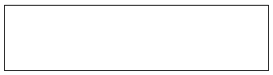

It represents external entity such as h/w, a person, another program etc. source and destination on system data.

* **Data Process:**

**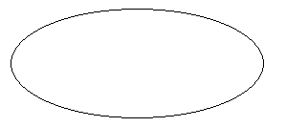**

It represents a process that transforms incoming data to outgoing data**.**

**Data Flow:**

It represents a data item or collection of data items the arrow indication direction of data flow.

**ZERO LEVEL DFD**



**ADMIN FIRST LEVEL DFD**



**DFD :**  **ADMIN Second level for 3.0**

****

**DFD :**  **ADMIN Second level for 4.0**



**ADMIN 2.5 DFD**



**ADMIN 2.6 DFD**



**Customer 1 DFD**



**Customer 2.3 DFD**



**Customer 2.4 DFD**



**5.3 E/R Diagram**

**► ENTITY – RELATIONSHIP MODEL:**

The ER model is based on the perception of real world as a collection of basic object called Entity and the relationship among the object.

A relationship is an association between different entities.

► **E-R DIAGRAM:**

In Entity Relationship diagram relationship between entities can be represented using symbols. It represents over all logical structure of database .Set of primary component of ER-diagram is:

1. Database Objects
2. Attributes
3. Relationship
4. Various type of Indication.

The symbol and the notation used in ER-diagram are as follow:

**► Rectangles:**

****

It represents entity sets.

**► Ellipses:-**

****

It represents attribute.

**► Diamond:-**

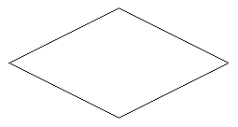

It represented entity relationship among the entity sets**.**

**► Line:-**

****

Lines links between entity sets and their relationship.

It represents attribute.

**ER-Diagram**



6) **Data Dictionary**

**Admin\_login**

|  |  |  |  |
| --- | --- | --- | --- |
| **Field** | **Type** | **Constraint** | **Description** |
| AID | int(5) | Primary key | Admin id |
| Name | varchar(20) |  | Name of admin |
| Email | varchar(50) |  | Email id of admin |
| Password | varchar(20) |  | Password |
| Dob | date |  | Date of birth |
| Image | varchar(50) |  | Image of admin |

**User\_master**

|  |  |  |  |
| --- | --- | --- | --- |
| **Field** | **Type** | **Constraint** | **Description** |
| UID | int(5) | primary key | User id |
| fname | varchar(20) |  | First name |
| lname | varchar(20) |  | Last name |
| mobile | varchar(10) |  | Mobile no |
| email | varchar(30) |  | Email id |
| uimage | varchar(50) |  | Image of user |

**\***

**User\_login**

|  |  |  |  |
| --- | --- | --- | --- |
| **Field** | **Type** | **Constraint** | **Description** |
| UID | int(5) |  | User id |
| Email | varchar(30) |  | Email id |
| Password | varchar(20) |  | Password |
| sec\_ques | varchar(30) |  | Security question |
| sec\_ans | varchar(30) |  | Security answer |
| Vemail | tinyint(1) |  | Email verification |

**Address**

|  |  |  |  |
| --- | --- | --- | --- |
| **Field** | **Type** | **Constraint** | **Description** |
| ADDID | int(5) | primary key | Address id |
| UID | int(5) | foreign key | User id |
| City | varchar(15) |  | City name |
| State | varchar(15) |  | State name |
| Pincode | varchar(8) |  | Pincode no. |
| Address | varchar(40) |  | Full address |
| Landmark | varchar(20) |  | Landmark |

**Products**

|  |  |  |  |
| --- | --- | --- | --- |
| **Field** | **Type** | **Constraint** | **Description** |
| PID | int(5) | primary key | Product id |
| pname | varchar(45) |  | Product name |
| pdesc | varchar(500) |  | Description |
| brand | varchar(50) |  | Brand of product |
| pprice | int(5) |  | Product price |
| pimage | varchar(30) |  | Product image |
| pdiscount | varchar(2) |  | Discount |
| ptag | varchar(50) |  | Product tags |
| date | date |  | Date of inserted |
| CID | int(5) | foreign key | Categories id |

**Cart\_master**

|  |  |  |  |
| --- | --- | --- | --- |
| **Field** | **Type** | **Constraint** | **Description** |
| CTID | int(5) | primary key | Cart id |
| UID | int(5) | Foreign key | User id |
| total\_cost | int(5) |  | Total amount to be pay |

**Cart\_details**

|  |  |  |  |
| --- | --- | --- | --- |
| **Field** | **Type** | **Constraint** | **Description** |
| CTID | int(5) | foreign key | Cart id |
| PID | int(5) | foreign key | Products id |
| quantity | int(5) |  | Quantity |

**orders**

|  |  |  |  |
| --- | --- | --- | --- |
| **Field** | **Type** | **Constraint** | **Description** |
| OID | int(5) | primary key | Order id |
| UID | int(5) | foreign key | User id |
| PID | int(5) | foreign key | Product id |
| ADDID | int(5) | foreign key | Address id |
| quantity | int(5) |  | Quatity |
| price | int(5) |  | Price of product |
| order\_date | datetime |  | Order date |
| pay\_method | varchar(20) |  | Payment method |
| Status | varchar(10) |  | Status of orders |

**delivery**

|  |  |  |  |
| --- | --- | --- | --- |
| **Field** | **Type** | **Constraint** | **Description** |
| OID | int(5) | foreign key | Order id |
| UID | int(5) | foreign key | User id |
| PID | int(5) | foreign key | Product id |
| ADDID | int(5) | foreign key | Address id |
| Quantity | varchar(3) |  | Quantity |
| Price | int(5) |  | Price |
| Date | varchar(10) |  | Date |
| pay\_method | varchar(20) |  | Payment method |

**wishlist**

|  |  |  |  |
| --- | --- | --- | --- |
| **Field** | **Type** | **Constraint** | **Description** |
| WID | int(5) | primary key | Wishlist id |
| UID | int(5) | foreign key | User id |
| PID | int(5) | foreign key | Product id |

**categories**

|  |  |  |  |
| --- | --- | --- | --- |
| **Field** | **Type** | **Constraint** | **Description** |
| CID | int(5) | Primary key | Categories id |
| cname | varchar(30) |  | Categories name |
| scname | varchar(100) |  | Sub categories name |

**review**

|  |  |  |  |
| --- | --- | --- | --- |
| **Field** | **Type** | **Constraint** | **Description** |
| ID | int(5) | primary key | Review id |
| name | varchar(20) |  | Customer name |
| email | varchar(30) |  | Customer email |
| review | varchar(50) |  | Review |
| rating | varchar(5) |  | Ratings |
| date | date |  | Date of review |
| PID | int(5) | foreign key | Product id |

**Contactus**

|  |  |  |  |
| --- | --- | --- | --- |
| **Field** | **Type** | **Constraint** | **Description** |
| ID | int(5) | primary key | Id |
| Fname | varchar(10) |  | First name |
| Lname | varchar(10) |  | Last name |
| Email | varchar(50) |  | Email id |
| Subject | varchar(20) |  | Subject |
| Message | varchar(50) |  | Message |

**brands**

|  |  |  |  |
| --- | --- | --- | --- |
| **Field** | **Type** | **Constraint** | **Description** |
| ID | int(3) | primary key | Id |
| Name | varchar(30) |  | Name of brand |
| Image | varchar(50) |  | Image of brand |

**newsletter**

|  |  |  |  |
| --- | --- | --- | --- |
| **Field** | **Type** | **Constraint** | **Description** |
| ID | int(5) | Primary key | Id |
| Email | varchar(50) |  | Email id |

**7. Form Designing and Coding**

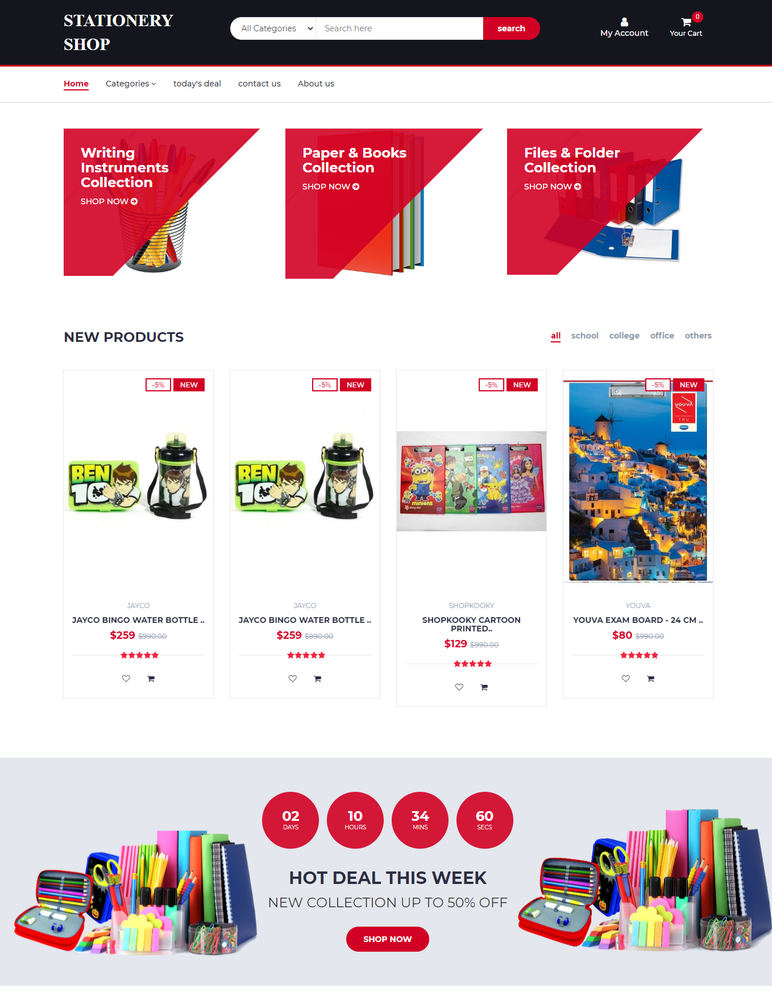

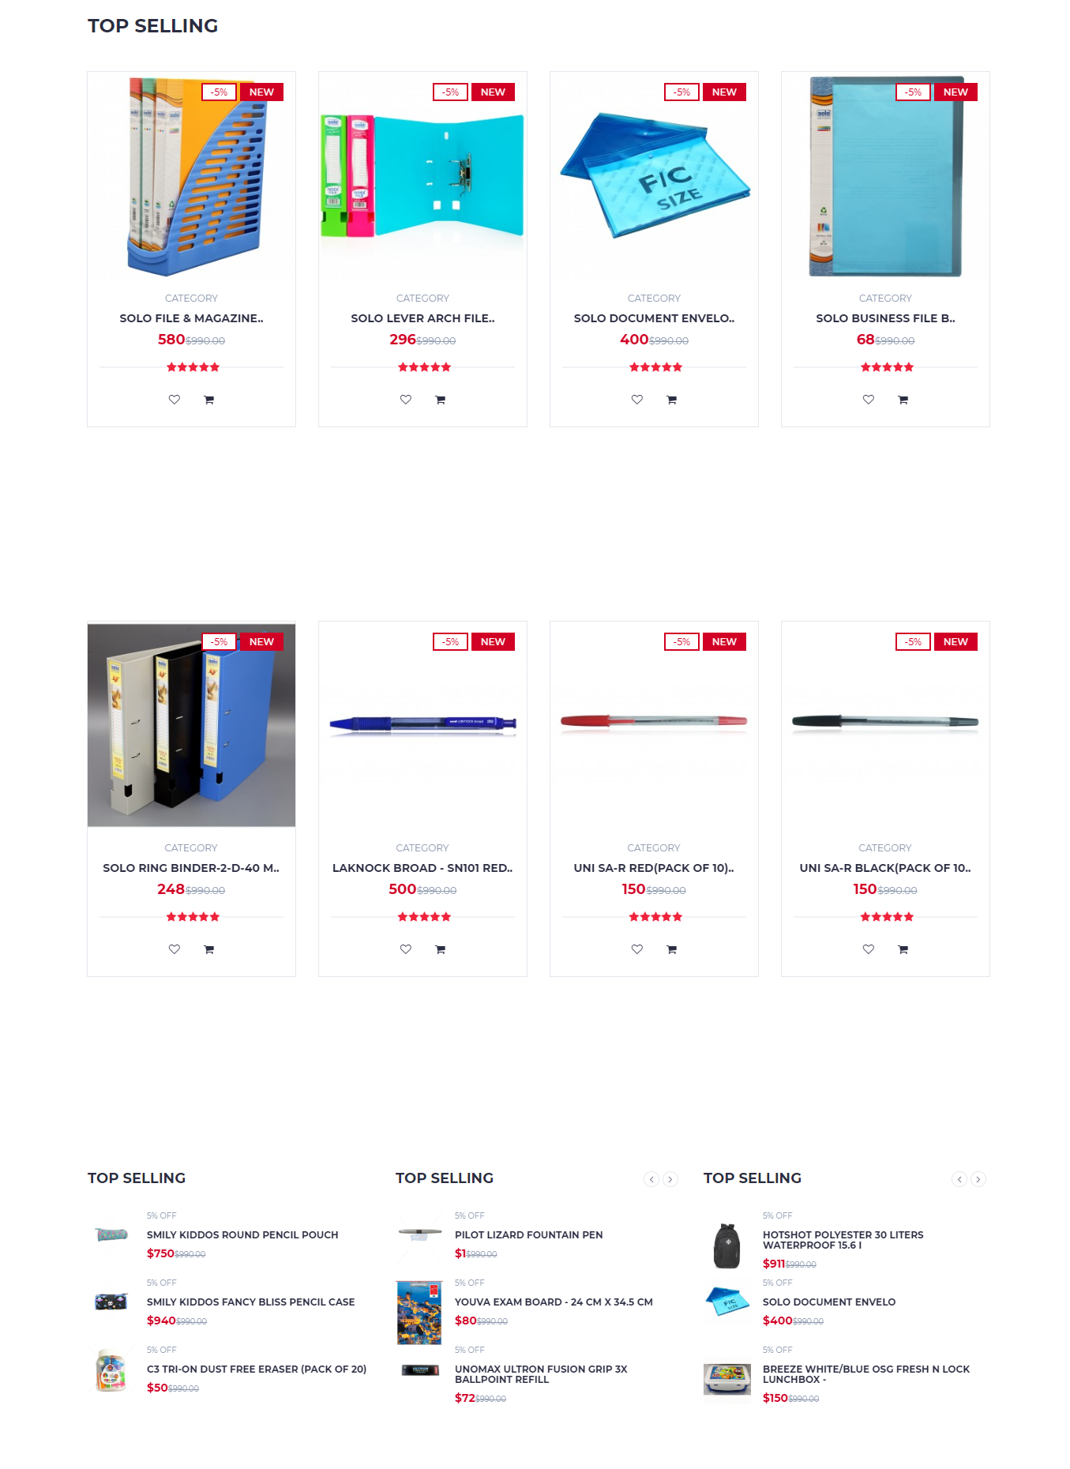

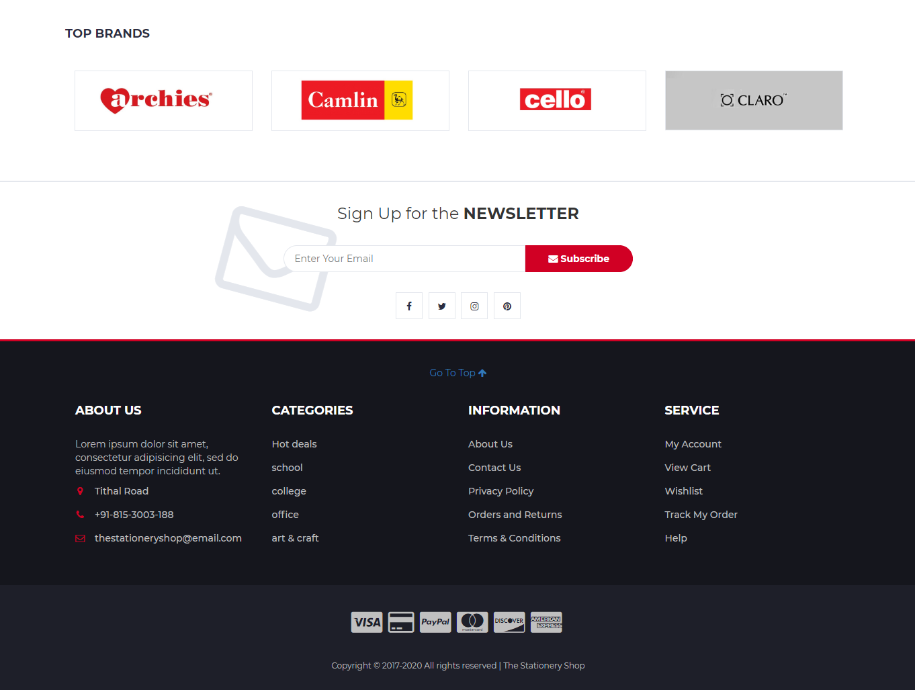

**Header.php**

<html lang="en">

<head>

<meta charset="utf-8">

<meta http-equiv="X-UA-Compatible" content="IE=edge">

<meta name="viewport" content="width=device-width, initial-scale=1">

<!-- The above 3 meta tags \*must\* come first in the head; any other head content must come \*after\* these tags -->

<title>STATIONERY SHOP</title>

<!-- Google font -->

<link href="https://fonts.googleapis.com/css?family=Montserrat:400,500,700" rel="stylesheet">

<!-- Bootstrap -->

<link type="text/css" rel="stylesheet" href="css/bootstrap.min.css"/>

<!-- Slick -->

<link type="text/css" rel="stylesheet" href="css/slick.css"/>

<link type="text/css" rel="stylesheet" href="css/slick-theme.css"/>

<!-- nouislider -->

<link type="text/css" rel="stylesheet" href="css/nouislider.min.css"/>

<!-- Font Awesome Icon -->

<link rel="stylesheet" href="css/font-awesome.min.css">

<!-- Custom stlylesheet -->

<link type="text/css" rel="stylesheet" href="css/style.css"/>

<link type="text/css" rel="stylesheet" href="css/custom.css"/>

<link type="text/css" rel="stylesheet" href="css/nav.css"/>

<script src="https://kit.fontawesome.com/6e49948015.js" crossorigin="anonymous"></script>

<!-- HTML5 shim and Respond.js for IE8 support of HTML5 elements and media queries --<!-- WARNING: Respond.js doesn't work if you view the page via file:// -->

<!--[if lt IE 9]>

<script src="https://oss.maxcdn.com/html5shiv/3.7.3/html5shiv.min.js"></script>

<script src="https://oss.maxcdn.com/respond/1.4.2/respond.min.js"></script>

<![endif]-->

</head>

<body bgcolor="lavender">

<a id="#top"></a>

<!-- HEADER -->

<header>

<!-- MAIN HEADER -->

<div id="header">

<!-- container -->

<div class="container">

<!-- row -->

<div class="row">

<!-- LOGO -->

<div class="col-md-3">

<div class="header-logo">

<a href="#" class="logo">

<font style="font-style:normal; font-size: 30px;color: #fff;font-family: serif">

<b>STATIONERY SHOP</b>

</font>

</a>

</div>

</div>

<!-- /LOGO -->

<!-- SEARCH BAR -->

<div class="col-md-6">

<div class="header-search">

<form method="post" action="store1.php">

<select name="scat" class="input-select">

<option value="0">All Categories</option>

<option value="1">School</option> <option value="1">College</option>

<option value="1">Office</option>

<option value="1">Art&Craft</option>

<option value="1">...</option>

</select>

<input name="stxt" class="input" placeholder="Search here" required>

<input name="sbtn" type="submit" value="search" class="search-btn">

</form>

</div>

</div>

<!-- /SEARCH BAR -->

<!-- ACCOUNT -->

<div class="col-md-3 clearfix">

<div class="header-ctn">

<!-- Login-->

<?php

session\_start();

include "db.php";

if(isset($\_SESSION["uid"]))

{

$sql = "SELECT fname FROM user\_master WHERE UID='$\_SESSION[uid]'";

$query = mysql\_query($sql,$conn );

$row = mysql\_fetch\_array($query);

echo '

<div class="dropdownn">

<a href="#" class="dropdownn" data-toggle="modal" data-target="#myModal" ><i class="fa fa-user-o"></i> HI '.$row['fname'].'</a>

<div class="dropdownn-content">

<a style="color:#fff" href="profile.php"><i class="fa fa-user-circle" aria-hidden="true" ></i> My Profile</a>

<a style="color:#fff" href="wishlist.php" ><i class="fa fa-heart" aria-hidden="true" ></i> Wishlist</a>

<a style="color:#fff" href="yourorder.php" ><i class="fa fa-first-order" aria-hidden="true" ></i> My Orders</a>

<a style="color:#fff" href="logout.php" ><i class="fa fa-sign-in" aria-hidden="true"></i> Log out</a>

</div>

</div>';

}

else

{

echo '

<div class="dropdownn">

<a href="#" class="dropdownn" data-toggle="modal" data-target="#myModal" ><i class="fa fa-user"></i> My Account</a>

<ul class="dropdownn-content nav" >

<li><a style="color:#D10024" href="" data-toggle="modal" data-target="#Modal\_login"><i class="fa fa-sign-in" aria-hidden="true" ></i> Login</a>

</li><li><a style="color:#D10024" href="" data-toggle="modal" data-target="#Modal\_register"><i class="fa fa-user-plus" aria-hidden="true"></i> Register</a>

</li></ul>

</div>

';

}

?>

<?php

$nitem=0;

if(isset($\_SESSION['uid']))

{

$sql="select \* from cart\_master where UID='$\_SESSION[uid]'"; $res=mysql\_query($sql,$conn);

$rset=mysql\_fetch\_array($res);

$ctid=$rset['CTID'];

$sql="select count(\*) from cart\_details where CTID='$ctid'";

$res1=mysql\_query($sql,$conn);

$rset1=mysql\_fetch\_array($res1); $nitem=$rset1[0];

}

?>

<!-- Login-->

<div class="dropdown">

<a class="dropdown-toggle" data-toggle="dropdown" aria-expanded="true" href="">

<i class="fa fa-shopping-cart"></i>

<span>Your Cart</span>

<div class="qty"><?php echo $nitem; ?></div>

</a>

<div class="cart-dropdown">

<div class="cart-list">

<?php

//to fetch product\_id

if( isset( $\_SESSION['uid'] ) )

{

$uid = $\_SESSION['uid'];

$sql = "select \* from cart\_master where UID='$uid'";

$res = mysql\_query( $sql,$conn ) or die( mysql\_error( ) );

$res1 = mysql\_fetch\_array( $res );

$total\_cost = $res1['total\_cost'];

$ctid = $res1['CTID'];

$sql = "select \* from cart\_details where CTID='$ctid'";

$res = mysql\_query( $sql,$conn ) or die( mysql\_error( ) );

while( $res1 = mysql\_fetch\_array( $res ) )

{

$sql1 = "select \* from products where PID=".$res1['PID']."";

$cmd1 = mysql\_query($sql1,$conn) or die( mysql\_error( ) );

$rset1 = mysql\_fetch\_array( $cmd1 );

$rset1['pname'];

?>

<div class="product-widget">

<div class="product-img">

<img src="<?php echo $rset1['pimage']; ?>" alt="">

</div>

<div class="product-body">

<h3 class="product-name"><a href="#"><?php echo $rset1['pname']; ?></a></h3>

<h4 class="product-price"><span class="qty"><?php echo $res1['quantity']; ?>x</span><?php echo $rset1['pprice']; ?></h4>

</div>

<a href="delete.php?pid=<?php echo $rset1['PID']; ?> & ctid=<?php echo $ctid; ?>"><button class="delete" ><i class="fa fa-close "></i></button></a>

</div>

<?php

}

?>

</div>

<div class="cart-summary">

<!--<small>3 Item(s) selected</small>-->

<h5>SUBTOTAL:<?php echo $total\_cost; ?></h5>

</div>

<div class="cart-btns">

<a href="cart.php" target="\_blank">View Cart</a>

<a href="checkout.php" target="\_blank">Checkout <i class="fa fa-arrow-circle-right"></i></a>

</div>

</div>

</div>

<!-- /Cart -->

<?php

}

else

{

echo "please login to view your cart";

}

?>

</div>

</div>

<!-- /ACCOUNT -->

</div>

<!-- row -->

</div>

<!-- container -->

</div>

<!-- /MAIN HEADER -->

</header>

<!-- /HEADER -->

<!-- NAVIGATION -->

<nav id="navigation">

<!-- container -->

<div class="container">

<!-- responsive-nav -->

<div id="responsive-nav">

<!-- NAV -->

<ul class="main-nav nav navbar-nav">

<li class="active"><a href="index.php"><b>Home</b></a></li>

<li><a href="#categories" data-toggle="collapse" role="button" >Categories <i class="fa fa-angle-down"></i></a></li>

<li><a href="store1.php">today's deal</a></li>

<li><a href="contact\_us.php">contact us</a></li>

<li><a href="#footer">About us</a></li>

</ul>

<!-- /NAV -->

</div>

<!-- /responsive-nav -->

<div class="collapse" id="categories" >

<div class="card card-body col-md-9">

<ul class="nav navbar-nav">

<?php

$cmd1 = mysql\_query( "select \* from categories", $conn );

while( $rset1 = mysql\_fetch\_array( $cmd1 ) )

{

echo "<li><a href='store1.php?stext=$rset1[1]'>$rset1[1]</a></li>";

}

?>

</ul>

</div>

</div>

<!-- /responsive-nav -->

</div>

<!-- /container -->

</nav>

<!-- /NAVIGATION -->

<div class="modal fade" id="Modal\_login" role="dialog">

<div class="modal-dialog">

<!-- Modal content-->

<div class="modal-content">

<div class="modal-header">

<button type="button" class="close" data-dismiss="modal">&times;</button>

</div>

<div class="modal-body">

<?php

include "login\_form.php";

?>

</div>

</div>

</div>

</div>

<div class="modal fade" id="Modal\_register" role="dialog">

<div class="modal-dialog" style="">

<!-- Modal content-->

<div class="modal-content">

<div class="modal-header">

<button type="button" class="close" data-dismiss="modal">&times;</button>

</div>

<div class="modal-body">

<?php

include "register\_form.php";

?>

</div>

</div>

</div>

</div>

**Index.php**

<!DOCTYPE html>

<?php include "header.php"; ?>

<!-- SECTION -->

<div class="section">

<!-- container -->

<div class="container">

<!-- row -->

<div class="row">

<!-- shop -->

<div class="col-md-4 col-xs-6">

<div class="shop">

<div class="shop-img">

<img src="./img/shop01.png" alt="">

</div>

<div class="shop-body">

<h3>Writing Instruments<br>Collection</h3>

<a href="#" class="cta-btn">Shop now <i class="fa fa-arrow-circle-right"></i></a>

</div>

</div>

</div>

<!-- /shop -->

<!-- shop -->

<div class="col-md-4 col-xs-6">

<div class="shop">

<div class="shop-img">

<img src="./img/shop02.png" alt="">

</div>

<div class="shop-body">

<h3>Paper & Books<br>Collection</h3>

<a href="#" class="cta-btn">Shop now <i class="fa fa-arrow-circle-right"></i></a>

</div>

</div>

</div>

<!-- /shop -->

<!-- shop -->

<div class="col-md-4 col-xs-6">

<div class="shop">

<div class="shop-img">

<img src="./img/shop03.jpg" alt="">

</div>

<div class="shop-body">

<h3>Files & Folder<br>Collection</h3>

<a href="#" class="cta-btn">Shop now <i class="fa fa-arrow-circle-right"></i></a>

</div>

</div>

</div>

<!-- /shop -->

</div>

<!-- /row -->

</div>

<!-- /container -->

</div>

<!-- /SECTION -->

<!-- SECTION -->

<div class="section">

<!-- container -->

<div class="container">

<!-- row -->

<div class="row">

<!-- section title -->

<div class="col-md-12">

<div class="section-title">

<h3 class="title">New Products</h3>

<div class="section-nav">

<ul class="section-tab-nav tab-nav">

<li class="active"><a href="index.php">all</a></li>

<li><a href="index.php?n=school">school</a></li>

<li><a href="index.php?n=college">college</a></li>

<li><a href="index.php?n=office">office</a></li>

<li><a href="index.php?n=pen">others</a></li>

</ul>

</div>

</div>

</div>

<!-- /section title -->

<!-- Products tab & slick -->

<div class="col-md-12">

<div class="row">

<div class="products-tabs">

<div id="tab1" class="tab-pane active" role='tab' >

<div class="products-slick" data-nav="#slick-nav-1">

<!-- product -->

<?php

if(isset($\_GET['n']))

{

$qq="where ptag like '%$\_GET[n]%'";

}

else

{

$qq='';

}

$query="select \* from products ".$qq;

$res=mysql\_query($query,$conn);

if(mysql\_num\_rows($res) > 0)

{

while($row = mysql\_fetch\_array($res))

{

$pid = $row['PID'];

$pname = $row['pname'];

$pdesc = $row['pdesc'];

$brand = $row['brand'];

$price = $row['pprice'];

$pimg = $row['pimage'];

$tag = $row['ptag'];

$discount= $row['pdiscount'];

$date=$row['date'];

?>

<div class="product" >

<a href="product.php?pid=<?php echo $pid;?>"> <div class="product-img">

<img src="<?php echo $pimg; ?>" alt="" >

<div class="product-label">

<span class="sale">-<?php echo $discount; ?>%</span>

<span class="new">NEW</span>

</div>

</div> </a>

<div class="product-body">

<p class="product-category"><?php echo $brand; ?></p>

<h3 class="product-name"><a href="product.php?pid=<?php echo $pid;?>"><?php echo substr($pname,0,25); ?>..</a></h3>

<h4 class="product-price">$<?php echo $price; ?> <del class="product-old-price"> $990.00</del></h4>

<div class="product-rating">

<i class="fa fa-star"></i>

<i class="fa fa-star"></i>

<i class="fa fa-star"></i>

<i class="fa fa-star"></i>

<i class="fa fa-star"></i>

</div>

<div class="product-btns">

<button class="add-to-wishlist">

<a href="insertwishlist.php?pid=<?php echo $pid; ?>"><i class="fa fa-heart-o"></i></a>

<span class="tooltipp">add to wishlist</span>

</button>

<button class="add-to-wishlist">

<a class="add-to-wishlist" target="\_blank" href="insertcart.php?pid=<?php echo $pid; ?>" >

<i class="fa fa-shopping-cart"></i><span class="tooltipp">add to cart</span>

</a>

</button>

</div>

</div>

</div>

<?php

}

}

?>

<div id="slick-nav-1" class="products-slick-nav"></div>

</div>

<!-- /tab -->

</div>

</div>

</div>

</div>

<!-- Products tab & slick -->

</div>

<!-- /row -->

</div>

<!-- /container -->

</div>

<!-- /SECTION -->

<!-- HOT DEAL SECTION -->

<div id="hot-deal" class="section">

<!-- container -->

<div class="container">

<!-- row -->

<div class="row">

<div class="col-md-12">

<div class="hot-deal">

<ul class="hot-deal-countdown">

<li>

<div>

<h3>02</h3>

<span>Days</span>

</div>

</li>

<li>

<div>

<h3>10</h3>

<span>Hours</span>

</div>

</li>

<li>

<div>

<h3>34</h3>

<span>Mins</span>

</div>

</li>

<li>

<div>

<h3>60</h3>

<span>Secs</span>

</div>

</li>

</ul>

<h2 class="text-uppercase">hot deal this week</h2>

<p>New Collection Up to 50% OFF</p>

<a class="primary-btn cta-btn" href="#">Shop now</a>

</div>

</div>

</div>

<!-- /row -->

</div>

<!-- /container -->

</div>

<!-- /HOT DEAL SECTION -->

<!-- SECTION -->

<div class="section">

<!-- container -->

<div class="container">

<!-- row -->

<div class="row">

<!-- section title -->

<div class="col-md-12">

<div class="section-title">

<h3 class="title">Top selling</h3>

</div>

</div>

<!-- /section title -->

<!-- Products tab & slick -->

<div class="col-md-12">

<div class="row">

<div class="products-tabs">

<!-- tab -->

<div id="tab1" class="tab-pane active">

<div class="products-slick" data-nav="#slick-nav-1">

<!-- product -->

<?php

$query="select \* from products ";

$res=mysql\_query($query,$conn);

if(mysql\_num\_rows($res) > 0)

{

while($row = mysql\_fetch\_array($res))

{

$pid = $row['PID'];

$pname = $row['pname'];

$pdesc = $row['pdesc'];

$price = $row['pprice'];

$pimg = $row['pimage'];

$tag = $row['ptag'];

$discount= $row['pdiscount'];

$date=$row['date'];

?>

<div class="col-md-3 col-xs-6">

<div class="product" >

<a href="product.php?pid=<?php echo $pid;?>"> <div class="product-img">

<img src="<?php echo $pimg; ?>" alt="" >

<div class="product-label">

<span class="sale">-<?php echo $discount; ?>%</span>

<span class="new">NEW</span>

</div>

</div> </a>

<div class="product-body">

<p class="product-category">Category</p>

<h3 class="product-name"><a href="product.php?pid=<?php echo $pid;?>"><?php echo substr($pname,0,25); ?>..</a></h3>

<h4 class="product-price"><?php echo $price; ?><del class="product-old-price">$990.00</del></h4>

<div class="product-rating">

<i class="fa fa-star"></i>

<i class="fa fa-star"></i>

<i class="fa fa-star"></i>

<i class="fa fa-star"></i>

<i class="fa fa-star"></i>

</div>

<div class="product-btns">

<button class="add-to-wishlist">

<a href="insertwishlist.php?pid=<?php echo $pid; ?>"><i class="fa fa-heart-o"></i></a>

<span class="tooltipp">add to wishlist</span>

</button>

<button class="add-to-wishlist">

<a class="add-to-wishlist" target="\_blank" href="insertcart.php?pid=<?php echo $pid; ?>" >

<i class="fa fa-shopping-cart"></i><span class="tooltipp">add to cart</span>

</a>

</button>

</div>

</div>

</div>

</div>

<?php

}

}

?>

<!-- /product -->

<div id="slick-nav-3" class="products-slick-nav"></div>

</div>

<!-- /tab -->

</div>

</div>

</div>

<!-- Products tab & slick -->

</div>

<!-- /Products tab & slick -->

</div>

<!-- /row -->

</div>

<!-- /container -->

</div>

<!-- /SECTION -->

<!-- SECTION -->

<div class="section">

<!-- container -->

<div class="container">

<!-- row -->

<div class="row">

<!-- Products tab & slick -->

<div class="col-md-12">

<div class="row">

<div class="products-tabs">

<!-- tab -->

<div id="tab1" class="tab-pane active">

<div class="products-slick" data-nav="#slick-nav-1">

<!-- product -->

<?php

$query="select \* from products ";

$res=mysql\_query($query,$conn);

if(mysql\_num\_rows($res) > 0)

{

while($row = mysql\_fetch\_array($res))

{

$pid = $row['PID'];

$pname = $row['pname'];

$pdesc = $row['pdesc'];

$price = $row['pprice'];

$pimg = $row['pimage'];

$tag = $row['ptag'];

$discount= $row['pdiscount'];

$date=$row['date'];

?>

<div class="col-md-3 col-xs-6">

<div class="product" >

<a href="product.php?pid=<?php echo $pid;?>"> <div class="product-img">

<img src="<?php echo $pimg; ?>" alt="" >

<div class="product-label">

<span class="sale">-<?php echo $discount; ?>%</span>

<span class="new">NEW</span>

</div>

</div> </a>

<div class="product-body">

<p class="product-category">Category</p>

<h3 class="product-name"><a href="product.php?pid=<?php echo $pid;?>"><?php echo substr($pname,0,25); ?>..</a></h3>

<h4 class="product-price"><?php echo $price; ?><del class="product-old-price">$990.00</del></h4>

<div class="product-rating">

<i class="fa fa-star"></i>

<i class="fa fa-star"></i>

<i class="fa fa-star"></i>

<i class="fa fa-star"></i>

<i class="fa fa-star"></i>

</div>

<div class="product-btns">

<button class="add-to-wishlist">

<a href="insertwishlist.php?pid=<?php echo $pid; ?>"><i class="fa fa-heart-o"></i></a>

<span class="tooltipp">add to wishlist</span>

</button>

<button class="add-to-wishlist">

<a class="add-to-wishlist" target="\_blank" href="insertcart.php?pid=<?php echo $pid; ?>" >

<i class="fa fa-shopping-cart"></i><span class="tooltipp">add to cart</span>

</a>

</button>

</div>

</div>

</div>

</div>

<?php

}

}

?>

<!-- /product -->

<div id="slick-nav-3" class="products-slick-nav"></div>

</div>

<!-- /tab -->

</div>

</div>

</div>

<!-- Products tab & slick -->

</div>

<!-- /Products tab & slick -->

</div>

<!-- /row -->

</div>

<!-- /container -->

</div>

<!-- /SECTION -->

<!-- SECTION -->

<div class="section">

<!-- container -->

<div class="container">

<!-- row -->

<div class="row">

<div class="col-md-4 col-xs-6">

<div class="section-title">

<h4 class="title">Top selling</h4>

<div class="section-nav">

<div id="slick-nav-3" class="products-slick-nav"></div>

</div>

</div>

<div class="products-widget-slick" data-nav="#slick-nav-3">

<?php

$query="select \* from products ORDER BY pdiscount";

$res=mysql\_query($query,$conn);

while($row = mysql\_fetch\_array($res))

{

?>

<div>

<!-- product widget -->

<div class="product-widget">

<a href="product.php?pid=<?php echo $row['PID'];?>">

<div class="product-img">

<img src="<?php echo $row['pimage'];?>" alt="">

</div>

</a>

<div class="product-body">

<p class="product-category"><?php echo $row['pdiscount']; ?>% OFF</p>

<h3 class="product-name"><a href="product.php?pid=<?php echo $row['PID'];?>"><?php echo $row['pname']; ?></a></h3>

<h4 class="product-price">$<?php echo $row['pprice']; ?><del class="product-old-price">$990.00</del></h4>

</div>

</div>

<!-- /product widget -->

</div>

<?php } ?>

</div>

</div>

<div class="clearfix visible-sm visible-xs"></div>

<div class="col-md-4 col-xs-6">

<div class="section-title">

<h4 class="title">Top selling</h4>

<div class="section-nav">

<div id="slick-nav-4" class="products-slick-nav"></div>

</div>

</div>

<div class="products-widget-slick" data-nav="#slick-nav-4">

<?php

$query="select \* from products order by ptag ";

$res=mysql\_query($query,$conn);

while($row = mysql\_fetch\_array($res))

{

?>

<div>

<!-- product widget -->

<div class="product-widget">

<a href="product.php?pid=<?php echo $row['PID'];?>">

<div class="product-img">

<img src="<?php echo $row['pimage'];?>" alt="">

</div>

</a>

<div class="product-body">

<p class="product-category"><?php echo $row['pdiscount']; ?>% OFF</p>

<h3 class="product-name"><a href="product.php?pid=<?php echo $row['PID'];?>"><?php echo $row['pname']; ?></a></h3>

<h4 class="product-price">$<?php echo $row['pprice']; ?><del class="product-old-price">$990.00</del></h4>

</div>

</div>

<!-- /product widget -->

</div>

<?php

}

?>

</div>

</div>

<div class="clearfix visible-sm visible-xs"></div>

<div class="col-md-4 col-xs-6">

<div class="section-title">

<h4 class="title">Top selling</h4>

<div class="section-nav">

<div id="slick-nav-5" class="products-slick-nav"></div>

</div>

</div>

<div class="products-widget-slick" data-nav="#slick-nav-5">

<?php

$query="select \* from products ORDER BY pprice";

$res=mysql\_query($query,$conn);

while($row = mysql\_fetch\_array($res))

{

?>

<div>

<!-- product widget -->

<div class="product-widget">

<a href="product.php?pid=<?php echo $row['PID'];?>">

<div class="product-img">

<img src="<?php echo $row['pimage'];?>" alt="">

</div>

</a>

<div class="product-body">

<p class="product-category"><?php echo $row['pdiscount']; ?>% OFF</p>

<h3 class="product-name"><a href="product.php?pid=<?php echo $row['PID'];?>"><?php echo $row['pname']; ?></a></h3>

<h4 class="product-price">$<?php echo $row['pprice']; ?><del class="product-old-price">$990.00</del></h4>

</div>

</div>

<!-- /product widget -->

</div>

<?php

}

?>

</div>

</div>

</div>

<div class="row">

<div class="col-md-4 col-xs-6">

<div class="products-widget-slick" data-nav="">

<?php

$query="select \* from products ORDER BY pdiscount desc";

$res=mysql\_query($query,$conn);

while($row = mysql\_fetch\_array($res))

{

?>

<div>

<!-- product widget -->

<div class="product-widget">

<a href="product.php?pid=<?php echo $row['PID'];?>">

<div class="product-img">

<img src="<?php echo $row['pimage'];?>" alt="">

</div>

</a>

<div class="product-body">

<p class="product-category"><?php echo $row['pdiscount']; ?>% OFF</p>

<h3 class="product-name"><a href="product.php?pid=<?php echo $row['PID'];?>"><?php echo $row['pname']; ?></a></h3>

<h4 class="product-price">$<?php echo $row['pprice']; ?><del class="product-old-price">$990.00</del></h4>

</div>

</div>

<!-- /product widget -->

</div>

<?php } ?>

</div>

</div>

<div class="clearfix visible-sm visible-xs"></div>

<div class="col-md-4 col-xs-6">

<div class="products-widget-slick" data-nav="">

<?php

$query="select \* from products ";

$res=mysql\_query($query,$conn);

while($row = mysql\_fetch\_array($res))

{

?>

<div>

<!-- product widget -->

<div class="product-widget">

<a href="product.php?pid=<?php echo $row['PID'];?>">

<div class="product-img">

<img src="<?php echo $row['pimage'];?>" alt="">

</div>

</a>

<div class="product-body">

<p class="product-category"><?php echo $row['pdiscount']; ?>% OFF</p>

<h3 class="product-name"><a href="product.php?pid=<?php echo $row['PID'];?>"><?php echo $row['pname']; ?></a></h3>

<h4 class="product-price">$<?php echo $row['pprice']; ?><del class="product-old-price">$990.00</del></h4>

</div>

</div>

<!-- /product widget -->

</div>

<?php

}

?>

</div>

</div>

<div class="clearfix visible-sm visible-xs"></div>

<div class="col-md-4 col-xs-6">

<div class="products-widget-slick" data-nav="">

<?php

$query="select \* from products ORDER BY PID desc ";

$res=mysql\_query($query,$conn);

while($row = mysql\_fetch\_array($res))

{

?>

<div>

<!-- product widget -->

<div class="product-widget">

<a href="product.php?pid=<?php echo $row['PID'];?>">

<div class="product-img">

<img src="<?php echo $row['pimage'];?>" alt="">

</div>

</a>

<div class="product-body">

<p class="product-category"><?php echo $row['pdiscount']; ?>% OFF</p>

<h3 class="product-name"><a href="product.php?pid=<?php echo $row['PID'];?>"><?php echo $row['pname']; ?></a></h3>

<h4 class="product-price">$<?php echo $row['pprice']; ?><del class="product-old-price">$990.00</del></h4>

</div>

</div>

<!-- /product widget -->

</div>

<?php

}

?>

</div>

</div>

</div>

<div class="row">

<div class="col-md-4 col-xs-6">

<div class="products-widget-slick" data-nav="">

<?php

$query="select \* from products order by pname desc";

$res=mysql\_query($query,$conn);

while($row = mysql\_fetch\_array($res))

{

?>

<div>

<!-- product widget -->

<div class="product-widget">

<a href="product.php?pid=<?php echo $row['PID'];?>">

<div class="product-img">

<img src="<?php echo $row['pimage'];?>" alt="">

</div>

</a>

<div class="product-body">

<p class="product-category"><?php echo $row['pdiscount']; ?>% OFF</p>

<h3 class="product-name"><a href="product.php?pid=<?php echo $row['PID'];?>"><?php echo $row['pname']; ?></a></h3>

<h4 class="product-price">$<?php echo $row['pprice']; ?><del class="product-old-price">$990.00</del></h4>

</div>

</div>

<!-- /product widget -->

</div>

<?php } ?>

</div>

</div>

<div class="clearfix visible-sm visible-xs"></div>

<div class="col-md-4 col-xs-6">

<div class="products-widget-slick" data-nav="">

<?php

$query="select \* from products order by CID";

$res=mysql\_query($query,$conn);

while($row = mysql\_fetch\_array($res))

{

?>

<div>

<!-- product widget -->

<div class="product-widget">

<a href="product.php?pid=<?php echo $row['PID'];?>">

<div class="product-img">

<img src="<?php echo $row['pimage'];?>" alt="">

</div>

</a>

<div class="product-body">

<p class="product-category"><?php echo $row['pdiscount']; ?>% OFF</p>

<h3 class="product-name"><a href="product.php?pid=<?php echo $row['PID'];?>"><?php echo $row['pname']; ?></a></h3>

<h4 class="product-price">$<?php echo $row['pprice']; ?><del class="product-old-price">$990.00</del></h4>

</div>

</div>

<!-- /product widget -->

</div>

<?php

}

?>

</div>

</div>

<div class="clearfix visible-sm visible-xs"></div>

<div class="col-md-4 col-xs-6">

<div class="products-widget-slick" data-nav="">

<?php

$query="select \* from products ORDER BY date desc ";

$res=mysql\_query($query,$conn);

while($row = mysql\_fetch\_array($res))

{

?>

<div>

<!-- product widget -->

<div class="product-widget">

<a href="product.php?pid=<?php echo $row['PID'];?>">

<div class="product-img">

<img src="<?php echo $row['pimage'];?>" alt="">

</div>

</a>

<div class="product-body">

<p class="product-category"><?php echo $row['pdiscount']; ?>% OFF</p>

<h3 class="product-name"><a href="product.php?pid=<?php echo $row['PID'];?>"><?php echo $row['pname']; ?></a></h3>

<h4 class="product-price">$<?php echo $row['pprice']; ?><del class="product-old-price">$990.00</del></h4>

</div>

</div>

<!-- /product widget -->

</div>

<?php

}

?>

</div>

</div>

</div>

<!-- /row -->

</div>

<!-- /container -->

</div>

<!-- /SECTION -->

<!-- SECTION -->

<div class="section">

<!-- container -->

<div class="container">

<div class="row">

<div class="section-title">

<h4 class="title">Top brands </h4>

</div>

<div class="products-tabs">

<div id="tab1" class="tab-pane active" role='tab' >

<div class="products-slick" data-nav="#slick-nav-1">

<?php

$query="select \* from brands";

$res=mysql\_query($query,$conn);

if(mysql\_num\_rows($res) > 0)

{

while($row = mysql\_fetch\_array($res))

{

?>

<div class="product">

<div class="product-img">

<img src="img/brands/<?php echo $row['image']; ?>" alt="" >

</div>

</div>

<?php

}

}

?>

</div>

<!-- /tab -->

</div>

</div>

</div>

<!-- Products tab & slick -->

</div>

<!-- /container -->

</div>

<!-- /SECTION -->

<!-- NEWSLETTER -->

<?php include "newsletter.php"; ?>

<?php include "footer.php"; ?>

</body>

</html>

**Footer.php**

<!-- FOOTER -->

<footer id="footer">

<!-- top footer -->

<div class="section">

<!-- container -->

<div class="container">

<!-- row -->

<div class="row">

<div class="col-md-12">

<center>

<a href="#top" class="btn btn-link">Go To Top <i class="fa fa-arrow-up"></i></a>

</center>

</div>

<div class="col-md-3 col-xs-6">

<div class="footer">

<h3 class="footer-title">About Us</h3>

<p>Lorem ipsum dolor sit amet, consectetur adipisicing elit, sed do eiusmod tempor incididunt ut.</p>

<ul class="footer-links">

<li><a href="#"><i class="fa fa-map-marker"></i>Tithal Road</a></li>

<li><a href="#"><i class="fa fa-phone"></i>+91-815-3003-188</a></li>

<li><a href="#"><i class="fa fa-envelope-o"></i>thestationeryshop@email.com</a></li>

</ul>

</div>

</div>

<div class="col-md-3 col-xs-6">

<div class="footer">

<h3 class="footer-title">Categories</h3>

<ul class="footer-links">

<li><a href="#">Hot deals</a></li>

<li><a href="#">school</a></li>

<li><a href="#">college</a></li>

<li><a href="#">office</a></li>

<li><a href="#">art & craft</a></li>

</ul>

</div>

</div>

<div class="clearfix visible-xs"></div>

<div class="col-md-3 col-xs-6">

<div class="footer">

<h3 class="footer-title">Information</h3>

<ul class="footer-links">

<li><a href="">About Us</a></li>

<li><a href="contact\_us.php">Contact Us</a></li>

<li><a href="privacy&policy.php">Privacy Policy</a></li>

<li><a href="yourorder.php">Orders and Returns</a></li>

<li><a href="terms&condition.php">Terms & Conditions</a></li>

</ul>

</div>

</div>

<div class="col-md-3 col-xs-6">

<div class="footer">

<h3 class="footer-title">Service</h3>

<ul class="footer-links">

<li><a href="profile.php">My Account</a></li>

<li><a href="cart.php">View Cart</a></li>

<li><a href="wishlist.php">Wishlist</a></li>

<li><a href="yourorder.php">Track My Order</a></li>

<li><a href="#">Help</a></li>

</ul>

</div>

</div>

</div>

<!-- /row -->

</div>

<!-- /container -->

</div>

<!-- /top footer -->

<!-- bottom footer -->

<div id="bottom-footer" class="section">

<div class="container">

<!-- row -->

<div class="row">

<div class="col-md-12 text-center">

<ul class="footer-payments" ">

<li><a href="#"><i style="color:silver;" class="fa fa-cc-visa"></i></a></li>

<li><a href="#"><i style="color:silver;" class="fa fa-credit-card"></i></a></li>

<li><a href="#"><i style="color:silver;" class="fa fa-cc-paypal"></i></a></li>

<li><a href="#"><i style="color:silver;" class="fa fa-cc-mastercard"></i></a></li>

<li><a href="#"><i style="color:silver;" class="fa fa-cc-discover"></i></a></li>

<li><a href="#"><i style="color:silver;" class="fa fa-cc-amex"></i></a></li>

</ul>

<span class="copyright">

Copyright &copy; 2017-<script>document.write(new Date().getFullYear());</script> All rights reserved | The Stationery Shop

</span>

</div>

</div>

<!-- /row -->

</div>

<!-- /container -->

</div>

<!-- /bottom footer -->

</footer>

<!-- /FOOTER -->

<!-- jQuery Plugins -->

<script src="js/jquery.min.js"></script>

<script src="js/bootstrap.min.js"></script>

<script src="js/slick.min.js"></script>

<script src="js/nouislider.min.js"></script>

<script src="js/jquery.zoom.min.js"></script>

<script src="js/main.js"></script>

<script src="js/process.js"></script>

**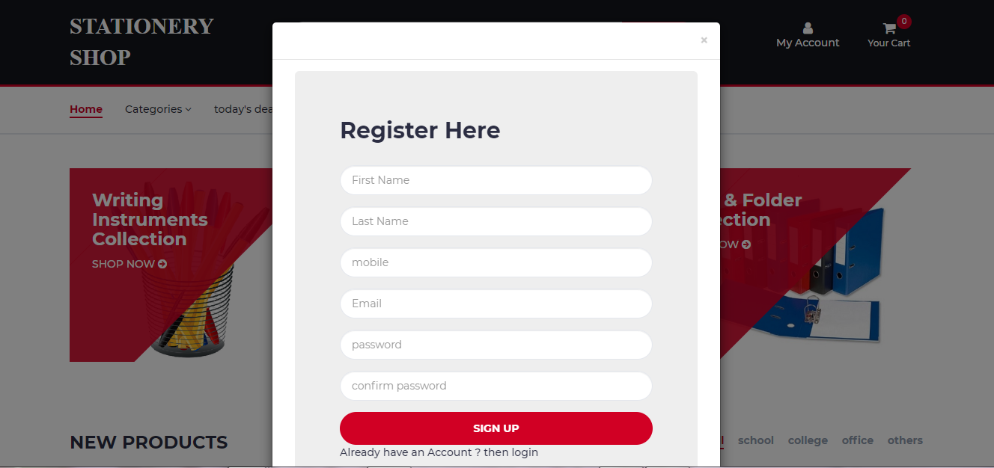**

**Register\_form.php**

<div class="wait overlay">

<div class="loader"></div>

</div>

<style>

.input-borders{

border-radius:30px;

}

</style>

<!-- row -->

<div class="container-fluid">

<!-- /Billing Details -->

<form id="signup\_form" class="login100-form" action="register.php" method="POST">

<div class="billing-details jumbotron">

<div class="section-title">

<h2 class="login100-form-title p-b-49" >Register Here</h2>

</div>

<div class="form-group ">

<input class="input form-control input-borders" type="text" name="f\_name" id="f\_name" placeholder="First Name" required>

</div>

<div class="form-group">

<input class="input form-control input-borders" type="text" name="l\_name" id="l\_name" placeholder="Last Name" required>

</div>

<div class="form-group">

<input class="input form-control input-borders" type="text" name="mobile" id="mobile" placeholder="mobile" required>

</div>

<div class="form-group">

<input class="input form-control input-borders" type="email" name="email" placeholder="Email" required>

</div>

<div class="form-group">

<input class="input form-control input-borders" type="password" name="password" id="password" placeholder="password" required>

</div>

<div class="form-group">

<input class="input form-control input-borders" type="password" name="repassword" id="repassword" placeholder="confirm password" required>

</div>

<div style="form-group">

<input class="primary-btn btn-block" value="Sign Up" type="submit" name="signup\_button">

</div>

<div class="text-pad">

<a href="" data-toggle="modal" data-target="#Modal\_login">Already have an Account ? then login</a>

</div>

</form>

<div class="login-marg">

<!-- Billing Details -->

<div class="row">

<div class="col-md-2"></div>

<div class="col-md-8" id="signup\_msg">

</div>

<!--Alert from signup form-->

</div>

<div class="col-md-2"></div>

</div>

</div>

</div>

<!-- /row -->

**Register.php**

<?php

include "db.php";

if (isset($\_POST["signup\_button"])) {

$fname = $\_POST["f\_name"];

$lname = $\_POST["l\_name"];

$email = $\_POST['email'];

$password = $\_POST['password'];

$password = md5($password);

$repassword = $\_POST['repassword'];

$mobile = $\_POST['mobile'];

//existing email address in our database

$sql = "SELECT UID FROM user\_master WHERE email = '$email' LIMIT 1" ;

$res = mysql\_query($sql,$conn);

$count\_email = mysql\_num\_rows($res);

if($count\_email > 0){

echo "

<div class='alert alert-danger'>

<a href='#' class='close' data-dismiss='alert' aria-label='close'>&times;</a>

<b>Email Address is already available Try Another email address</b>

</div> ";

}

else {

//auto id start

$sql = "select max(UID) from user\_master";

$cmd = mysql\_query( $sql, $conn );

$cnt = mysql\_num\_rows( $cmd );

if( $cnt == 0 )

{

$uid = 1;

}

else

{

$rset = mysql\_fetch\_array( $cmd );

$uid = $rset[0] + 1;

}

//auto id end

$sql = "INSERT INTO `user\_master` (`uid`, `fname`, `lname`, `mobile`, `email`) VALUES ($uid, '$fname', '$lname', '$mobile', '$email')";

$sql1="INSERT INTO `user\_login` (`UID`,`email`,`password`) VALUES ('$uid','$email','$password') ";

$res = mysql\_query($sql,$conn);

$res1=mysql\_query($sql1,$conn) or die(mysql\_error());

$vkey = mt\_rand(100000,999999);

setcookie('vkey',"$vkey",time() +84600);

setcookie('email',"$email",time() +84600);

$to = $email;

$subject = "email verification";

$message = "<a href='http://localhost/stationeryshop/index.php?vk=$vkey'>Register account</a>";

$headers = "from: testmycode404@gmail.com";

mail( $to, $subject, $message, $headers );

if($res1){

echo "<script>alert( 'Register successful login now' ); window.location.href='index.php';</script>";

}

}

}

?>

**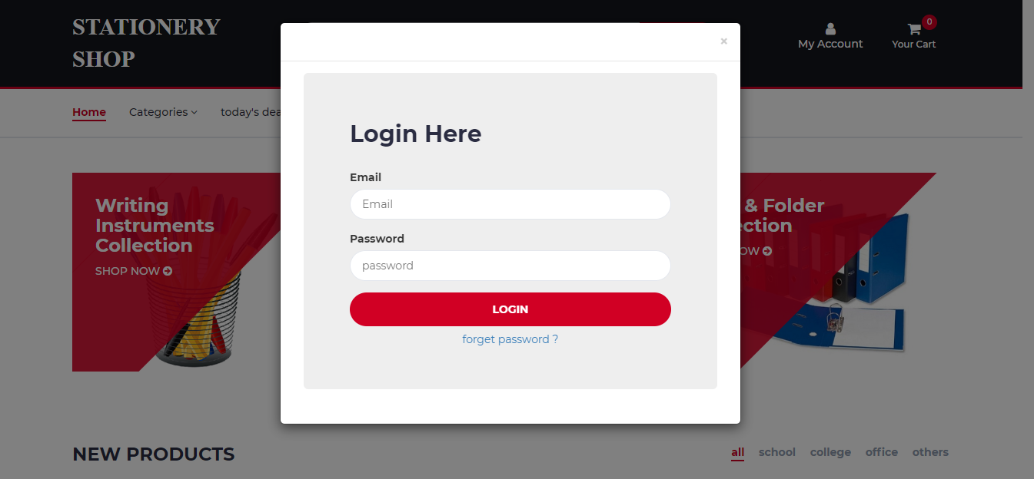**

**Login\_form.php**

<?php

include "db.php";

$emsg = '';

if(isset($\_POST['login\_button']))

{

$email = $\_POST["email"];

$password = $\_POST["password"];

$sql = "SELECT \* FROM user\_login WHERE email = '$email' AND password = '$password'";

$res = mysql\_query($sql,$conn);

$count = mysql\_num\_rows($res);

$row = mysql\_fetch\_array($res);

//if user record is available in database then $count will be equal to 1

if($count == 1)

{

$v=$row[5];

if($v == 1)

{

$\_SESSION['uid'] = $row['UID'];

//if user is login from page we will send login\_success

echo "<script>alert( 'login successful' ); window.location.href='index.php';</script>";

}

else

{

echo "<script>alert( 'this account has not been verified, check your email inbox' ); window.location.href='index.php';</script>";

}

}

else

{

echo "<script>alert( 'incorrect password or username' ); </script>";

}

}

?>

<div class="wait overlay">

<div class="loader"></div>

</div>

<div class="container-fluid">

<!-- row -->

<div class="login-marg">

<form id="login" method="POST">

<div class="billing-details jumbotron">

<div class="section-title">

<h2 class="login100-form-title p-b-49" >Login Here</h2>

</div>

<div class="form-group">

<label for="email">Email</label>

<input class="input input-borders" type="email" name="email" placeholder="Email" id="password" required>

</div>

<div class="form-group">

<label for="email">Password</label>

<input class="input input-borders" type="password" name="password" placeholder="password" id="password" required>

</div>

<input class="primary-btn btn-block" type="submit" Value="Login" name="login\_button">

<div class="text-pad">

<a class="btn btn-link btn-block" href="forgot1.php"> forget password ?</a>

</div>

</div>

</form>

</div>

<!-- /row -->

</div>

**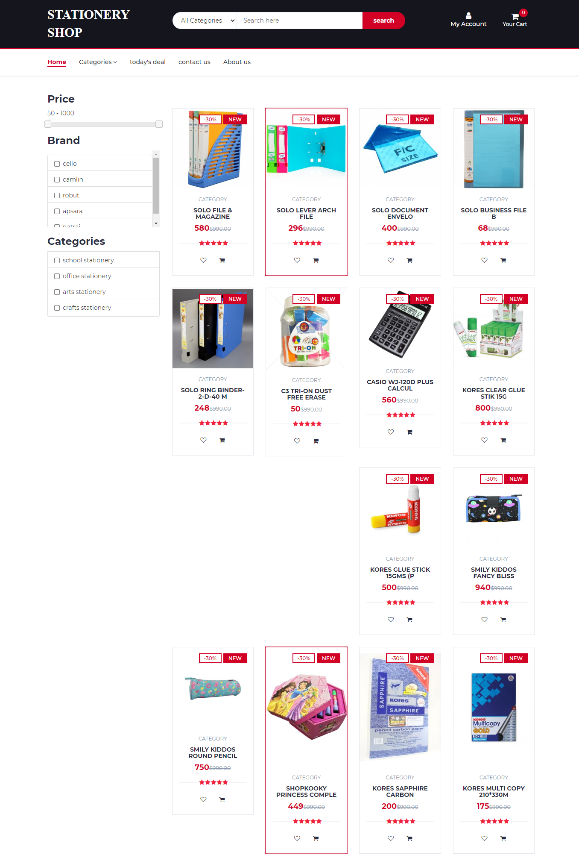**

**Store1.php**

<?php

include "header.php";

$stext='';

if(isset($\_POST['sbtn']))

{

$stext = $\_POST['stxt'];

}

?>

<!DOCTYPE html>

<html lang="en">

<head>

<title>Product filter in php</title>

<script src="js/jquery-1.10.2.min.js"></script>

<script src="js/jquery-ui.js"></script>

<script src="js/bootstrap.min.js"></script>

<link rel="stylesheet" href="css/bootstrap.min.css">

<link href = "css/jquery-ui.css" rel = "stylesheet">

<!-- Custom CSS -->

<link href="css/style.css" rel="stylesheet">

</head>

<body>

<!-- Page Content -->

<div class="container">

<div class="row">

<br />

<br />

<div class="col-md-3">

<div class="list-group">

<h3>Price</h3>

<input type="hidden" id="hidden\_minimum\_price" value="50" />

<input type="hidden" id="hidden\_maximum\_price" value="1000" />

<p id="price\_show">50 - 1000</p>

<div id="price\_range"></div>

</div>

<div class="list-group">

<h3>Brand</h3>

<div style="height: 180px; overflow-y: auto; overflow-x: hidden;">

<div class="list-group-item checkbox">

<label><input type="checkbox" class="common\_selector brand" value="cello" > cello</label>

</div>

<div class="list-group-item checkbox">

<label><input type="checkbox" class="common\_selector brand" value="camlin" > camlin</label>

</div>

<div class="list-group-item checkbox">

<label><input type="checkbox" class="common\_selector brand" value="robut" > robut</label>

</div>

<div class="list-group-item checkbox">

<label><input type="checkbox" class="common\_selector brand" value="apsara" > apsara</label>

</div>

<div class="list-group-item checkbox">

<label><input type="checkbox" class="common\_selector brand" value="natraj" > natraj</label>

</div>

</div>

</div>

<div class="list-group">

<h3>Categories</h3>

<div class="list-group-item checkbox">

<label><input type="checkbox" class="common\_selector category" value="bcd" > school stationery</label>

</div>

<div class="list-group-item checkbox">

<label><input type="checkbox" class="common\_selector category" value="bcd" > office stationery</label>

</div>

<div class="list-group-item checkbox">

<label><input type="checkbox" class="common\_selector category" value="bcd" > arts stationery</label>

</div>

<div class="list-group-item checkbox">

<label><input type="checkbox" class="common\_selector category" value="bcd" > crafts stationery</label>

</div>

</div>

<input type="text" name="stxt" id="stext" value="<?php echo $stext; ?>" hidden>

</div>

<div class="col-md-9">

<br />

<div class="row filter\_data">

</div>

</div>

</div>

</div>

<style>

#loading

{

text-align:center;

background: url('loader.gif') no-repeat center;

height: 150px;

}

</style>

<script>

$(document).ready(function(){

filter\_data();

function filter\_data()

{

$('.filter\_data').html('<div id="loading" style="" ></div>');

var action = 'fetch\_data';

var minimum\_price = $('#hidden\_minimum\_price').val();

var maximum\_price = $('#hidden\_maximum\_price').val();

var stext = $('#stext').val();

var brand = get\_filter('brand');

var ram = get\_filter('ram');

var storage = get\_filter('storage');

$.ajax({

url:"fetch\_data.php",

method:"POST",

data:{action:action, minimum\_price:minimum\_price, maximum\_price:maximum\_price, brand:brand, stext:stext },

success:function(data){

$('.filter\_data').html(data);

}

});

}

function get\_filter(class\_name)

{

var filter = [];

$('.'+class\_name+':checked').each(function(){

filter.push($(this).val());

});

return filter;

}

$('.common\_selector').click(function(){

filter\_data();

});

$('#price\_range').slider({

range:true,

min:50,

max:1000,

values:[50, 1000],

step:50,

stop:function(event, ui)

{

$('#price\_show').html(ui.values[0] + ' - ' + ui.values[1]);

$('#hidden\_minimum\_price').val(ui.values[0]);

$('#hidden\_maximum\_price').val(ui.values[1]);

filter\_data();

}

});

});

</script>

</body>

</html>

**Fetch\_data.php**

<?php

include "db.php";

//fetch\_data.php

if(isset($\_POST["action"]))

{

$query = " SELECT \* FROM products where CID='0' ";

if(isset($\_POST['brand']))

{

$brand\_filter = implode("','",$\_POST["brand"]);

$query .=" AND brand IN('$brand\_filter') ";

}

if(isset($\_POST["minimum\_price"], $\_POST["maximum\_price"]) && !empty($\_POST["minimum\_price"]) && !empty($\_POST["maximum\_price"]))

{

$min = $\_POST["minimum\_price"];

$max = $\_POST["maximum\_price"];

$query .= " AND pprice BETWEEN $min AND $max ";

}

if($\_REQUEST["stext"]!='')

{

//echo "<script>alert('hello');</script>";

$stext = $\_REQUEST["stext"];

$query .=" AND pname LIKE '%$stext%' OR pdesc LIKE '%$stext%' ";

$stext = '';

}

//$statement = $conn->prepare($query);

//$statement->execute();

//echo "$query";

$statement=mysql\_query( $query,$conn );

$count=mysql\_num\_rows( $statement );

//$total\_row = $statement->rowCount();

if($count>0)

{

while($row = mysql\_fetch\_array($statement))

{

$pid = $row['PID'];

$pname = $row['pname'];

$pdesc = $row['pdesc'];

$price = $row['pprice'];

$pimg = $row['pimage'];

$tag = $row['ptag'];

$discount= $row['pdiscount'];

$date=$row['date'];

?>

<div class="col-md-3 col-xs-6">

<div class="product">

<a href="product.php?pid=<?php echo $pid;?>">

<div class="product-img">

<img src="<?php echo $pimg; ?>" alt="" >

<div class="product-label">

<span class="sale">-30%</span>

<span class="new">NEW</span>

</div>

</div>

</a>

<div class="product-body">

<p class="product-category">Category</p>

<h3 class="product-name"><a href=""><?php echo substr($pname,0,25); ?> </a></h3>

<h4 class="product-price"><?php echo $price; ?><del class="product-old-price">$990.00</del></h4>

<div class="product-rating">

<i class="fa fa-star"></i>

<i class="fa fa-star"></i>

<i class="fa fa-star"></i>

<i class="fa fa-star"></i>

<i class="fa fa-star"></i>

</div>

<div class="product-btns">

<button class="add-to-wishlist"><a href="insertwishlist.php?pid=<?php echo $pid; ?>"><i class="fa fa-heart-o"></i><span class="tooltipp">add to wishlist</span></a></button>

<button class="add-to-wishlist"><a href="insertcart.php?pid=<?php echo $pid; ?>" ><i class="fa fa-shopping-cart"></i><span class="tooltipp">add to cart</span></a></button>

</div>

</div>

</div>

</div>

<?php

}

}}

?>

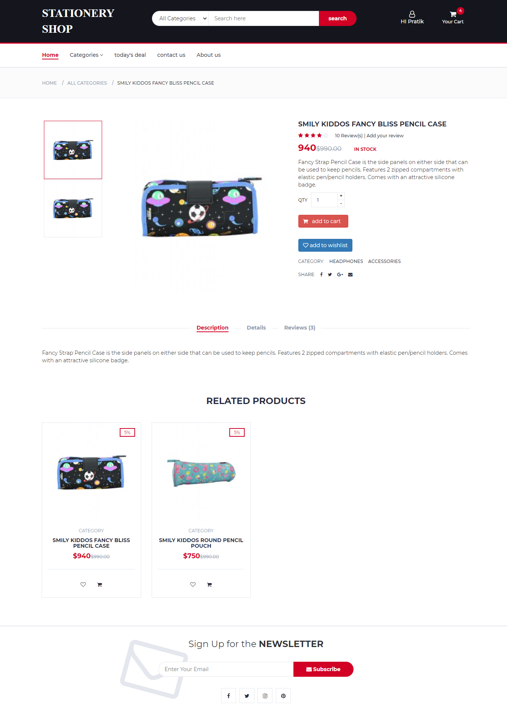

**Product.php**

<!DOCTYPE html>

<?php

include "header.php";

//$pid=$\_GET['pid'];

if(!isset($\_GET['pid']))

{

echo "<h3 class='section'>!something wrong <a href='index.php'><- go to home</a></h3>";

}

else

{

$pid=$\_GET['pid'];

$sql="select \* from products where PID='$pid'";

$res=mysql\_query($sql,$conn);

$res1=mysql\_fetch\_array($res);

?>

<!-- BREADCRUMB -->

<div id="breadcrumb" class="section">

<!-- container -->

<div class="container">

<!-- row -->

<div class="row">

<div class="col-md-12">

<ul class="breadcrumb-tree">

<li><a href="#">Home</a></li>

<li><a href="#">All Categories</a></li>

<li class="active"><?php echo $res1['pname']; ?></li>

</ul>

</div>

</div>

<!-- /row -->

</div>

<!-- /container -->

</div>

<!-- /BREADCRUMB -->

<!-- SECTION -->

<div class="section">

<!-- container -->

<div class="container">

<!-- row -->

<div class="row">

<!-- Product main img -->

<div class="col-md-5 col-md-push-2">

<div id="product-main-img">

<div class="product-preview">

<img src="<?php echo $res1['pimage']; ?>" alt="">

</div>

<div class="product-preview">

<img src="<?php echo $res1['pimage']; ?>" alt="">

</div>

</div>

</div>

<!-- /Product main img -->

<!-- Product thumb imgs -->

<div class="col-md-2 col-md-pull-5">

<div id="product-imgs">

<div class="product-preview">

<img src="<?php echo $res1['pimage']; ?>" alt="">

</div>

<div class="product-preview">

<img src="<?php echo $res1['pimage']; ?>" alt="">

</div>

</div>

</div>

<!-- /Product thumb imgs -->

<!-- Product details -->

<div class="col-md-5">

<div class="product-details">

<h2 class="product-name"><?php echo $res1['pname']; ?></h2>

<div>

<div class="product-rating">

<i class="fa fa-star"></i>

<i class="fa fa-star"></i>

<i class="fa fa-star"></i>

<i class="fa fa-star"></i>

<i class="fa fa-star-o"></i>

</div>

<a class="review-link" href="#">10 Review(s) | Add your review</a>

</div>

<div>

<h3 class="product-price"><?php echo $res1['pprice']; ?><del class="product-old-price">$990.00</del></h3>

<span class="product-available">In Stock</span>

</div>

<p><?php echo $res1['pdesc']; ?></p>

<form method="POST" action="product.php">

<input type="hidden" name='pid' value="<?php echo $pid; ?>"></input>

<div class="add-to-cart">

<div class="qty-label">

Qty &nbsp;

<div class="input-number">

<input type="number" name="qty" value='1'>

<span class="qty-up">+</span>

<span class="qty-down">-</span>

</div>

</div>

<br><br>

<button type="submit" name="submit" class="btn-danger btn" ><i class="fa fa-shopping-cart"></i> &nbsp add to cart &nbsp;</button>

</div>

</form>

<a class="btn btn-primary" href="insertwishlist.php?pid=<?php echo $pid; ?>" target="\_blank"><i class="fa fa-heart-o"></i> <span class="tooltipp">add to wishlist</span></a>

<ul class="product-links">

<li>Category:</li>

<li><a href="#">Headphones</a></li>

<li><a href="#">Accessories</a></li>

</ul>

<ul class="product-links">

<li>Share:</li>

<li><a href="#"><i class="fa fa-facebook"></i></a></li>

<li><a href="#"><i class="fa fa-twitter"></i></a></li>

<li><a href="#"><i class="fa fa-google-plus"></i></a></li>

<li><a href="#"><i class="fa fa-envelope"></i></a></li>

</ul>

</div>

</div>

<!-- /Product details -->

<!-- Product tab -->

<div class="col-md-12">

<div id="product-tab">

<!-- product tab nav -->

<ul class="tab-nav">

<li class="active"><a data-toggle="tab" href="#tab1">Description</a></li>

<li><a data-toggle="tab" href="#tab2">Details</a></li>

<li><a data-toggle="tab" href="#tab3">Reviews (3)</a></li>

</ul>

<!-- /product tab nav -->

<!-- product tab content -->

<div class="tab-content">

<!-- tab1 -->

<div id="tab1" class="tab-pane fade in active">

<div class="row">

<div class="col-md-12">

<p><?php echo $res1['pdesc']; ?></p>

</div>

</div>

</div>

<!-- /tab1 -->

<!-- tab2 -->

<div id="tab2" class="tab-pane fade in">

<div class="row">

<div class="col-md-12">

<table class="table table-bordered" align="center">

<p><?php echo $res1['pdesc']; ?></p>

<tr>

<td>product name</td>

<td><?php echo $res1['pname']; ?></td>

</tr>

<tr>

<td>product price</td>

<td><?php echo $res1['pprice']; ?></td>

</tr>

<tr>

<td>product brand</td>

<td><?php echo $res1['brand']; ?></td>

</tr>

<tr>

<td>product discount</td>

<td><?php echo $res1['pdiscount']; ?></td>

</tr>

<tr>

<td>product tags</td>

<td><?php echo $res1['ptag']; ?></td>

</tr>

</table>

</div>

</div>

</div>

<!-- /tab2 -->

<!-- tab3 -->

<div id="tab3" class="tab-pane fade in">

<div class="row">

<!-- Rating -->

<div class="col-md-3">

<div id="rating">

<div class="rating-avg">

<span>4.5</span>

<div class="rating-stars">

<i class="fa fa-star"></i>

<i class="fa fa-star"></i>

<i class="fa fa-star"></i>

<i class="fa fa-star"></i>

<i class="fa fa-star-o"></i>

</div>

</div>

<ul class="rating">

<li>

<div class="rating-stars">

<i class="fa fa-star"></i>

<i class="fa fa-star"></i>

<i class="fa fa-star"></i>

<i class="fa fa-star"></i>

<i class="fa fa-star"></i>

</div>

<div class="rating-progress">

<div style="width: 80%;"></div>

</div>

<span class="sum">3</span>

</li>

<li>

<div class="rating-stars">

<i class="fa fa-star"></i>

<i class="fa fa-star"></i>

<i class="fa fa-star"></i>

<i class="fa fa-star"></i>

<i class="fa fa-star-o"></i>

</div>

<div class="rating-progress">

<div style="width: 60%;"></div>

</div>

<span class="sum">2</span>

</li>

<li>

<div class="rating-stars">

<i class="fa fa-star"></i>

<i class="fa fa-star"></i>

<i class="fa fa-star"></i>

<i class="fa fa-star-o"></i>

<i class="fa fa-star-o"></i>

</div>

<div class="rating-progress">

<div></div>

</div>

<span class="sum">0</span>

</li>

<li>

<div class="rating-stars">

<i class="fa fa-star"></i>

<i class="fa fa-star"></i>

<i class="fa fa-star-o"></i>

<i class="fa fa-star-o"></i>

<i class="fa fa-star-o"></i>

</div>

<div class="rating-progress">

<div></div>

</div>

<span class="sum">0</span>

</li>

<li>

<div class="rating-stars">

<i class="fa fa-star"></i>

<i class="fa fa-star-o"></i>

<i class="fa fa-star-o"></i>

<i class="fa fa-star-o"></i>

<i class="fa fa-star-o"></i>

</div>

<div class="rating-progress">

<div></div>

</div>

<span class="sum">0</span>

</li>

</ul>

</div>

</div>

<!-- /Rating -->

<!-- Reviews -->

<div class="col-md-6">

<div id="reviews">

<ul class="reviews">

<?php

$cmdd = mysql\_query( "select \* from review where PID = $pid limit 3", $conn );

while( $rsett = mysql\_fetch\_array( $cmdd ) )

{

?>

<li>

<div class="review-heading">

<h5 class="name"><?php echo "$rsett[name]"; ?></h5>

<p class="date"><?php echo "$rsett[date]"; ?></p>

<div class="review-rating">

<?php

$r=$rsett['rating'];

for( $i=0; $i<5; $i++ )

{

if($i<$r)

echo "<i class='fa fa-star'></i>";

else

echo "<i class='fa fa-star-o empty'></i>";

}

?>

</div>

</div>

<div class="review-body">

<p><?php echo "$rsett[review]"; ?></p>

</div>

</li>

<?php } ?>

</ul>

<ul class="reviews-pagination">

<li class="active">1</li>

<li><a href="#">2</a></li>

<li><a href="#">3</a></li>

<li><a href="#">4</a></li>

<li><a href="#"><i class="fa fa-angle-right"></i></a></li>

</ul>

</div>

</div>

<!-- /Reviews -->

<!-- Review Form -->

<div class="col-md-3">

<div id="review-form">

<form class="review-form" method="post">

<input type="hidden" name='pid' value="<?php echo $pid; ?>" required></input>

<input class="input" type="text" name="name" placeholder="Your Name" required>

<input class="input" type="email" name="email" placeholder="Your Email" required>

<textarea class="input" name="review" placeholder="Your Review" required></textarea>

<div class="input-rating">

<span>Your Rating: </span>

<div class="stars">

<input id="star5" name="rating" value="5" type="radio"><label for="star5"></label>

<input id="star4" name="rating" value="4" type="radio"><label for="star4"></label>

<input id="star3" name="rating" value="3" type="radio"><label for="star3"></label>

<input id="star2" name="rating" value="2" type="radio"><label for="star2"></label>

<input id="star1" name="rating" value="1" type="radio"><label for="star1"></label>

</div>

</div>

<button type="submit" class="primary-btn" name="review\_submit">Submit</button>

</form>

</div>

</div>

<!-- /Review Form -->

</div>

</div>

<!-- /tab3 -->

</div>

<!-- /product tab content -->

</div>

</div>

<!-- /product tab -->

</div>

<!-- /row -->

</div>

<!-- /container -->

</div>

<!-- /SECTION -->

<!-- Section -->

<div class="section">

<!-- container -->

<div class="container">

<!-- row -->

<div class="row">

<div class="col-md-12">

<div class="section-title text-center">

<h3 class="title">Related Products</h3>

</div>

</div>

<?php

$t=$res1['ptag'];

$cmd3 = mysql\_query( "select \* from products where ptag like '%$t%'", $conn );

while( $rset3 = mysql\_fetch\_array( $cmd3 ) )

{

?>

<!-- product -->

<div class="col-md-3 col-xs-6">

<div class="product">

<div class="product-img">

<img src="<?php echo $rset3['pimage']; ?>" alt="">

<div class="product-label">

<span class="sale"><?php echo $rset3['pdiscount']; ?>%</span>

</div>

</div>

<div class="product-body">

<p class="product-category">Category</p>

<h3 class="product-name"><a href="#"><?php echo $rset3['pname']; ?></a></h3>

<h4 class="product-price">$<?php echo $rset3['pprice']; ?><del class="product-old-price">$990.00</del></h4>

<div class="product-rating">

</div>

<div class="product-btns">

<button class="add-to-wishlist">

<a href="insertwishlist.php?pid=<?php echo $pid; ?>"><i class="fa fa-heart-o"></i></a>

<span class="tooltipp">add to wishlist</span>

</button>

<button class="add-to-wishlist">

<a class="add-to-wishlist" target="\_blank" href="insertcart.php?pid=<?php echo $pid; ?>" >

<i class="fa fa-shopping-cart"></i><span class="tooltipp">add to cart</span>

</a>

</button>

</div>

</div>

</div>

</div>

<!-- /product -->

<?php } ?>

</div>

<!-- /row -->

</div>

<!-- /container -->

</div>

<!-- /Section -->

<?php

}

include "newsletter.php";

include "footer.php";

?>

</body>

</html>

<?php

if(isset($\_POST['submit']))

{ if(isset($\_SESSION['uid']))

{

$qty=$\_POST['qty'];

$pid = $\_POST['pid'];

$sql = "select CTID from cart\_master where UID = '$\_SESSION[uid]'";

$cmd = mysql\_query( $sql, $conn);

$rset = mysql\_fetch\_array( $cmd );

$count = mysql\_num\_rows( $cmd );

if( $count == 1 )

{

$sql="select \* from cart\_details where PID='$pid' and CTID='$rset[0]' ";

$cmd=mysql\_query($sql,$conn);

$count1 = mysql\_num\_rows( $cmd );

if( $count1 >= 1 )

{

echo "<script type='text/javascript'>";

echo "alert('product already in cart');";

echo "window.location.href='cart.php';";

echo "</script>";

}

else

{

$sql = "insert into cart\_details values( $rset[CTID], $pid, $qty)";

$cmd = mysql\_query( $sql, $conn ) or die( mysql\_error() );

header( 'location:cart.php' );

}

}

else

{

//auto id start

$sql = "select max( CTID ) from cart\_master";

$cmd = mysql\_query( $sql, $conn );

$cnt = mysql\_num\_rows( $cmd );

if( $cnt == 0 )

{

$cartid = 1;

}

else

{

$rset = mysql\_fetch\_array( $cmd );

$cartid = $rset[0] + 1;

}

//auto id end

$sql = "insert into cart\_master values( $cartid, $\_SESSION[uid], 0)";

$cmd = mysql\_query( $sql, $conn );

$sql = "insert into cart\_details values( $cartid, $pid, $qty)";

$cmd = mysql\_query( $sql, $conn ) or die( mysql\_error() );

header( 'location:cart.php' );

}

}

else

{

echo "<script> alert('please login to insert product in cart');</script>";

}

}

if(isset($\_POST['review\_submit']))

{

$name = $\_POST["name"];

$email = $\_POST['email'];

$review = $\_POST['review'];

$rating = $\_POST['rating'];

$pid = $\_POST['pid'];

if(isset($\_SESSION['uid']))

{

//auto id start

$sql = "select max(ID) from review";

$cmd = mysql\_query( $sql, $conn );

$cnt = mysql\_num\_rows( $cmd );

if( $cnt == 0 )

{

$id = 1;

}

else

{

$rset = mysql\_fetch\_array( $cmd );

$id = $rset[0] + 1;

}

//auto id end

$sql = "INSERT INTO `review` VALUES ($id, '$name', '$email', '$review', '$rating', NOW(), '$pid')";

$res = mysql\_query($sql,$conn);

if($res)

{

echo "<script>alert( 'your review is successfully submitted!' );</script>";

}

}

else

{

echo "<script>alert( 'dear $name please login to add your product review' );</script>";

}

}

?>

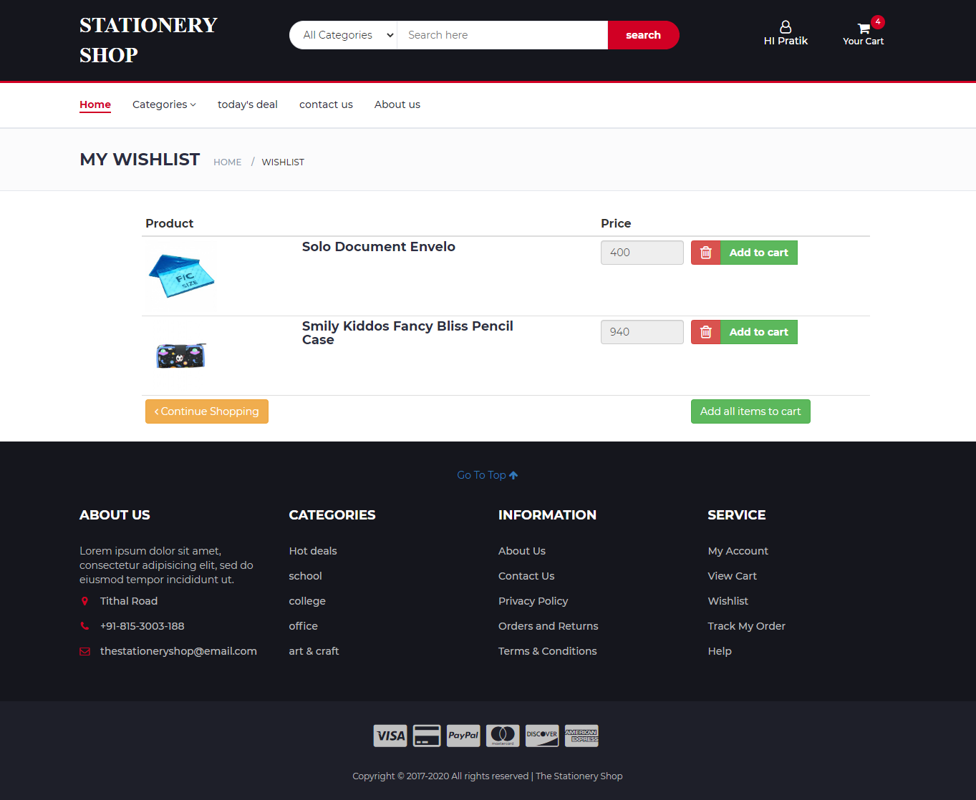

**Insertwishlist.php**

<?php

session\_start();

include "db.php";

if(isset($\_SESSION['uid']))

{

if(isset($\_GET['pid']))

{

$pid=$\_GET['pid'];

//auto id start

$sql = "select max( WID ) from wishlist";

$cmd = mysql\_query( $sql, $conn );

$cnt = mysql\_num\_rows( $cmd );

if( $cnt == 0 )

{

$cartid = 1;

}

else

{

$rset = mysql\_fetch\_array( $cmd );

$WID = $rset[0] + 1;

}

//auto id end

$sql = "insert into wishlist values( $WID, $\_SESSION[uid],$pid)";

$cmd = mysql\_query( $sql, $conn );

if($cmd)

{

header( 'location:wishlist.php' );

}

}

}

else

{

echo "<script type='text/javascript'>";

echo "alert('product can be added only after login');";

echo "window.location.href='index.php';";

echo "</script>";

}

?>

**Wishlist.php**

<?php

include "header.php";

?>

<!-- BREADCRUMB -->

<div id="breadcrumb" class="section">

<!-- container -->

<div class="container">

<!-- row -->

<div class="row">

<div class="col-md-12">

<h3 class="breadcrumb-header">my wishlist</h3>

<ul class="breadcrumb-tree">

<li><a href="index.php">Home</a></li>

<li class="active">wishlist</li>

</ul>

</div>

</div>

<!-- /row -->

</div>

<!-- /container -->

</div>

<!-- /BREADCRUMB -->

<?php

if(!isset($\_SESSION['uid']))

{

echo "<div class='container'>

<h3 style='margin:50px'>please login to view your wishlist

<br><a href='' class='btn btn-link' data-toggle='modal' data-target='#Modal\_login'><i class='fa fa-sign-in' aria-hidden='true'></i> Login</a>

</h3>

</div>";

}

else

{

$uid=$\_SESSION['uid'];

//to fetch cart\_id

$sql="select \* from wishlist where UID='$uid'";

$res=mysql\_query($sql,$conn) or die(mysql\_error());

$res1=mysql\_fetch\_array($res);

$wid=$res1['WID'];

?>

<div class="row">

<div class="col-md-9" style="margin-left:200px;">

<div class="main" >

<div class="table-responsive">

<form method="post" action="login\_form.php">

<table id="cart" class="table table-hover table-condensed" id="" width="100%">

<thead>

<tr>

<th style="width:50%">Product </th>

<th style="width:10%">Price</th>

<th style="width:20%"></th>

</tr>

</thead>

<tbody>

<?php

//to fetch product\_id

$sql="select \* from wishlist where UID='$uid'";

$res=mysql\_query($sql,$conn) or die(mysql\_error());

while($res1=mysql\_fetch\_array($res))

{

$sql1 = "select \* from products where PID=".$res1['PID']."";

$cmd1 = mysql\_query($sql1,$conn) or die( mysql\_error( ) );

$rset1 = mysql\_fetch\_array( $cmd1 );

//echo $rset1['pname'];

?>

<tr>

<td data-th="Product" >

<div class="row">

<div class="col-sm-4"><img src="<?php echo $rset1['pimage']; ?>" style="height: 100px;width:100px;"/>

</div>

<div class="col-sm-6">

<div style="">

<h4> <?php echo $rset1['pname']; ?></h4>

</div>

</div>

</div>

</td>

<input type="hidden" name="product\_id[]" value=""/>

<td data-th="Price"><input type="text" class="form-control price" value="<?php echo $rset1['pprice']; ?>" readonly="readonly"></td>

<td class="actions" data-th="">

<div class="btn-group">

<a href="delete.php ? wpid=<?php echo $rset1['PID']; ?>" class="btn btn-danger" ><i style="font-size:20px;" class="fa fa-trash-o"></i></a>

<a href="insertcart.php?pid=<?php echo $rset1['PID']; ?>" class="btn btn-success" ><b>Add to cart<b></a>

</div>

</td>

</tr>

<?php

}

?>

</tbody>

<tfoot>

<tr>

<td><a href="index.php" class="btn btn-warning"><i class="fa fa-angle-left"></i> Continue Shopping</a></td>

<td colspan="1" class="hidden-xs"></td>

<td>

<a href="" data-toggle="modal" data-target="#Modal\_register" class="btn btn-success">Add all items to cart </a>

</td>

</tr>

</tfoot>

</table>

</div>

</div>

</div>

</div>

<?php

}

include "footer.php"; ?>

</body>

</html>

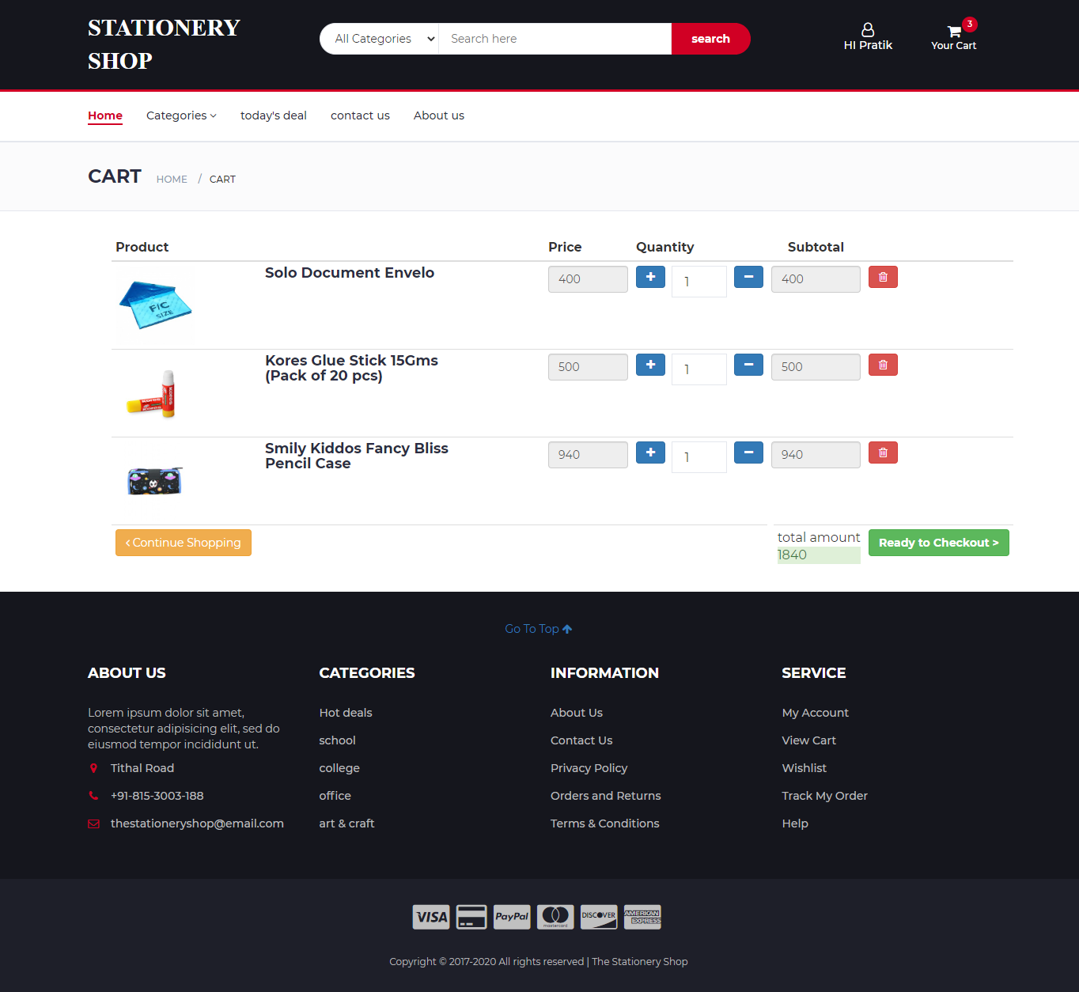

**Insertcart.php**

<?php

session\_start();

include "db.php";

if(isset($\_SESSION['uid']))

{

if(isset($\_GET['pid']))

{

$pid = $\_GET['pid'];

$sql = "select CTID from cart\_master where UID = '$\_SESSION[uid]'";

$cmd = mysql\_query( $sql, $conn);

$rset = mysql\_fetch\_array( $cmd );

$count = mysql\_num\_rows( $cmd );

if( $count == 1 )

{

$sql = "select \* from cart\_details where PID='$pid' and CTID='$rset[0]' ";

$cmd = mysql\_query($sql,$conn);

$count1 = mysql\_num\_rows( $cmd );

if( $count1 >= 1 )

{

echo "<script type='text/javascript'>";

echo "alert('product already in cart');";

echo "window.location.href='cart.php';";

echo "</script>";

}

else

{

$sql = "insert into cart\_details values( $rset[CTID], $pid, 1)";

$cmd = mysql\_query( $sql, $conn ) or die( mysql\_error() );

header( 'location:cart.php' );

}

}

else

{

//auto id start

$sql = "select max( CTID ) from cart\_master";

$cmd = mysql\_query( $sql, $conn );

$cnt = mysql\_num\_rows( $cmd );

if( $cnt == 0 )

{

$cartid = 1;

}

else

{

$rset = mysql\_fetch\_array( $cmd );

$cartid = $rset[0] + 1;

}

//auto id end

$sql = "insert into cart\_master values( $cartid, $\_SESSION[uid], 0)";

$cmd = mysql\_query( $sql, $conn );

$sql = "insert into cart\_details values( $cartid, $pid, 1)";

$cmd = mysql\_query( $sql, $conn ) or die( mysql\_error() );

header( 'location:index.php' );

}

}

}

else

{

echo "<script type='text/javascript'>";

echo "alert('product can be added only after login');";

echo "window.location.href='index.php';";

echo "</script>";

}

?>

**Cart.php**

<?php

include "header.php";

?>

<!-- BREADCRUMB -->

<div id="breadcrumb" class="section">

<!-- container -->

<div class="container">

<!-- row -->

<div class="row">

<div class="col-md-12">

<h3 class="breadcrumb-header">CART</h3>

<ul class="breadcrumb-tree">

<li><a href="index.php">Home</a></li>

<li class="active">cart</li>

</ul>

</div>

</div>

<!-- /row -->

</div>

<!-- /container -->

</div>

<!-- /BREADCRUMB -->

<?php

if(!isset($\_SESSION['uid']))

{

echo "<div class='container'>

<h3 style='margin:50px'>please login to view your cart

<br><a href='' class='btn btn-link' data-toggle='modal' data-target='#Modal\_login'><i class='fa fa-sign-in' aria-hidden='true'></i> Login</a>

</h3>

</div>";

}

else

{

$uid=$\_SESSION['uid'];

$tot=0;

//to fetch cart\_id

$sql="select \* from cart\_master where UID='$uid'";

$res=mysql\_query($sql,$conn) or die(mysql\_error());

$res1=mysql\_fetch\_array($res);

$ctid=$res1['CTID'];

if($res<0)

{

echo "no products in ur cart";

}

else

{

?>

<div class="container">

<div class="row">

<div class="col-md-12" style="margin-left:30px;">

<div class="main" >

<div class="table-responsive">

<table class="table table-hover table-condensed" id="">

<thead>

<tr>

<th style="width:48%">Product </th>

<th >Price</th>

<th style="width:15%" >Quantity</th>

<th class="text-center">Subtotal</th>

<th ></th>

</tr>

</thead>

<tbody>

<?php

//to fetch product\_id

$\_SESSION['ctid']=$ctid;

$sql="select \* from cart\_details where CTID='$ctid'";

$res=mysql\_query($sql,$conn) or die(mysql\_error());

while($res1=mysql\_fetch\_array($res))

{

$sql1 = "select \* from products where PID=".$res1['PID']."";

$cmd1 = mysql\_query($sql1,$conn) or die( mysql\_error( ) );

$rset1 = mysql\_fetch\_array( $cmd1 );

//echo $rset1['pname'];

$p=$rset1['pprice'];

$q=$res1['quantity'];

$st=$p \* $q ;

$tot=$tot+$st;

?>

<tr>

<td data-th="Product" >

<div class="row">

<div class="col-sm-4 "><img src="<?php echo $rset1['pimage']; ?>" style="height: 100px;width:100px;"/>

</div>

<div class="col-sm-6">

<div style="max-width=50px;">

<h4> <?php echo $rset1['pname']; ?></h4>

</div>

</div>

</div>

</td>

<input type="hidden" name="product\_id[]" value=""/>

<input type="hidden" name="" value=""/>

<td data-th="Price"><input type="text" class="form-control price" value="<?php echo $rset1['pprice']; ?>" readonly="readonly"></td>

<td data-th="Quantity">

<div class="inline-form">

<form method="POST">

<input type="hidden" value="<?php echo $res1['PID']; ?>" name="pid1">

<button type="submit" class="btn btn-primary pull-left" name="qplus"><i class="fa fa-plus"></i></button>&nbsp;

<input type="text" class="input" value="<?php echo $res1['quantity']; ?>" name="qty" style="width:70px" readonly="readonly"/>

<button type="submit" class="btn btn-primary pull-right" name="qminus"><i class="fa fa-minus"></i></button>

</form>

</div>

</td>

<td data-th="Subtotal" class="text-center"><input type="text" class="form-control total" value="<?php echo $st; ?>" readonly="readonly"></td>

<td class="actions" data-th="">

<div class="btn-group">

<a href="delete.php ? pid=<?php echo $rset1['PID']; ?> & ctid=<?php echo $ctid; ?>" class="btn btn-danger remove" ><i class="fa fa-trash-o"></i></a>

</div>

</td>

</tr>

<?php

}

?>

</tbody>

<tfoot>

<tr>

<td><a href="index.php" class="btn btn-warning"><i class="fa fa-angle-left"></i> Continue Shopping</a></td>

<td colspan="1" class="hidden-xs"></td>

<td class="hidden-xs text-center"><b class="net\_total" ></b></td>

<td class="pull-right">total amount<p class="alert-success"> <?php echo $tot; ?></p></td>

<td><a href="checkout.php " class="btn btn-success"><b>Ready to Checkout ></b></a></td>

</tr>

</tfoot>

<?php

$sql="update cart\_master set total\_cost='$tot' where CTID='$ctid'";

$res=mysql\_query($sql,$conn);

?>

</table>

</div>

</div>

</div>

</div>

</div>

</div>

<?php

}}

if(isset($\_POST['qplus']))

{

$pid1=$\_POST['pid1'];

$q=$\_POST['qty'];

if($q < 20)

{

$q=$q+1;

$sql="update cart\_details set quantity='$q' where PID='$pid1' and CTID='$ctid'";

$res=mysql\_query($sql);

header('location:cart.php');

}

}

if(isset($\_POST['qminus']))

{

$pid1=$\_POST['pid1'];

$q=$\_POST['qty'];

if($q != 1)

{

$q=$q-1;

$sql="update cart\_details set quantity='$q' where PID='$pid1' and CTID='$ctid'";

$res=mysql\_query($sql);

header('location:cart.php');

}

}

include "footer.php";

?>

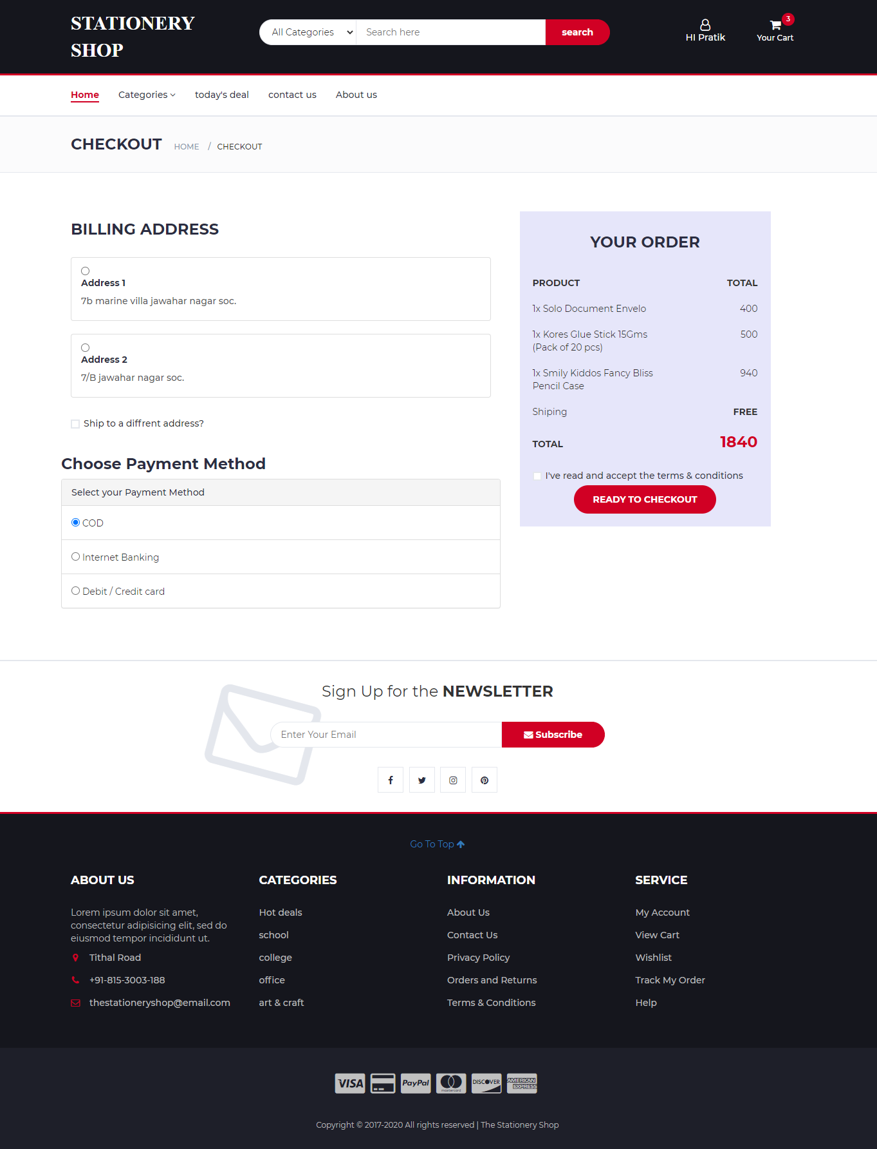

**Checkout.php**

<!DOCTYPE html>

<?php

include "header.php";

?>

<!-- BREADCRUMB -->

<div id="breadcrumb" class="section">

<!-- container -->

<div class="container">

<!-- row -->

<div class="row">

<div class="col-md-12">

<h3 class="breadcrumb-header">Checkout</h3>

<ul class="breadcrumb-tree">

<li><a href="#">Home</a></li>

<li class="active">Checkout</li>

</ul>

</div>

</div>

<!-- /row -->

</div>

<!-- /container -->

</div>

<!-- /BREADCRUMB -->

<!-- SECTION -->

<div class="section">

<form method="POST" action="order.php">

<!-- container -->

<div class="container">

<!-- row -->

<div class="row">

<div class="col-md-7">

<!-- Billing Details -->

<div class="billing-details">

<div class="section-title">

<h3 class="title">Billing address</h3>

</div>

<?php

$uid=$\_SESSION['uid'];

$r=1;

$sql="select \* from address where UID='$uid'";

$res=mysql\_query($sql,$conn);

while($res1=mysql\_fetch\_array($res))

{

?>

<div class="list-group">

<a class="list-group-item list-group-item-action">

<div class="d-flex w-100">

<input class="" type="radio" name="addid" value="<?php echo $res1['ADDID']; ?>"><h5 class="mb-1">Address <?php echo $r++; ?> </h5>

</div>

<p class="mb-1"><?php echo $res1['address']; ?></p>

</a>

</div>

<?php

}

?>

</div>

<!-- /Billing Details -->

<!-- Shiping Details -->

<form method="POST" >

<div class="shiping-details">

<div class="input-checkbox">

<input type="checkbox" id="shiping-address">

<label for="shiping-address">

<span></span>

Ship to a diffrent address?

</label>

<div class="caption">

<div class="form-group">

<input class="input" type="text" name="fname" placeholder="First Name">

</div>

<div class="form-group">

<input class="input" type="text" name="lname" placeholder="Last Name">

</div>

<div class="form-group">

<input class="input" type="text" name="city" placeholder="City">

</div>

<div class="form-group">

<input class="input" type="text" name="state" placeholder="State">

</div>

<div class="form-group">

<input class="input" type="text" name="zip-code" placeholder="ZIP Code">

</div>

<div class="form-group">

<input class="input" type="text" name="address" placeholder="Address">

</div>

<div class="form-group">

<input class="input" type="text" name="landmark" placeholder="Landmark">

</div>

<div class="form-group">

<input class="button btn btn-primary" type="submit" value="Add Address" name="add">

</div>

</div>

</div>

</div>

</form>

<!-- /Shiping Details -->

<!-- payment method -->

<div class="checkout-box faq-page inner-bottom-sm">

<div class="row">

<div class="col-xl-6">

<h3 class="title">Choose Payment Method</h3>

<div class="panel-group " id="accordion">

<!-- checkout-step-01 -->

<div class="panel panel-default checkout-step-01">

<!-- panel-heading -->

<div class="panel-heading">

<a data-toggle="collapse" class="" data-parent="#accordion" href="#collapseOne">

Select your Payment Method

</a>

</div>

<!-- panel-heading -->

<div id="collapseOne" class="panel-collapse collapse in">

<!-- panel-body -->

<div class="panel-body">

<input type="radio" name="paymethod" value="COD" checked="checked"> COD

</div>

<div class="panel-body">

<input type="radio" name="paymethod" value="Internet Banking"> Internet Banking

</div>

<div class="panel-body">

<input type="radio" name="paymethod" value="Debit / Credit card"> Debit / Credit card

</div>

<!-- panel-body -->

</div>

<!-- row -->

</div>

<!-- checkout-step-01 -->

</div>

</div>

</div>

</div>

</div>

<!-- Order Details -->

<div class="col-md-4 " style="margin-left:30px; background-color:lavender; padding:20px">

<div class="section-title text-center">

<h3 class="title">Your Order</h3>

</div>

<div class="order-summary">

<div class="order-col">

<div><strong>PRODUCT</strong></div>

<div><strong>TOTAL</strong></div>

</div>

<?php

//$ctid=$\_SESSION['ctid'];

//to fetch product\_id

$sql="select \* from cart\_details where CTID='$ctid'";

$res=mysql\_query($sql,$conn) or die(mysql\_error());

$sql="select \* from cart\_master where CTID='$ctid'";

$tot1=mysql\_query($sql,$conn);

$tot2=mysql\_fetch\_array($tot1);

while($res1=mysql\_fetch\_array($res))

{

$sql1 = "select \* from products where PID=".$res1['PID']."";

$cmd1 = mysql\_query($sql1,$conn) or die( mysql\_error( ) );

$rset1 = mysql\_fetch\_array( $cmd1 );

//echo $rset1['pname'];

$p=$rset1['pprice'];

$q=$res1['quantity'];

$st=$p \* $q ;

?>

<div class="order-products">

<div class="order-col">

<div><?php echo $res1['quantity']; ?>x <?php echo $rset1['pname']; ?></div>

<div><?php echo $st; ?></div>

</div>

</div>

<?php

}

?>

<div class="order-col">

<div>Shiping</div>

<div><strong>FREE</strong></div>

</div>

<div class="order-col">

<div><strong>TOTAL</strong></div>

<div><strong class="order-total"><?php echo $tot2['total\_cost']; ?></strong></div>

</div>

</div>

<div class="input-checkbox">

<input type="checkbox" id="terms">

<label for="terms">

<span></span>

I've read and accept the <a href="#">terms & conditions</a>

</label>

</div>

<center><input type="submit" name="checkout" value="Ready To Checkout" class="primary-btn order-submit"></input></center>

</div>

<!-- /Order Details -->

</div>

<!-- /row -->

</div>

<!-- /container -->

</div>

</form>

<!-- /SECTION -->

<?php include "newsletter.php"; ?>

<?php include "footer.php"; ?>

</body>

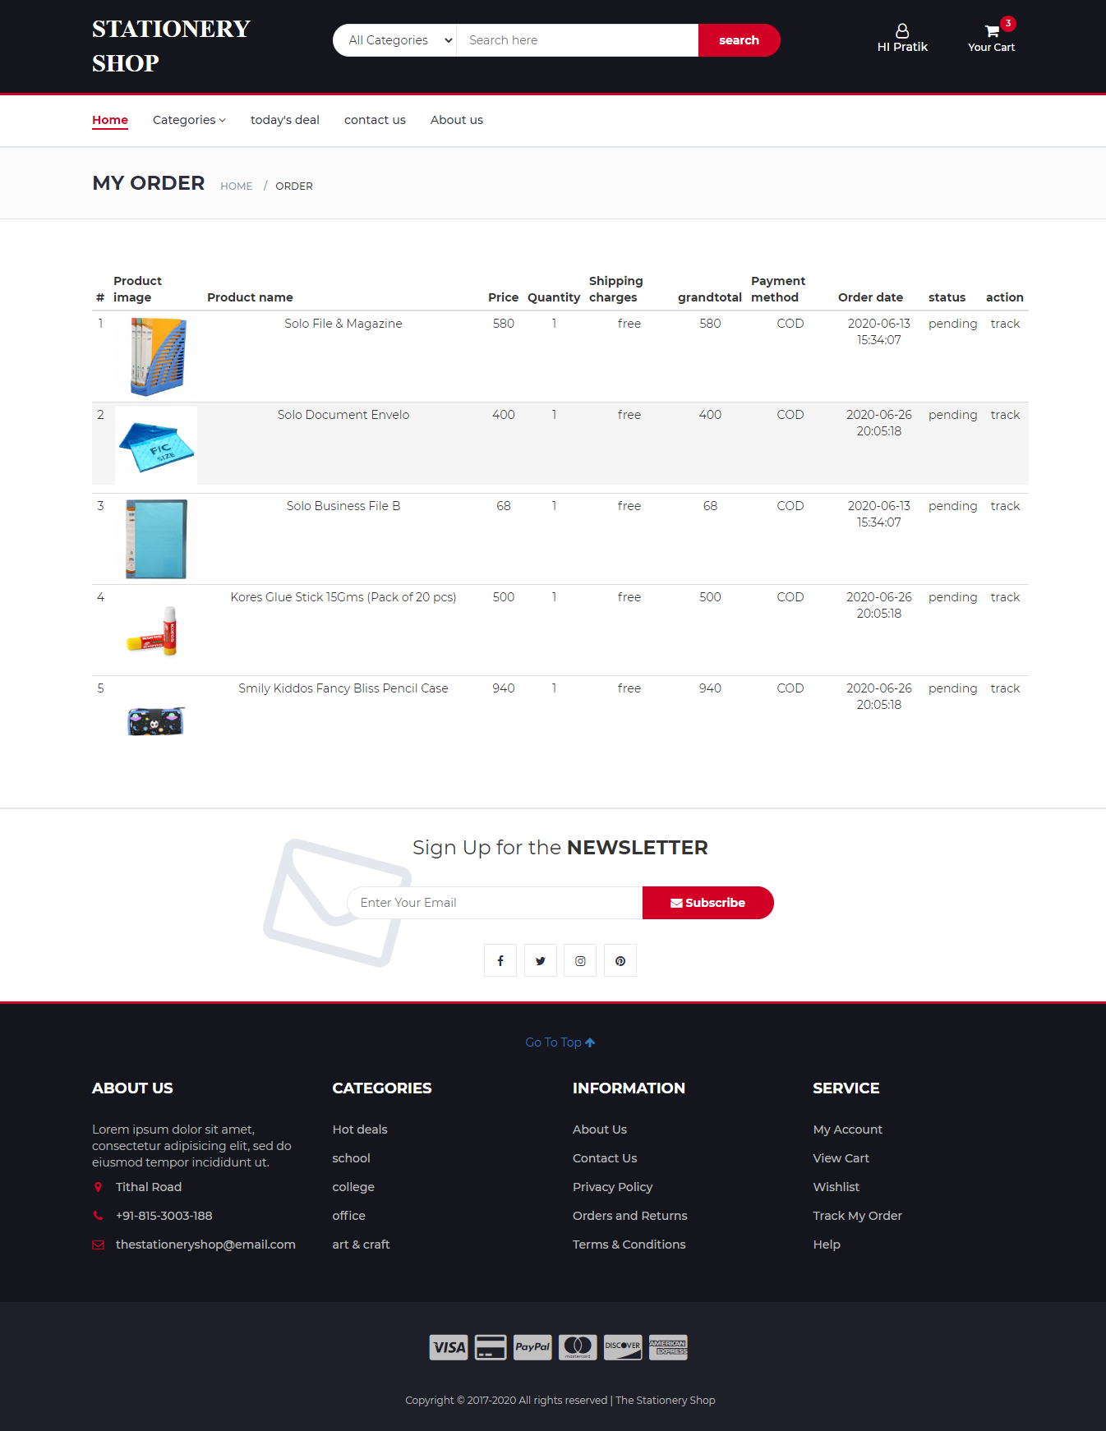

**order.php**

<?php

session\_start();

include "db.php";

$uid=$\_SESSION['uid'];

$ctid=$\_SESSION['ctid'];

if(isset($\_POST['add']))

{

$fname = $\_POST["f\_name"];

$lname = $\_POST["l\_name"];

$city = $\_POST['city'];

$state = $\_POST['state'];

$zipcode = $\_POST['zip-code'];

$add = $\_POST['address'];

$landmark=$\_POST['landmark'];

//auto id start

$sql = "select max(ADDID) from address";

$cmd = mysql\_query( $sql, $conn );

$cnt = mysql\_num\_rows( $cmd );

if( $cnt == 0 )

{

$addid = 1;

}

else

{

$rset = mysql\_fetch\_array( $cmd );

$addid = $rset[0] + 1;

}

//auto id end

$sql = "INSERT INTO `address`

(`ADDID`, `UID`, `city`, `state`, `pincode`,`address`,`landmark`)

VALUES ($addid, '$uid', '$city', '$state', '$zipcode','$add','$landmark')";

$res = mysql\_query($sql,$conn);

if($res){

header('location:checkout.php');

}

}

if(isset($\_POST['checkout']))

{

$paymethod=$\_POST['paymethod'];

$addid=$\_POST['addid'];

$sql="select \* from cart\_details where CTID='$ctid' ";

$res=mysql\_query($sql,$conn) or die(mysql\_error());

while($res1=mysql\_fetch\_array($res))

{

$pid=$res1['PID'];

$quantity=$res1['quantity'];

$sql1="select pprice from products where PID='$pid'";

$res3=mysql\_query($sql1,$conn);

$rset2=mysql\_fetch\_array($res3);

$price=$rset2['pprice'];

$pr=$quantity\*$price;

//auto id start

$sql = "select max( OID ) from orders";

$cmd = mysql\_query( $sql, $conn );

$cnt = mysql\_num\_rows( $cmd );

if( $cnt == 0 )

{

$oid = 1;

}

else

{

$rset = mysql\_fetch\_array( $cmd );

$oid = $rset[0] + 1;

}

//auto id end

$sql = "insert into orders values( '$oid','$\_SESSION[uid]','$pid','$addid','$quantity','$pr',NOW(),'$paymethod','pending')";

$cmd = mysql\_query( $sql, $conn ) ;

}

header('location:yourorder.php');

}

?>

**Yourorder.php**

<!DOCTYPE html>

<?php

include "header.php";

?>

<!-- BREADCRUMB -->

<div id="breadcrumb" class="section">

<!-- container -->

<div class="container">

<!-- row -->

<div class="row">

<div class="col-md-12">

<h3 class="breadcrumb-header">my order</h3>

<ul class="breadcrumb-tree">

<li><a href="index.php">Home</a></li>

<li class="active">order</li>

</ul>

</div>

</div>

<!-- /row -->

</div>

<!-- /container -->

</div>

<!-- /BREADCRUMB -->

<?php

if(!isset($\_SESSION['uid']))

{

echo "<div class='container'>

<h3 style='margin:50px'>please login to view your oreders

<br><a href='' class='btn btn-link' data-toggle='modal' data-target='#Modal\_login'><i class='fa fa-sign-in' aria-hidden='true'></i> Login</a>

</h3>

</div>";

}

else

{

?>

<!-- SECTION -->

<div class="section">

<!-- container -->

<div class="container">

<div class="row">

<div class="col-md-12">

<div class="main" >

<div class="table-responsive">

<table class="table table-hover table-condensed">

<thead >

<tr >

<th >#</th>

<th width=10%>Product image </th>

<th width=30%>Product name </th>

<th >Price</th>

<th >Quantity</th>

<th >Shipping charges </th>

<th >grandtotal</th>

<th >Payment method </th>

<th >Order date </th>

<th> status </th>

<th> action</th>

</tr>

</thead>

<tbody align="center">

<?php

$no = 0;

$sql="select \* from orders where UID='$uid'";

$res1=mysql\_query($sql,$conn);

while($rset1=mysql\_fetch\_array($res1))

{

if( $no == 0 )

{

$no = 1;

}

else

{

$no = $no + 1;

}

$pid=$rset1['PID'];

$sql="select \* from products where PID='$pid'";

$res2=mysql\_query($sql,$conn);

$rset2=mysql\_fetch\_array($res2);

?>

<tr>

<td><?php echo $no; ?></td>

<td><img src="<?php echo $rset2['pimage']; ?>" width="100px"></td>

<td ><?php echo $rset2['pname']; ?></td>

<td><?php echo $rset1['price']; ?></td>

<td><?php echo $rset1['quantity']; ?></td>

<td>free</td>

<td><?php echo $rset1['price']\*$rset1['quantity']; ?></td>

<td><?php echo $rset1['pay\_method']; ?></td>

<td><?php echo $rset1['order\_date']; ?></td>

<td><?php echo $rset1['status']; ?></td>

<td>track</td>

</tr>

<?php

} }

?>

</tbody>

</table>

</div>

</div>

</div>

</div>

</div>

<!-- NEWSLETTER -->

<?php include "newsletter.php"; ?>

<!-- /NEWSLETTER -->

<?php include "footer.php"; ?>

</body>

</html>

**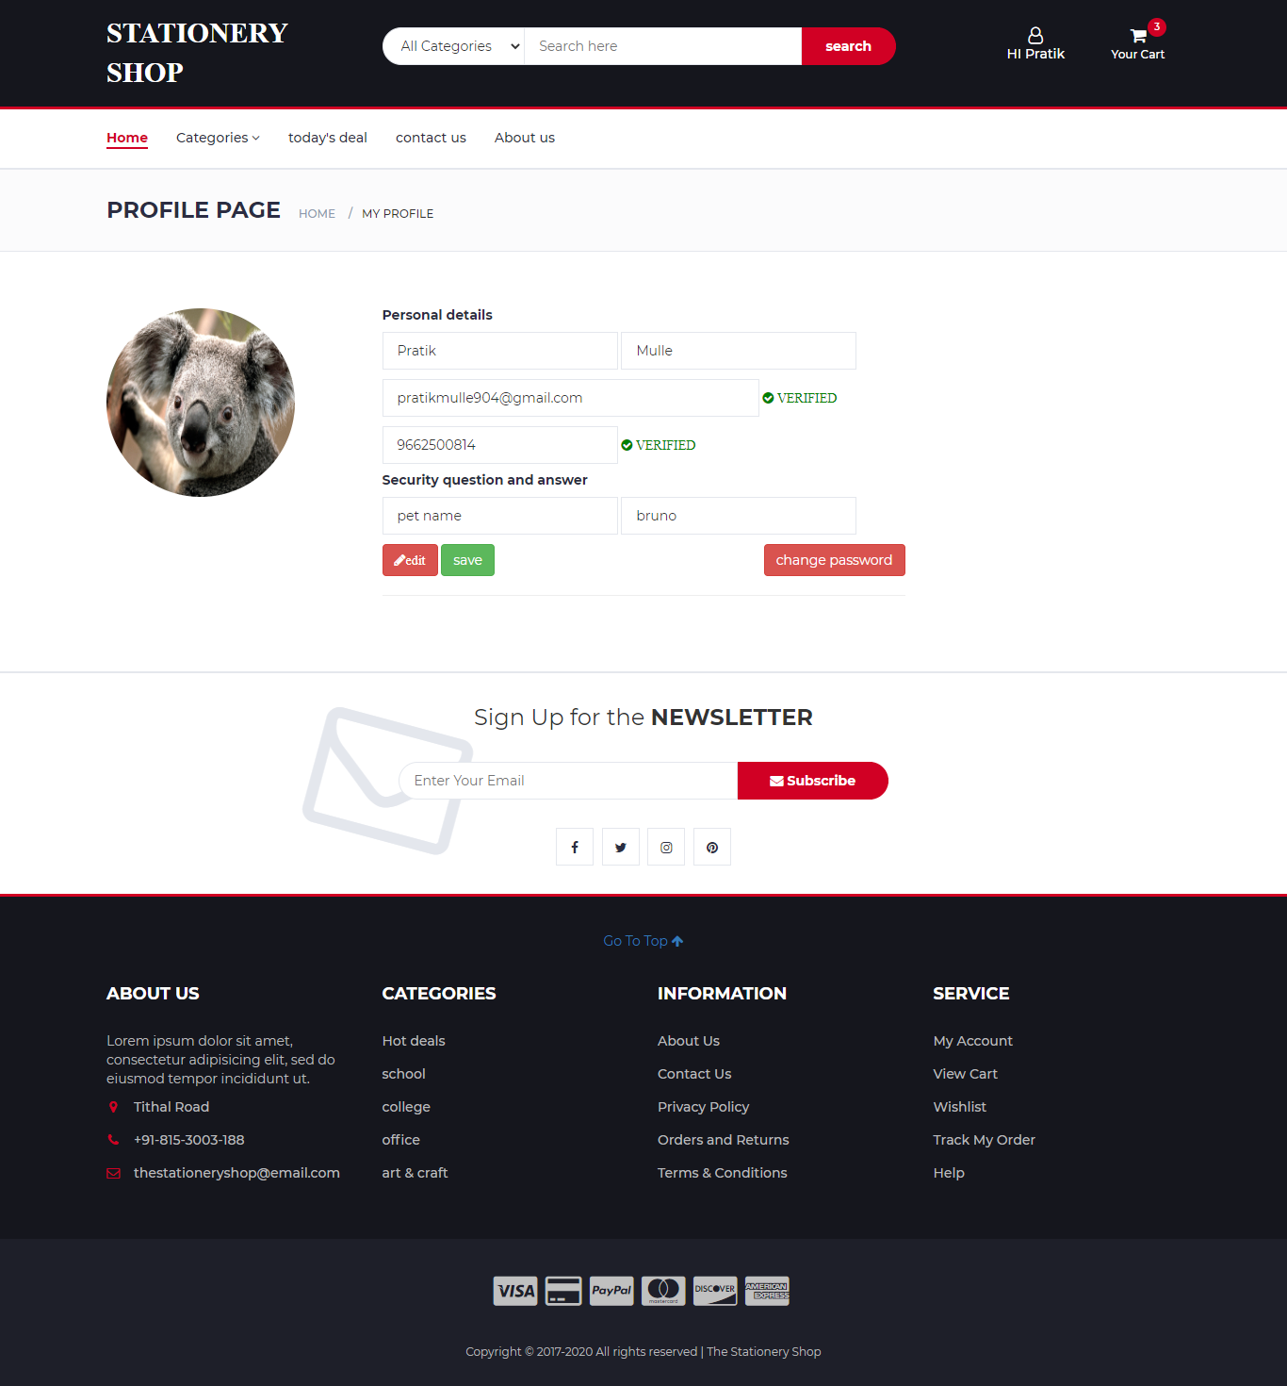**

**Profile.php**

<!DOCTYPE html>

<?php

include "header.php";

?>

<script src="js/jquery.min.js"></script>

<script>

$(document).ready(function(){

$("form input[type=text],form input[type=checkbox]").prop("disabled",true);

document.getElementById('file').style.display = 'none';

document.getElementById('changepwd').style.display = 'none';

$("#edit").on("click",function(){

$("form input[type=text],form input[type=checkbox]").prop("disabled",false);

document.getElementById('file').style.display = 'block';

});

$("#changep").on("click",function(){

document.getElementById('changepwd').style.display = 'block';

document.getElementById('updateprofile').style.display = 'none';

});

$("#cancel").on("click",function(){

document.getElementById('changepwd').style.display = 'none';

document.getElementById('updateprofile').style.display = 'block';

});

});

</script>

<!-- BREADCRUMB -->

<div id="breadcrumb" class="section">

<!-- container -->

<div class="container">

<!-- row -->

<div class="row">

<div class="col-md-12">

<h3 class="breadcrumb-header">Profile Page</h3>

<ul class="breadcrumb-tree">

<li><a href="#">Home</a></li>

<li class="active">my profile</li>

</ul>

</div>

</div>

<!-- /row -->

</div>

<!-- /container -->

</div>

<!-- /BREADCRUMB -->

<?php

if(isset($\_SESSION['uid']))

{

$uid=$\_SESSION['uid'];

$cmd1=mysql\_query( "select \* from user\_master where UID='$uid'", $conn );

$res1=mysql\_fetch\_array( $cmd1 );

$cmd2=mysql\_query( "select \* from user\_login where UID='$uid'", $conn );

$res2=mysql\_fetch\_array( $cmd2 );

?>

<!-- SECTION -->

<div class="section">

<!-- container -->

<div class="container">

<!-- row -->

<div class="row">

<div class="col-sm-3">

<image class="img-circle" style="width:200px;height:200px" src="<?php echo $res1['uimage']; ?>" alt="user image"></image>

</div>

<div class="col-sm-6">

<form id="updateprofile" name="updateprofile" method="post" enctype="multipart/form-data">

<h5>Personal details</h5>

<input id='file' class="input" style="width:500px;margin:0 0 10px;border:0" type="file" name="uimage" />

<input name="fname" class="input" style="width:250px;margin:0 0 10px" type="text" value="<?php echo $res1['fname']; ?>">

<input name="lname" class="input" style="width:250px;margin:0 0 10px" type="text" value="<?php echo $res1['lname']; ?>">

<input name="email" class="input" style="width:400px;margin:0 0 10px" type="text" value="<?php echo $res1['email']; ?>">

<?php

//echo $\_SESSION['uid'];

$uid=$\_SESSION['uid'];

$q="select \* from user\_login where UID = $uid";

$q1=mysql\_query($q,$conn);

$q2=mysql\_fetch\_array($q1);

$vemail=$q2['vemail'];

if($vemail==0)

{

?>

<i class="fas fa-ban" style="color:red;"><b> NOT VERIFIED</b></i>

<a class="btn btn-success" name="clickhere" href="#" >VERIFY email</a>

<?php

}

else

{

?>

<i class="fa fa-check-circle" style="color:green;" aria-hidden="true"> VERIFIED</i>

<?php

}

?>

<input name="mobile" class="input" style="width:250px;margin:0 0 10px" type="text" value="<?php echo $res1['mobile']; ?>">

<?php

//echo $\_SESSION['uid'];

$uid=$\_SESSION['uid'];

$q="select \* from user\_master where UID = $uid";

$q1=mysql\_query($q,$conn);

$q2=mysql\_fetch\_array($q1);

$vmobile=$q2['vmobile'];

//echo $vmobile;

if($vmobile==0)

{

?>

<i class="fas fa-ban" style="color:red;"><b> NOT VERIFIED</b></i>

<a class="btn btn-success" name="clickhere" href="verifymobile.php" >VERIFY MOBILE</a>

<?php

}

else

{

?>

<i class="fa fa-check-circle" style="color:green;" aria-hidden="true"> VERIFIED</i>

<?php

}

?>

<br/>

<h5>Security question and answer</h5>

<input name="que" class="input" style="width:250px;margin:0 0 10px" type="text" value="<?php echo $res2['sec\_ques']; ?>">

<input name="ans" class="input" style="width:250px;margin:0 0 10px" type="text" value="<?php echo $res2['sec\_ans']; ?>">

<br>

<button class="btn btn-danger" type="button" name='edit' id="edit" ><i class="fa fa-pencil">edit</i></button>

<input class="btn btn-success" type="submit" name='save' value='save'/>

<button class="btn btn-danger pull-right" type="button" id="changep">change password</button>

</form>

<hr>

<form id="changepwd" name="changepwd" method="post">

<h4>Change password <i class="fa fa-key"></i></h4>

<input name="old" class="input" style="width:500px;margin:0 0 10px" type="password" placeholder="enter your current password">

<input name="new1" class="input" style="width:500px;margin:0 0 10px" type="password" placeholder="enter new password">

<input name="new2" class="input" style="width:500px;margin:0 0 10px" type="password" placeholder="re-enter new password">

<input class="btn btn-success" type="submit" name='change' value='save'/>

<button class="btn btn-danger " type="reset" id="cancel">cancel</button>

</form>

</div>

</div>

<!-- /row -->

</div>

<!-- /container -->

</div>

<!-- /SECTION -->

<?php }

else{

echo "<div class='container'>

<h3 style='margin:50px'>please login to view your profile

<br><a href='' class='btn btn-link' data-toggle='modal' data-target='#Modal\_login'><i class='fa fa-sign-in' aria-hidden='true'></i> Login</a>

</h3>

</div>";

}?>

<!-- NEWSLETTER -->

<?php include "newsletter.php"; ?>

<!-- /NEWSLETTER -->

<?php include "footer.php"; ?>

</body>

</html>

<?php

if(isset($\_POST['save']))

{

$fname1 = $\_POST['fname'];

$lname1 = $\_POST['lname'];

$mobile1 = $\_POST['mobile'];

$email1 = $\_POST['email'];

$que1 = $\_POST['que'];

$ans1 = $\_POST['ans'];

//file upload

if(($\_FILES['uimage']['type']=="image/gif")||($\_FILES['uimage']['type']=="image/jpeg")||($\_FILES['uimage']['type']=="image/png"))

{

$tpath=$\_FILES['uimage']['tmp\_name'];

$apath='uimage/'.$\_FILES['uimage']['name'];

move\_uploaded\_file($tpath,$apath);

$sql1="update user\_master set fname='$fname1',lname='$lname1',mobile='$mobile1',email='$email1',uimage='$apath' where UID='$uid'";

}

else

{

$sql1="update user\_master set fname='$fname1',lname='$lname1',mobile='$mobile1',email='$email1' where UID='$uid'";

}

$res1=mysql\_query($sql1,$conn) or die(mysql\_error());

$sql2="update user\_login set sec\_ques='$que1',sec\_ans='$ans1' where UID='$uid'";

$res2=mysql\_query($sql2,$conn) or die(mysql\_error());

if($res1)

{

echo "<script type='text/javascript'> alert('profile data updated $fname1'); window.location.href='profile.php'; </script>";

}

}

if(isset($\_POST['change']))

{

$oldpwd = $\_POST['old'];

$pwd1 = $\_POST['new1'];

$pwd2 = $\_POST['new2'];

if( $pwd1 != $pwd2 )

{

echo "<script>alert( 'password dosn't match try again' );</script>";

}

else

{

$sql = "select password from user\_login where UID = '$uid'";

$cmd = mysql\_query( $sql, $conn );

$res = mysql\_fetch\_array( $cmd );

if( $res['password'] == $oldpwd )

{

$sql = "UPDATE user\_login SET password='$pwd1' WHERE UID='$uid'";

$cmd = mysql\_query( $sql, $conn );

if( $cmd )

{

echo "<script>alert( 'password changed successfully' );</script>";

}

else

{

echo "something wrong";

}

}

else

{

echo "<script>alert( 'wrong password entered.' );</script>";

}

}

}

?>

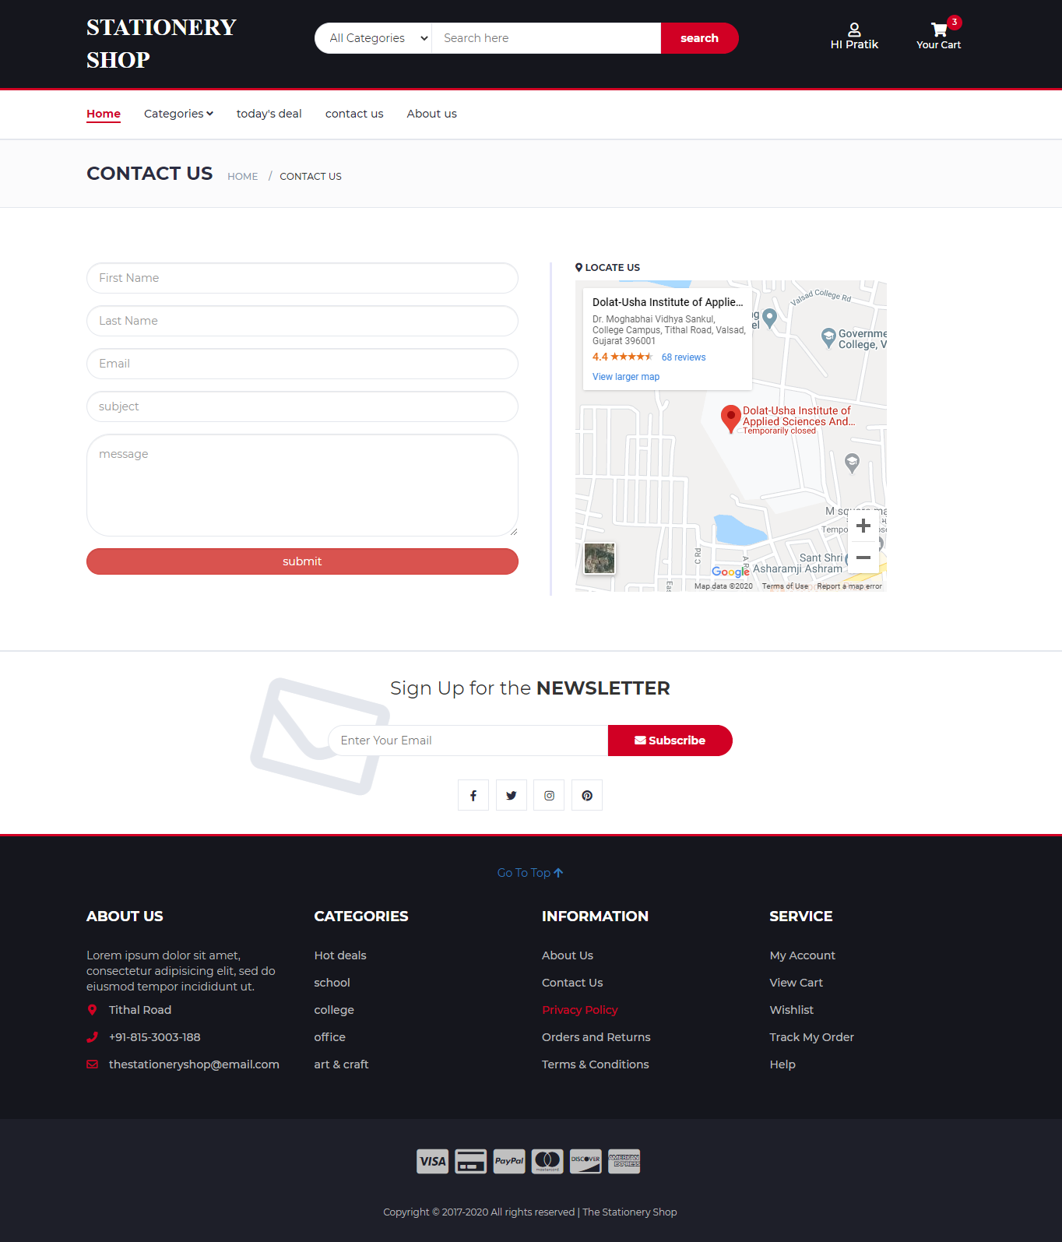

**Contact\_us.php**

<!DOCTYPE html>

<?php

include "header.php";

?>

<!-- BREADCRUMB -->

<div id="breadcrumb" class="section">

<!-- container -->

<div class="container">

<!-- row -->

<div class="row">

<div class="col-md-12">

<h3 class="breadcrumb-header">Contact us</h3>

<ul class="breadcrumb-tree">

<li><a href="index.php">Home</a></li>

<li class="active">contact us</li>

</ul>

</div>

</div>

<!-- /row -->

</div>

<!-- /container -->

</div>

<!-- /BREADCRUMB -->

<!-- SECTION -->

<div class="section">

<!-- container -->

<div class="container">

<!-- row -->

<div class="row">

<div class="col-sm-6">

<form name="contactus" method="post">

<h5></h5>

<div class="form-group ">

<input class="input form-control input-borders" type="text" name="fname" placeholder="First Name" required>

</div>

<div class="form-group">

<input class="input form-control input-borders" type="text" name="lname" placeholder="Last Name" required>

</div>

<div class="form-group">

<input class="input form-control input-borders" type="email" name="email" placeholder="Email" required>

</div>

<div class="form-group">

<input class="input form-control input-borders" type="text" name="subject" placeholder="subject" required>

</div>

<div class="form-group">

<textarea class="input form-control input-borders" type="text" name="message" rows="5" placeholder="message" required></textarea>

</div>

<div class="form-group">

<input class="btn btn-danger form-control input-borders" type="submit" name='submit' value='submit'/>

</div>

</form>

</div>

<div class="col-sm-6">

<div style="border-left:solid lavender;margin:10px;padding-left:30px">

<h6 class="heading"><i class="fa fa-map-marker"></i> LOCATE US</h6>

<iframe src="https://www.google.com/maps/embed?pb=!1m18!1m12!1m3!1d3734.5249357481007!2d72.90652331447743!3d20.607449486228013!2m3!1f0!2f0!3f0!3m2!1i1024!2i768!4f13.1!3m3!1m2!1s0x3be0c2b845dced6f%3A0xd07d6ae76f715053!2sDolat-Usha+Institute+of+Applied+Sciences+And+Dhiru-Sarla+Institute+Of+Management+And+Commerce!5e0!3m2!1sen!2sin!4v1565954051135!5m2!1sen!2sin" width="400" height="400" frameborder="0"></iframe>

</div>

</div>

</div>

<!-- /row -->

</div>

<!-- /container -->

</div>

<!-- /SECTION -->

<!-- NEWSLETTER -->

<?php include "newsletter.php"; ?>

<!-- /NEWSLETTER -->

<?php include "footer.php"; ?>

</body>

</html>

<?php

if(isset($\_POST['submit']))

{

$fname = $\_POST["fname"];

$lname = $\_POST["lname"];

$email = $\_POST['email'];

$subject = $\_POST['subject'];

$message = $\_POST['message'];

//auto id start

$sql = "select max(ID) from contactus";

$cmd = mysql\_query( $sql, $conn );

$cnt = mysql\_num\_rows( $cmd );

if( $cnt == 0 )

{

$id = 1;

}

else

{

$rset = mysql\_fetch\_array( $cmd );

$id = $rset[0] + 1;

}

//auto id end

$sql = "INSERT INTO `contactus` VALUES ($id, '$fname', '$lname', '$email', '$subject', '$message')";

$res = mysql\_query($sql,$conn);

if($res)

{

echo "<script>alert( 'your message is successfully sent!' );</script>";

}

}

?>

**Delete.php**

<?php

session\_start();

include "db.php";

if(isset($\_REQUEST['pid'] ))

{

$pid=$\_REQUEST['pid'];

$ctid=$\_REQUEST['ctid'];

$sql="delete from cart\_details where PID='$pid' and CTID='$ctid'";

$res=mysql\_query($sql,$conn);

if($res)

{

echo "<script type='text/javascript'>";

//echo "alert('record deleted successfully');";

echo "window.location.href='cart.php';";

echo "</script>";

}

}

if(isset($\_REQUEST['wpid'] ))

{

$wpid=$\_REQUEST['wpid'];

$uid=$\_SESSION['uid'];

$sql="delete from wishlist where PID='$wpid' and UID='$uid'";

$res=mysql\_query($sql,$conn);

if($res)

{

echo "<script type='text/javascript'>";

//echo "alert('record deleted successfully');";

echo "window.location.href='wishlist.php';";

echo "</script>";

}

}

?>

**Forgot1.php**

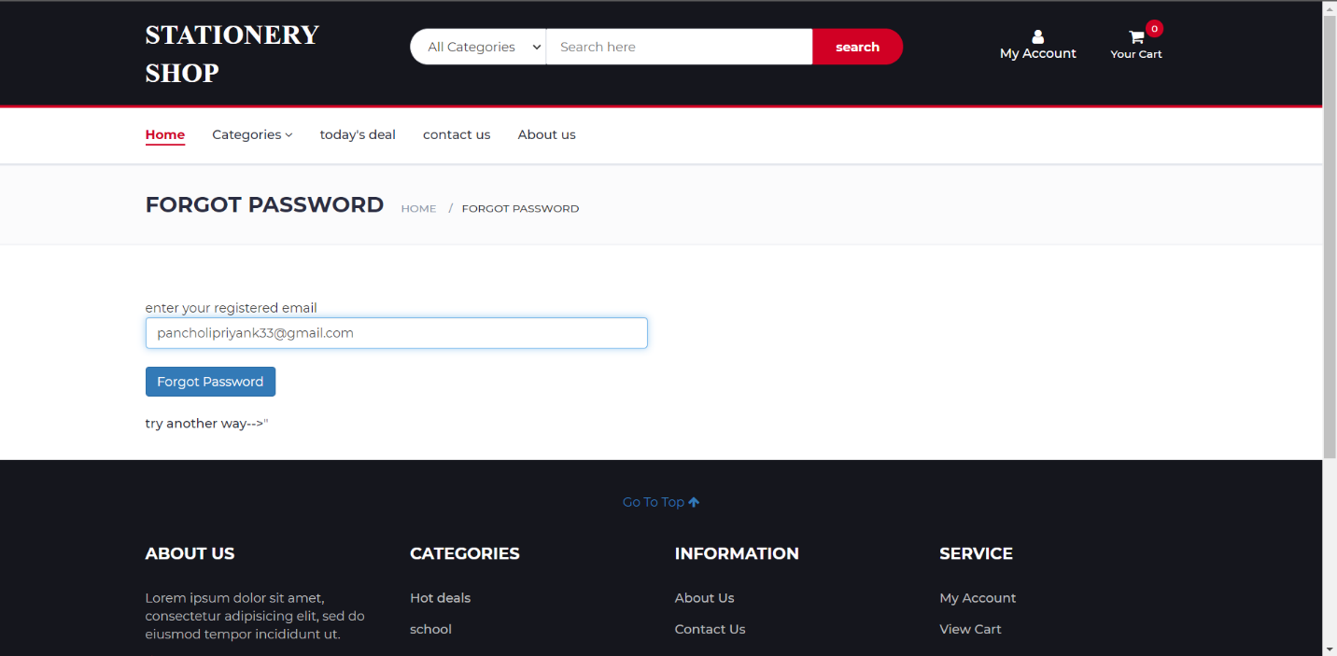

<!DOCTYPE html>

<?php include "header.php"; ?>

<!-- BREADCRUMB -->

<div id="breadcrumb" class="section">

<!-- container -->

<div class="container">

<!-- row -->

<div class="row">

<div class="col-md-12">

<h3 class="breadcrumb-header">forgot password</h3>

<ul class="breadcrumb-tree">

<li><a href="index.php">Home</a></li>

<li class="active">forgot password</li>

</ul>

</div>

</div>

<!-- /row -->

</div>

<!-- /container -->

</div>

<!-- /BREADCRUMB -->

<!-- SECTION -->

<div class="section">

<!-- container -->

<div class="container ">

<!-- row -->

<div class="row">

<div class="col-md-6">

<form method="POST" class="form">

<span>enter your registered email</span>

<input class="form-control" type="text" name="user" placeholder="example@email.com" required><br>

<button class="btn btn-primary" type="submit" name="forgot">Forgot Password</button>

</form>

<?php

$emsg='';

$user='';

if( isset( $\_POST['forgot'] ) ){

$user=$\_POST['user'];

$sql = "SELECT \* FROM `user\_login` WHERE email='$user'";

$cmd = mysql\_query( $sql, $conn ) or die(mysql\_error());

$rset = mysql\_fetch\_array( $cmd );

if( $rset[0] == '' )

{

$emsg = "! not register with '$user'";

}

else

{

echo "<form name='form1' method='post'> <br/>";

echo "<input class='' type='text' name='user' value='$rset[email]' hidden>";

echo "<input class='form-control' type='text' name='que' value='$rset[sec\_ques]' readonly>";

echo "<input class='form-control' type='text' name='ans' placeholder='answer' require></br>";

echo "<input class='btn btn-success' type='submit' name='submit' value='submit'> ";

echo "</form>";

}

}

if( isset( $\_POST['submit'] ) )

{

$ans = $\_POST['ans'];

$user = $\_POST['user'];

$sql = "SELECT \* FROM `user\_login` WHERE email = '$user'";

$cmd = mysql\_query( $sql, $conn );

$rset=mysql\_fetch\_array( $cmd );

if( $rset['sec\_ans'] == $ans )

{

$emsg = "password is '$rset[password]'";

}

else

{

$emsg = "incorrect answer try another way <a href='forgot2.php'> --></a>";

}

}

?>

<br><?php if($emsg!='') {echo "<p class=' alert alert-danger'> $emsg</p>";} ?>

</div>

</div>

</div>

</div>

<?php

include "footer.php";?>

</body>

</html>

**Forgot2.php**



<!DOCTYPE html>

<?php include "header.php"; ?>

<!-- BREADCRUMB -->

<div id="breadcrumb" class="section">

<!-- container -->

<div class="container">

<!-- row -->

<div class="row">

<div class="col-md-12">

<h3 class="breadcrumb-header">forgot password</h3>

<ul class="breadcrumb-tree">

<li><a href="index.php">Home</a></li>

<li class="active">forgot password</li>

</ul>

</div>

</div>

<!-- /row -->

</div>

<!-- /container -->

</div>

<!-- /BREADCRUMB -->

<!-- SECTION -->

<div class="section">

<!-- container -->

<div class="container ">

<!-- row -->

<div class="row">

<div class="col-md-6">

<form method="POST">

<span>@ enter your registered email</span>

<input class="form-control" type="email" name="email" placeholder="Example@email.com" required>

<br />

<button class="btn btn-primary" type="submit" name="forgot">Forgot Password</button>

</form>

<?php

$emsg = '';

if( isset( $\_POST['forgot'] ) ){

$email=$\_POST['email'];

$sql = "SELECT \* FROM `user\_login` WHERE email='$email'";

$res = mysql\_query( $sql, $conn );

$count = mysql\_num\_rows( $res );

if( $count == 1 ){

$r = mysql\_fetch\_assoc( $res );

$password = $r['password'];

$to = $r['email'];

$subject = "Your Recovered Password";

$message = "Please use this password to login -> " . $password;

$headers = "From : testmycode404@gmail.com";

if( mail( $to, $subject, $message, $headers ) ){

$emsg = "Your Password has been sent to your email id";

}else{

$emsg = "Failed to Recover your password, try again";

}

}

else{

$emsg = "User name or email does not exist in database";

}

}

?>

<br><?php if($emsg!='') {echo "<p class=' alert alert-danger'> $emsg</p>";} ?>

</div>

</div>

</div>

</div>

<?php

include "footer.php";?>

</body>

</html>

**Newsletter.php**

<?php

if( isset( $\_POST['newsletterbtn'] ) )

{

$email = $\_POST['email'];

$sql = "select \* from newsletter where email = '$email'";

$cmd = mysql\_query( $sql, $conn );

$count = mysql\_num\_rows( $cmd );

if( $count == 1 )

{

echo "<script> alert( 'your email already in subscription list' ); window.location.href='index.php'; </script>";

}

else

{

//auto id start

$sql = "select max( ID ) from newsletter";

$cmd = mysql\_query( $sql, $conn );

$cnt = mysql\_num\_rows( $cmd );

if( $cnt == 0 )

{

$ID = 1;

}

else

{

$rset = mysql\_fetch\_array( $cmd );

$ID = $rset[0] + 1;

}

//auto id end

$sql = "insert into newsletter values( $ID, '$email' )";

$cmd = mysql\_query( $sql, $conn );

if($cmd)

{

echo "<script> alert( 'your email added to subscription list' ); window.location.href='index.php'; </script>";

}

}

}

?>

<!-- NEWSLETTER -->

<div id="newsletter" class="section">

<!-- container -->

<div class="container">

<!-- row -->

<div class="row">

<div class="col-md-12">

<div class="newsletter">

<p>Sign Up for the <strong>NEWSLETTER</strong></p>

<form method="POST">

<input class="input" type="email" name="email" placeholder="Enter Your Email">

<button type="submit" name="newsletterbtn" class="newsletter-btn"><i class="fa fa-envelope"></i> Subscribe</button>

</form>

<ul class="newsletter-follow">

<li>

<a href="#"><i class="fa fa-facebook"></i></a>

</li>

<li>

<a href="#"><i class="fa fa-twitter"></i></a>

</li>

<li>

<a href="#"><i class="fa fa-instagram"></i></a>

</li>

<li>

<a href="#"><i class="fa fa-pinterest"></i></a>

</li>

</ul>

</div>

</div>

</div>

<!-- /row -->

</div>

<!-- /container -->

</div>

<!-- /NEWSLETTER -->

**Verifymobile.php**

<!DOCTYPE html>

<?php

include "header.php";

?>

<script src="js/jquery.min.js"></script>

<!-- BREADCRUMB -->

<div id="breadcrumb" class="section">

<!-- container -->

<div class="container">

<!-- row -->

<div class="row">

<div class="col-md-12">

<h3 class="breadcrumb-header">Profile Page</h3>

<ul class="breadcrumb-tree">

<li><a href="#">Home</a></li>

<li class="active">my profile</li>

</ul>

</div>

</div>

<!-- /row -->

</div>

<!-- /container -->

</div>

<!-- /BREADCRUMB -->

<?php

if(isset($\_SESSION['uid']))

{

$uid=$\_SESSION['uid'];

$cmd1=mysql\_query( "select \* from user\_master where UID='$uid'", $conn );

$res1=mysql\_fetch\_array( $cmd1 );

$cmd2=mysql\_query( "select \* from user\_login where UID='$uid'", $conn );

$res2=mysql\_fetch\_array( $cmd2 );

if(isset($\_POST['sendotp'])) {

require('textlocal.class.php');

require('credential.php');

$textlocal = new Textlocal(false, false, API\_KEY);

// You can access MOBILE from credential.php

// $numbers = array(MOBILE);

// Access enter mobile number in input box

$numbers = array($\_POST['mobile']);

$sender = 'TXTLCL';

$otp = mt\_rand(10000, 99999);

$message = "Hello " . $res1['fname'] . " This is your OTP: " . $otp;

try {

$result = $textlocal->sendSms($numbers, $message, $sender);

setcookie('otp', $otp);

echo "<script>alert('OTP successfully send..');</script>";

} catch (Exception $e) {

die('Error: ' . $e->getMessage());

}

}

if(isset($\_POST['verifyotp'])) {

$otp = $\_POST['otp'];

if($\_COOKIE['otp'] == $otp) {

echo "<script>alert('Congratulation, Your mobile is verified.');</script>";

$q="update user\_master set vmobile='1' where UID='$uid'";

mysql\_query($q,$conn);

echo "window.location.href='profile.php';";

} else {

echo "Please enter correct otp.";

}

}

?>

<!-- SECTION -->

<div class="section">

<!-- container -->

<div class="container">

<!-- row -->

<div class="row">

<div class="col-sm-3">

<image class="img-circle" style="width:200px;height:200px" src="<?php echo $res1['uimage']; ?>" alt="user image"></image>

</div>

<div class="col-sm-6">

<form action="" method="post" >

<div class="row">

<div class="col-sm-9 form-group">

<label for="mobile">Mobile</label>

<input type="text" class="form-control" id="mobile" name="mobile" value="<?php echo $res1['mobile']; ?>" maxlength="10" placeholder="Enter valid mobile number" required="">

</div>

</div>

<div class="row">

<div class="col-sm-9 form-group">

<button type="submit" name="sendotp" class="btn btn-lg btn-success btn-block">Send OTP</button>

</div>

</div>

</form>

<form method="POST" action="">

<div class="row">

<div class="col-sm-9 form-group">

<label for="otp">OTP</label>

<input type="text" class="form-control" id="otp" name="otp" placeholder="Enter OTP" maxlength="5" required="">

</div>

</div>

<div class="row">

<div class="col-sm-9 form-group">

<button type="submit" name="verifyotp" class="btn btn-lg btn-info btn-block">Verify</button>

</div>

</div>

</form>

</div>

</div>

<!-- /row -->

</div>

<!-- /container -->

</div>

<!-- /SECTION -->

<?php }

else{

echo "<div class='container'>

<h3 style='margin:50px'>please login to view your profile

<br><a href='' class='btn btn-link' data-toggle='modal' data-target='#Modal\_login'><i class='fa fa-sign-in' aria-hidden='true'></i> Login</a>

</h3>

</div>";

}?>

<!-- NEWSLETTER -->

<?php include "newsletter.php"; ?>

<!-- /NEWSLETTER -->

<?php include "footer.php"; ?>

</body>

</html>

**Credential.php**

<?php

/\*Enter your API\_KEY\*/

define("API\_KEY", 'v8Yp0TzyTxg-pybk8OdLoVLa5DaD8oASTSKvRZUOjU');

/\*You can enter mobile number here\*/

define("MOBILE", '8200250675');

?>

**Db.php**

<?php

$servername = "localhost";

$username = "root";

$password = "";

$db = "stationeryshop";

// Create connection

$conn = mysql\_connect($servername, $username, $password) or die("connection failed".mysql\_connect\_error());

mysql\_select\_db($db,$conn);

?>

**ADMIN SIDE**

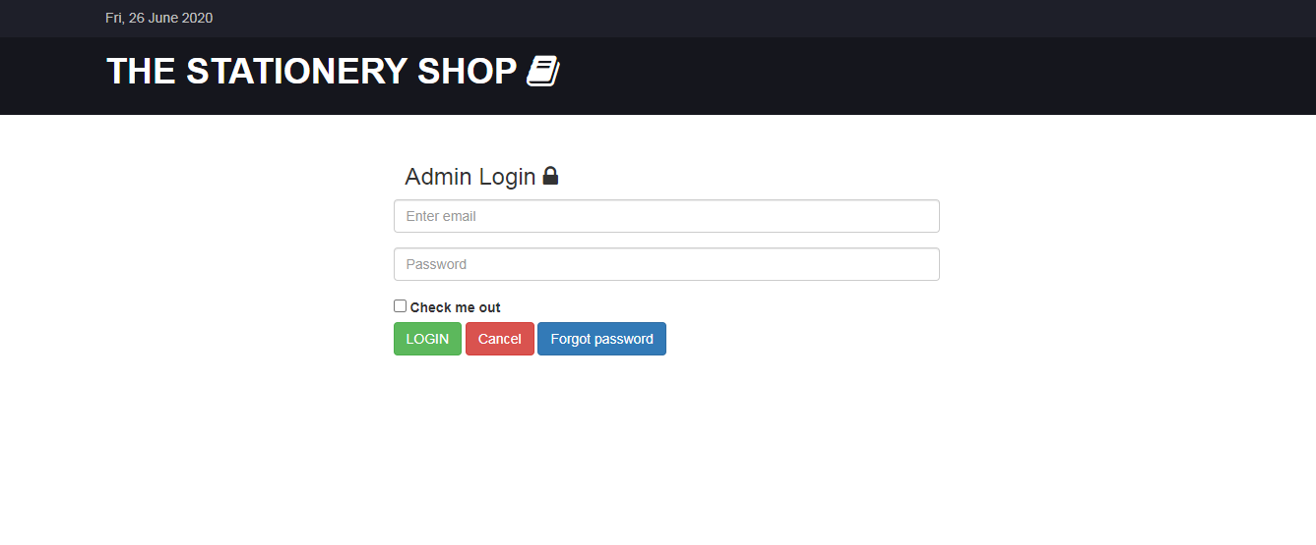

**Login.php**

<!DOCTYPE html>

<?php

require\_once( '../db.php' );

$msg = '';

if( isset( $\_POST['submit'] ) )

{

session\_start();

$email = $\_POST['email'];

$password = $\_POST['password'];

$sql = "select \* from admin\_login where email='$email' and password = '$password'";

$cmd = mysql\_query( $sql, $conn );

$count = mysql\_num\_rows( $cmd );

if( $count == 1 )

{

$\_SESSION['email']=$email;

$\_SESSION['password']=$password;

header('location:index.php');

}

else

{

echo "<script>alert('incorrect password or username');</script>";

}

}

if(isset($\_POST['forgot']))

{

$email=$\_POST['email'];

$sql = "SELECT \* FROM `admin\_login` WHERE email='$email'";

$res = mysql\_query( $sql, $conn );

$count = mysql\_num\_rows( $res );

if( $count == 1 ){

$r = mysql\_fetch\_assoc( $res );

$password = $r['password'];

$to = $r['email'];

$subject = "Your Recovered Password";

$message = "Please use this password to login -> " . $password;

$headers = "From : testmycode404@gmail.com";

if(mail($to, $subject, $message, $headers)){

$msg = "! Your Password has been sent to your email id";

}else{

$msg = "! Failed to Recover your password, try again";

}

}else{

$msg = "! email does not exist in database";

}

}

mysql\_close($conn);

?>

<html lang="en">

<head>

<title>ADMIN | login</title>

<!-- Bootstrap -->

<link type="text/css" rel="stylesheet" href="../css/bootstrap.min.css"/>

<!-- Slick -->

<link type="text/css" rel="stylesheet" href="../css/slick.css"/>

<link type="text/css" rel="stylesheet" href="../css/slick-theme.css"/>

<!-- nouislider -->

<link type="text/css" rel="stylesheet" href="../css/nouislider.min.css"/>

<!-- Font Awesome Icon -->

<link rel="stylesheet" href="../css/font-awesome.min.css">

<!-- Custom stlylesheet -->

<link type="text/css" rel="stylesheet" href="../css/style.css"/>

</head>

<body>

<!-- TOP HEADER -->

<div id="top-header">

<div class="container">

<ul style="color:silver">

<li><i class=""></i><?php echo " " . date("D, d F Y"); ?></li>

</ul>

</div>

</div>

<!-- /TOP HEADER -->

<!-- MAIN HEADER -->

<div id="header">

<!-- container -->

<div class="container">

<!-- row -->

<div class="row">

<!-- LOGO -->

<div class="col-md-9">

<div class="header-logo">

<h1 style="color:#fff">THE STATIONERY SHOP <i class="fa fa-book"></i></h1>

</div>

</div>

<!-- /LOGO -->

</div>

<!-- row -->

</div>

<!-- container -->

</div>

<!-- /MAIN HEADER -->

<!-- SECTION -->

<div class="section">

<!-- container -->

<div class="container ">

<!-- row -->

<div class="row">

<div class="col-md-3">

</div>

<div class="col-md-6 ">

<form name="login" method="post" action="login.php">

<p class="h3">&nbsp Admin Login <i class="fa fa-lock"></i></p>

<div class="form-group">

<input type="email" class="form-control" name="email" placeholder="Enter email" required>

</div>

<div class="form-group">

<input type="password" class="form-control" name="password" placeholder="Password" required>

</div>

<div class="form-check">

<input type="checkbox" class="form-check-input" id="exampleCheck1">

<label class="form-check-label" for="exampleCheck1">Check me out</label>

</div>

<button type="submit" name="submit" class="btn btn-success">LOGIN</button>

<button type="reset" class="btn btn-danger">Cancel</button>

<button class="btn btn-primary" type="button" data-toggle="collapse" data-target="#collapseExample" aria-expanded="false" aria-controls="collapseExample">

Forgot password

</button>

</form>

<br>

<div class="collapse" id="collapseExample">

<div class="card card-body">

<form method="POST" class="">

<p class="h3">&nbsp forgot password <i class="fa fa-unlock"></i></p>

<div class="col-md-6">

<input type="email" class="form-control" name="email" placeholder="Email">

</div>

<button type="submit" class="btn btn-primary" name="forgot">Forgot Password</button>

</form>

</div>

</div>

<div class="alert alert-warning alert-dismissible show" role="alert">

<strong> <?php echo "$msg"; ?> </strong>

<button type="button" class="close" data-dismiss="alert" aria-label="Close">

<span aria-hidden="true">&times;</span>

</button>

</div>

</div>

</div>

<!-- /row -->

</div>

<!-- /container -->

</div>

<!-- /SECTION -->

<!-- jQuery Plugins -->

<script src="../js/jquery.min.js"></script>

<script src="../js/bootstrap.min.js"></script>

<script src="../js/slick.min.js"></script>

<script src="../js/nouislider.min.js"></script>

<script src="../js/jquery.zoom.min.js"></script>

<script src="../js/main.js"></script>

</body>

</html>

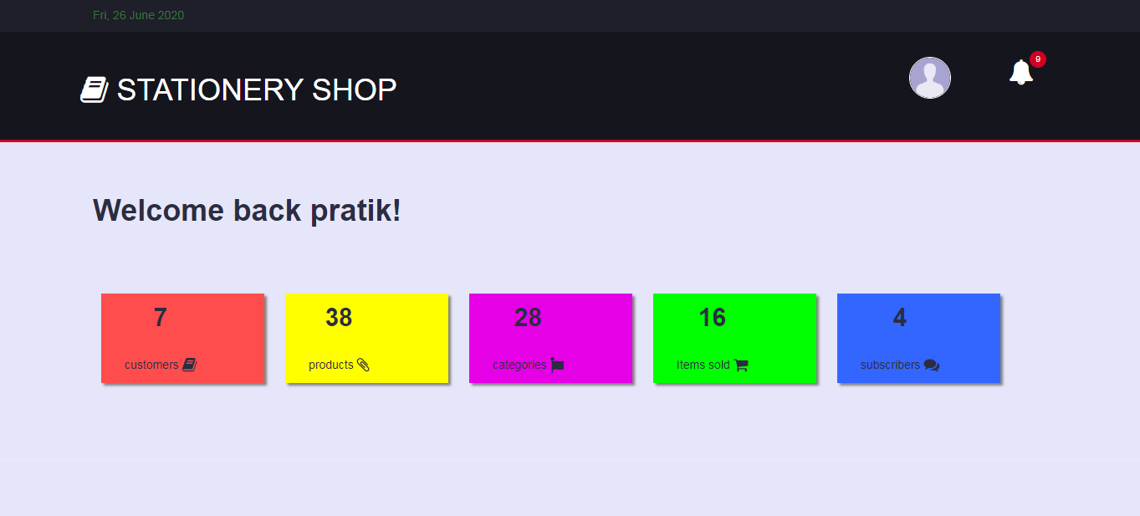

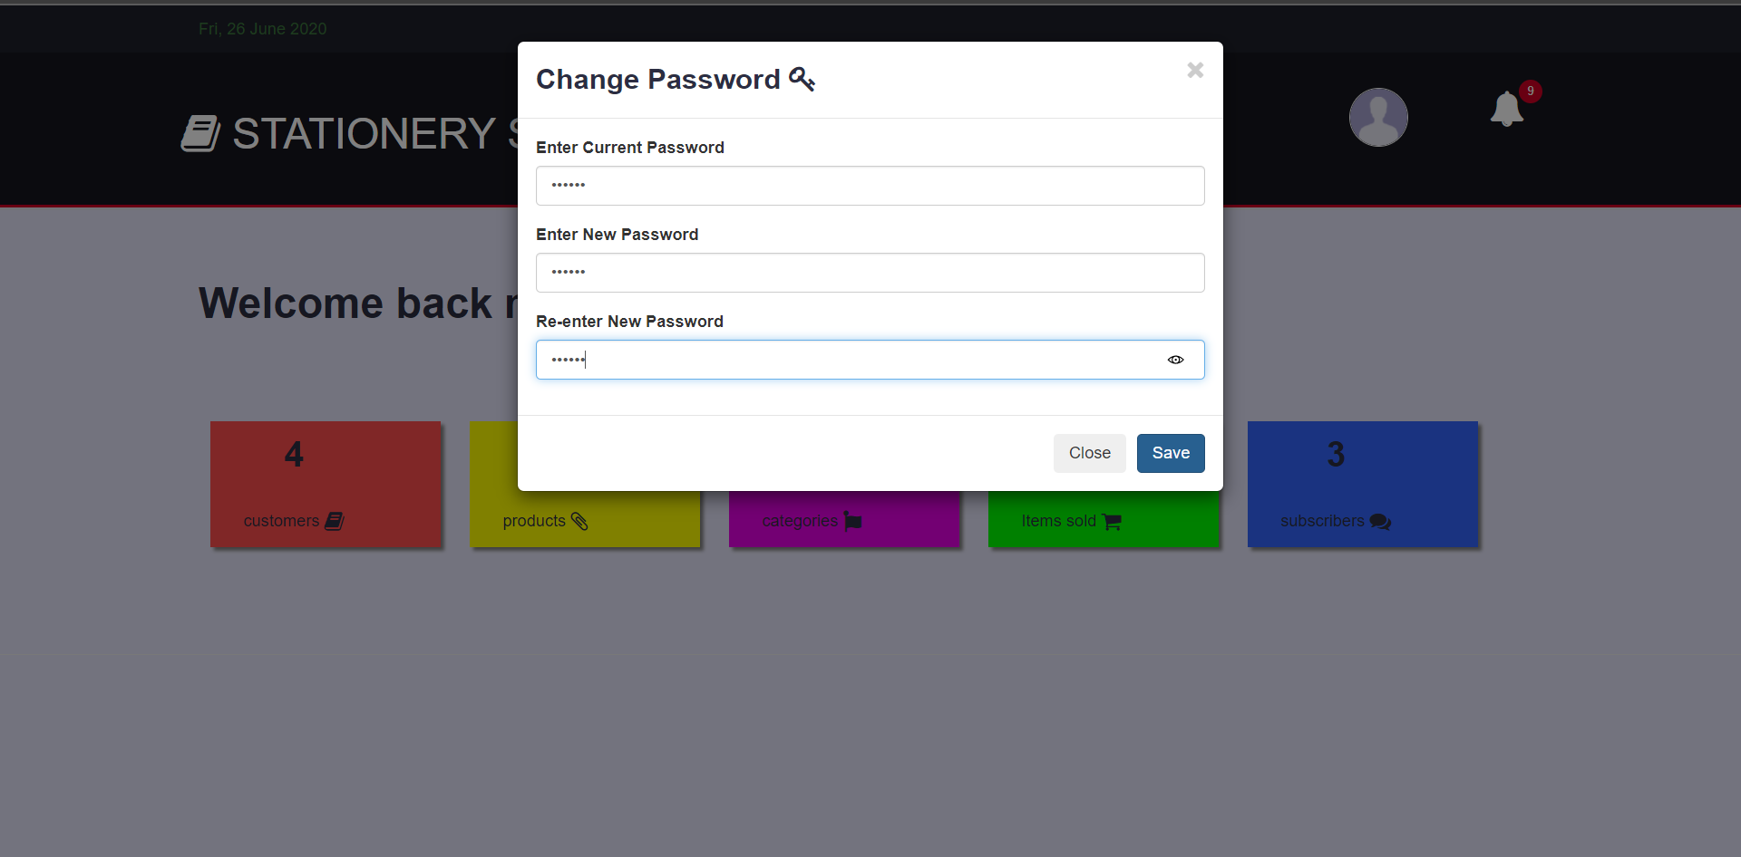

**Header.php**

<?php

require\_once( "../db.php" );

session\_start();

if(!isset($\_SESSION['email']))

{

header( 'location:login.php' );

}

$cmd143 = mysql\_query( "SELECT \* FROM admin\_login where email = '$\_SESSION[email]'", $conn );

$rset143 = mysql\_fetch\_array( $cmd143 );

?>

<style>

.box{

margin-left:25px;

box-shadow:3px 3px 3px grey;

padding:5px;

}

.logo{

border:1px solid;

border-radius:50%;

width:50px;

height:50px;

}

.bg-dark{background-color:#343a40;color:white}

.bg-light{background-color:#fff;color:black}

.bg-lav{background-color:lavender}

.bg-grey{background-color:grey}

</style>

<!-- Bootstrap -->

<link type="text/css" rel="stylesheet" href="../css/bootstrap.min.css"/>

<!-- Slick -->

<link type="text/css" rel="stylesheet" href="../css/slick.css"/>

<link type="text/css" rel="stylesheet" href="../css/slick-theme.css"/>

<!-- nouislider -->

<link type="text/css" rel="stylesheet" href="../css/nouislider.min.css"/>

<!-- Font Awesome Icon -->

<link rel="stylesheet" href="../css/font-awesome.min.css">

<!-- Custom stlylesheet -->

<link type="text/css" rel="stylesheet" href="../css/style.css"/>

<!-- jQuery Plugins -->

<script src="../js/jquery.min.js"></script>

<script src="../js/bootstrap.min.js"></script>

<script src="../js/slick.min.js"></script>

<script src="../js/nouislider.min.js"></script>

<script src="../js/jquery.zoom.min.js"></script>

<script src="../js/main.js"></script>

</head>

<body class="bg-lav">

<!-- TOP HEADER -->

<div id="top-header">

<div class="container text-success">

<i class=""></i><?php echo " " . date("D, d F Y"); ?>

</div>

</div>

<!-- /TOP HEADER -->

<header id="header">

<!-- MAIN HEADER -->

<!-- container -->

<div class="container">

<!-- row -->

<div class="row">

<div class="header-ctn pull-left">

<h1 class="h1" style="color:#fff"><i class="fa fa-book"></i> STATIONERY SHOP</h1>

</div>

<div class="header-ctn">

<!-- dropdown -->

<div class="dropdown">

<a href="" class="dropdown-toggle" data-toggle="dropdown" data-toggle="tooltip" title="My account">

<img class="logo dropdown-toggle" src="img/user.png"></img></a>

<div class="dropdown-menu" style="width:200px">

<ul class="nav">

<li><a class="dropdown-item" href="#" data-toggle="modal" data-target="#account"><i class="fa fa-user"></i> Account</a></li>

<li><a class="dropdown-item" href="#" data-toggle="modal" data-target="#change\_password"><i class="fa fa-key"></i> Change Password</a></li>

<li><a class="dropdown-item" href="logout.php"><i class="fa fa-sign-out"></i> Logout</a></li>

</ul>

</div>

</div>

<!-- /dropdown -->

<div>

<a href="#" data-toggle="tooltip" title="Notification">

<i class="fa fa-bell" style="font-size:30px;"></i>

<span></span>

<div class="qty">9</div>

</a>

</div>

</div>

</div>

<!-- row -->

</div>

<!-- container -->

<!-- /MAIN HEADER -->

</header>

<!-- /HEADER -->

<!-- Button trigger modal -->

<!-- Modal -->

<div class="modal fade" id="change\_password" tabindex="-1" role="dialog" aria-labelledby="change\_password" aria-hidden="true">

<div class="modal-dialog modal-dialog-centered" role="document">

<div class="modal-content">

<div class="modal-header">

<h3 class="modal-title" id="change\_password">Change Password <i class="fa fa-key"></i>

<a class="close" data-dismiss="modal"><i class="fa fa-close"></i></a></h3>

</div>

<div class="modal-body">

<form name="changepassword" method="post" >

<div class="form-group">

<label for="oldpassword">Enter Current Password</label>

<input class="form-control" type="password" name="oldpassword" placeholder="current password" value="">

</div>

<div class="form-group">

<label for="newpassword">Enter New Password</label>

<input class="form-control" type="password" name="newpassword" placeholder="new password" value="">

</div>

<div class="form-group">

<label for="1newpassword"> Re-enter New Password</label>

<input class="form-control" type="password" name="1newpassword" placeholder="new password" value="">

</div>

</div>

<div class="modal-footer">

<button type="button" class="btn btn-secondary" data-dismiss="modal">Close</button>

<button type="submit" name="submit" class="btn btn-primary">Save</button>

</form>

</div>

</div>

</div>

</div>

<!--modal account start -->

<div class="modal fade" id="account" role="dialog" aria-hidden="true">

<div class="modal-dialog modal-dialog-centered">

<div class="modal-content">

<div class="modal-header">

<h3 class="modal-title" id="account">Account profile <a class="close" data-dismiss="modal"><i class="fa fa-close"></i></a></h3>

</div>

<div class="modal-body row">

<div class="col-xs-12">

<div class="row well">

<div class="col-sm-6 col-md-4">

<img src="<?php echo "$rset143[image]"; ?>" alt="admin image" class="img-rounded img-responsive" ></img>

</div>

<div class="col-sm-6 col-md-8">

<h3><?php echo "$rset143[name]"; ?></h3>

<p>

<i class="fa fa-envelope"></i> <?php echo "$rset143[email]"; ?>

<br />

<i class="fa fa-globe"></i><a href="http://www.stationeryshop.com"> www.stationeryshop.com</a>

<br />

<i class="fa fa-gift"></i> <?php echo date('M d Y',strtotime($rset143['dob'])); ?>

</p>

</div>

</div>

</div>

</div>

</div>

</div>

</div>

</div>

<?php

if( isset( $\_POST['submit'] ) )

{

$email = $\_SESSION['email'];

$oldpassword = $\_POST['oldpassword'];

$password1 = $\_POST['newpassword'];

$password2 = $\_POST['1newpassword'];

if( $password1 != $password2 )

{

echo "<script>alert( 'password dosn't match try again' );</script>";

}

else

{

$sql = "select password from admin\_login where email = '$email'";

$cmd = mysql\_query( $sql, $conn );

$res = mysql\_fetch\_array( $cmd );

if( $res['password'] == $oldpassword )

{

$sql = "UPDATE admin\_login SET password='$password1' WHERE email='$email'";

$cmd = mysql\_query( $sql, $conn );

if( $cmd )

{

echo "<script>alert( 'password changed successfully' );</script>";

}

else

{

echo "something wrong";

}

}

else

{

echo "<script>alert( 'wrong password entered.' );</script>";

}

}

}

?>

<!-- NAVIGATION -->

<nav id="navigation">

<!-- container -->

<div class="container">

<!-- responsive-nav -->

<div id="responsive-nav">

<!-- NAV -->

**Index.php**

<?php

require\_once( "../db.php" );

$cmd1 = mysql\_query( "select \* from user\_master", $conn );

$customers = mysql\_num\_rows( $cmd1 );

$cmd2 = mysql\_query( "select \* from products", $conn );

$products = mysql\_num\_rows( $cmd2 );

$cmd3 = mysql\_query( "select \* from categories", $conn );

$categories = mysql\_num\_rows( $cmd3 );

$cmd4 = mysql\_query( "select \* from orders", $conn );

$orders = mysql\_num\_rows( $cmd4 );

$cmd5 = mysql\_query( "select \* from newsletter", $conn );

$newsletter = mysql\_num\_rows( $cmd5 );

?>

<!DOCTYPE html>

<html lang="en">

<head>

<title>ADMIN | HOME </title>

<?php include "header.php";?>

</div>

<!-- /responsive-nav -->

</div>

<!-- /container -->

</nav>

<!-- /NAVIGATION -->

<!-- SECTION -->

<div class="section">

<!-- container -->

<div class="container">

<!-- row -->

<div class="section"><h1>Welcome back <?php echo "$rset143[name]";?>!</h1></div>

<br/><br/>

<div class="row">

<div class="col-lg-2 box" style="background-color:#ff4d4d">

<a href="customer.php" class="btn">

<h2><?php echo $customers; ?></h2>

<br>

customers <i class="fa fa-book fa-lg"></i>

</a>

</div>

<div class="col-lg-2 box" style="background-color:yellow">

<a class="btn" href="products.php">

<h2><?php echo $products; ?></h2>

<br>

products <i class="fa fa-paperclip fa-lg"></i>

</a>

</div>

<div class="col-lg-2 box" style="background-color:#e600e6">

<a class="btn" href="categories.php">

<h2><?php echo $categories; ?></h2>

<br>

categories <i class="fa fa-fa fa-lg"></i>

</a>

</div>

<div class="col-lg-2 box" style="background-color:lime">

<a class="btn" href="orders.php">

<h2><?php echo $orders; ?></h2>

<br>

Items sold <i class="fa fa-shopping-cart fa-lg"></i>

</a>

</div>

<div class="col-lg-2 box" style="background-color:#3366ff">

<a class="btn" href="">

<h2><?php echo $newsletter; ?></h2>

<br>

subscribers <i class="fa fa-comments fa-lg"></i>

</a>

</div>

</div>

<!-- /row -->

<br><br>

<div class="row" >

<div class="col-md-6">

<div id="piechart"></div>

<script type="text/javascript" src="https://www.gstatic.com/charts/loader.js"></script>

<script type="text/javascript">

// Load google charts

google.charts.load('current', {'packages':['corechart']});

google.charts.setOnLoadCallback(drawChart);

// Draw the chart and set the chart values

function drawChart() {

var data = google.visualization.arrayToDataTable([

['categories', 'products per categories'],

['school', 8],

['college', 2],

['office', 4],

['art & craft', 2]

]);

// Optional; add a title and set the width and height of the chart

var options = {'title':'products in %', 'width':500, 'height':400};

// Display the chart inside the <div> element with id="piechart"

var chart = new google.visualization.PieChart(document.getElementById('piechart'));

chart.draw(data, options);

}

</script>

</div>

<div class="col-md-6">

<div id="columnchart\_values"></div>

<script type="text/javascript">

google.charts.load("current", {packages:['corechart']});

google.charts.setOnLoadCallback(drawChart);

function drawChart() {

var data = google.visualization.arrayToDataTable([

["Element", "Density", { role: "style" } ],

["Copper", 8.94, "gold"],

["Silver", 10.49, "green"],

["Gold", 19.30, "purple"],

["Platinum", 21.45 ,"red"]

]);

var view = new google.visualization.DataView(data);

view.setColumns([0, 1,

{ calc: "stringify",

sourceColumn: 1,

type: "string",

role: "annotation" },

2]);

var options = {

title: "Density of Precious Metals, in g/cm^3",

width: 600,

height: 400,

bar: {groupWidth: "95%"},

legend: { position: "none" },

};

var chart = new google.visualization.ColumnChart(document.getElementById("columnchart\_values"));

chart.draw(view, options);

}

</script>

</div>

</div>

</div>

<!-- /container -->

</div>

<!-- /SECTION -->

<hr/>

</body>

</html>

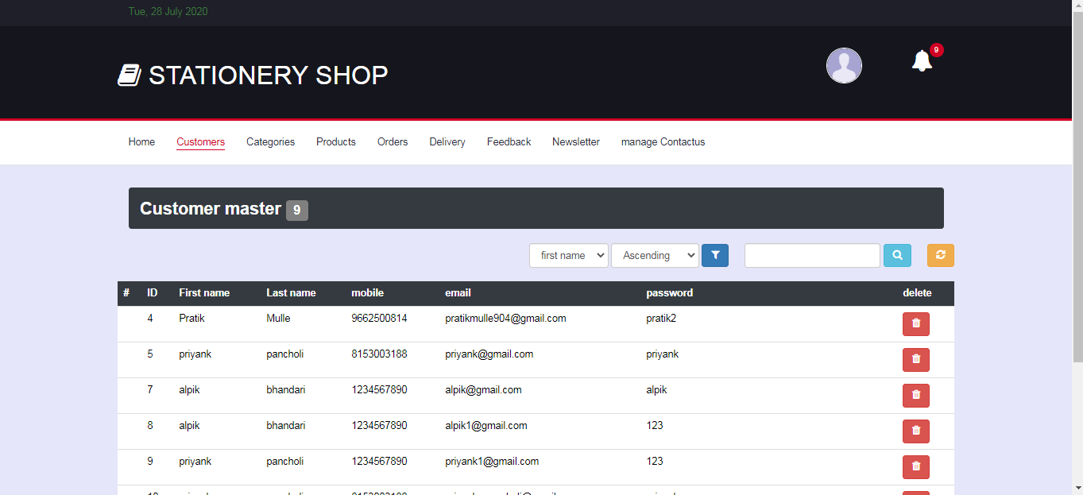

**Customer.php**

<!DOCTYPE html>

<html lang="en">

<head>

<title>ADMIN | customer </title>

<?php include "header.php";?>

<ul class="main-nav nav navbar-nav">

<li><a href="index.php">Home</a></li>

<li class="active"><a href="customer.php">Customers</a></li>

<li><a href="categories.php">Categories</a></li>

<li><a href="products.php">Products</a></li>

<li><a href="orders.php">Orders</a></li>

<li><a href="delivery.php">Delivery</a></li>

<li><a href="feedback.php">Feedback</a></li>

<li><a href="newsletter.php">Newsletter</a></li>

<li><a href="manage\_contactus.php">manage Contactus</a></li>

</ul>

<!-- /NAV -->

</div>

<!-- /responsive-nav -->

</div>

<!-- /container -->

</nav>

<!-- /NAVIGATION -->

<!-- SECTION -->

<div class="section">

<!-- container -->

<div class="container">

<!-- row -->

<div class="row">

<?php

$cmd1 = mysql\_query( "select \* from user\_master", $conn );

$cnt = mysql\_num\_rows( $cmd1 );

?>

<div class="col-md-6 pull-left" >

<h2>Customer master <div class="label bg-grey"><?php echo $cnt; ?></div></h2>

</div>

<div class="col pull-right" >

<a class="btn btn-warning" href="customer.php" data-toggle="tooltip" title="Refresh page"><i class="fa fa-refresh"></i></a>

</div>

<div class="col-md-3 pull-right">

<form name="searchform" method="post" action="customer.php">

<div class="form-group form-inline">

<input class="form-control" type="text" name="stext" />

<button type="submit" name="sbtn" class="btn btn-info" data-toggle="tooltip" data-placement="top" title="Search row"><i class="fa fa-search"></i></button>

</div>

</form>

</div>

<table class="table table-hover">

<thead class="bg-dark">

<tr>

<th scope="col">#</th>

<th scope="col">ID</th>

<th scope="col">First name</th>

<th scope="col">Last name</th>

<th scope="col">mobile</th>

<th scope="col">email</th>

<th scope="col">password</th>

<th scope="col">delete</th>

</tr>

</thead>

<tbody class="bg-light">

<?php

if(isset($\_POST['sbtn']))

{

$stext = $\_POST['stext'];

$sql="select \* from user\_master where fname='$stext' or lname='$stext' or UID='$stext' or mobile='$stext' or email='$stext' ";

$cmd1 = mysql\_query( $sql, $conn ) or die(mysql\_error());

}

else

{

$cmd1 = mysql\_query( "select \* from user\_master", $conn );

}

while( $rset = mysql\_fetch\_array( $cmd1 ) )

{

$cmd2 = mysql\_query( "select password from user\_login where UID = $rset[0]", $conn );

$pwd = mysql\_fetch\_array( $cmd2 );

?>

<tr>

<!--<th scope="row"><image src="../<?php echo $rset[6]; ?>" style="width:100px; height:auto"></image></th> -->

<th></th>

<td><?php echo "$rset[0]"; ?></td>

<td><?php echo "$rset[1]"; ?></td>

<td><?php echo "$rset[2]"; ?></td>

<td><?php echo "$rset[3]"; ?></td>

<td><?php echo "$rset[4]"; ?></td>

<td><?php echo "$pwd[password]"; ?></td>

<td><a class="btn btn-danger" href='customer.php?uid=<?php echo $rset['UID']; ?>' data-toggle="tooltip" title="Delete row" ><i class="fa fa-trash"></a></a></td>

</tr>

<?php

}

?>

</tbody>

</table>

</div>

<!-- /row -->

</div>

<!-- /container -->

</div>

<!-- /SECTION -->

</body>

</html>

<?php

if(isset($\_GET['uid']))

{

$uid = $\_GET['uid'];

$sql = "DELETE FROM user\_login WHERE UID='$uid'";

$cmd = mysql\_query( $sql, $conn ) or die( mysql\_error() );

$sql = "DELETE FROM user\_master WHERE UID='$uid'";

$cmd = mysql\_query( $sql, $conn ) or die( mysql\_error() );

echo "<script>alert('deleted'); window.location.href='customer.php'; </script>";

}

?>

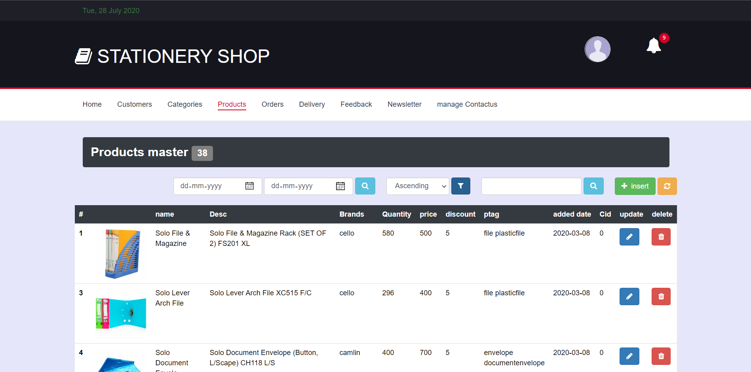

**Products.php**

<!DOCTYPE html>

<html lang="en">

<head>

<title>ADMIN | products </title>

<?php include "header.php";?>

<ul class="main-nav nav navbar-nav">

<li><a href="index.php">Home</a></li>

<li><a href="customer.php">Customers</a></li>

<li><a href="categories.php">Categories</a></li>

<li class="active"><a href="products.php">Products</a></li>

<li><a href="orders.php">Orders</a></li>

<li><a href="delivery.php">Delivery</a></li>

<li><a href="feedback.php">Feedback</a></li>

<li><a href="newsletter.php">Newsletter</a></li>

<li><a href="manage\_contactus.php">manage Contactus</a></li>

</ul>

<!-- /NAV -->

</div>

<!-- /responsive-nav -->

</div>

<!-- /container -->

</nav>

<!-- /NAVIGATION -->

<!-- SECTION -->

<div class="section">

<!-- container -->

<div class="container">

<!-- row -->

<div class="row">

<?php

$cmd1 = mysql\_query( "select \* from products", $conn );

$cnt = mysql\_num\_rows( $cmd1 );

?>

<div class="col pull-left" >

<h2>Products master <span class= "label bg-grey"><?php echo $cnt; ?></span></h2>

</div>

<div class="col pull-right" >

<a class="btn btn-success" href="" data-toggle="modal" data-target="#Modal\_insert"><i class="fa fa-plus"></i> &nbsp;insert</a>

<a class="btn btn-warning" href="products.php"><i class="fa fa-refresh"></i></a>

</div>

<div class="col-md-3 pull-right">

<form name="searchform" method="post" action="products.php">

<div class="form-group form-inline">

<input class="form-control" type="text" name="stext" />

<button type="submit" name="sbtn" class="btn btn-info" data-toggle="tooltip" data-placement="top" title="Search row"><i class="fa fa-search"></i></button>

</div>

</form>

</div>

</div>

<div class="row">

<div class="table-responsive ">

<table class="table table-hover">

<thead class="bg-dark">

<tr>

<th scope="col">#</th>

<th scope="col"></th>

<th scope="col">name</th>

<th scope="col">description</th>

<th scope="col">Brands</th>

<th scope="col">price</th>

<th scope="col">discount</th>

<th scope="col">ptag</th>

<th scope="col">added date</th>

<th scope="col">categories id</i></th>

<th scope="col">update</i></th>

<th scope="col">delete</th>

</tr>

</thead>

<tbody class="bg-light">

<?php

if(isset($\_POST['sbtn']))

{

$stext = $\_POST['stext'];

$sql="select \* from products where PID='$stext' or pname LIKE '%$stext%' or pdesc LIKE '%$stext%'";

$cmd1 = mysql\_query( $sql, $conn ) or die(mysql\_error());

}

else

{

$cmd1 = mysql\_query( "select \* from products", $conn );

}

while( $rset = mysql\_fetch\_array( $cmd1 ) )

{

?>

<tr>

<form name="up" method="post">

<th scope="row"><?php echo "$rset[0]"; ?><input type="hidden" name="upid" value="<?php echo $rset[0]; ?>"></th>

<td><image src="../<?php echo $rset[5]; ?>" style="width:100px; height:100px"></image></td>

<td><?php echo "$rset[1]"; ?></td>

<td><?php echo "$rset[2]"; ?></td>

<td><?php echo "$rset[3]"; ?></td>

<td><?php echo "$rset[4]"; ?></td>

<td><?php echo "$rset[6]"; ?></td>

<td><?php echo "$rset[7]"; ?></td>

<td class="text-nowrap"><?php echo "$rset[8]"; ?></td>

<td><?php echo "$rset[9]"; ?></td>

<td><a class="btn btn-primary" href="products\_update.php?upid=<?php echo $rset[0]; ?>"><i class="fa fa-pencil"></a></td>

<td><a class="btn btn-danger" href="products.php?pid=<?php echo $rset[0]; ?>"><i class="fa fa-trash"></a></td>

</form>

</tr>

<?php

}

?>

</tbody>

</table>

</div>

</div>

<!-- /row -->

</div>

<!-- /container -->

</div>

<!-- /SECTION -->

<!-- insert start -->

<div class="modal fade" id="Modal\_insert" role="dialog">

<div class="modal-dialog">

<!-- Modal content-->

<div class="modal-content">

<div class="modal-header">

<button type="button" class="close" data-dismiss="modal">&times;</button>

</div>

<div class="modal-body">

<div class="container-fluid">

<?php

$sql = "select max( PID ) from products";

$cmd = mysql\_query( $sql, $conn );

$cnt = mysql\_num\_rows( $cmd );

if( $cnt == 0 )

{

$pid = 1;

}

else

{

$rset = mysql\_fetch\_array( $cmd );

$pid = $rset[0] + 1;

}

?>

<form id="insert" class="login100-form " action="products.php" method="POST" enctype="multipart/form-data" >

<div class="billing-details jumbotron">

<div class="section-title">

<h2 class="login100-form-title p-b-49" >Insert Products</h2>

</div>

<div class="form-group">

<label for="id">ID</label>

<input class="input" type="text" name="pid" value="<?php echo "$pid"; ?>" readonly >

</div>

<div class="form-group">

<label for="id">Upload images</label>

<input class="input" type="file" name="pimage" >

</div>

<div class="form-group">

<label for="name">Name</label>

<input class="input " type="text" name="name" value="" required>

</div>

<div class="form-group">

<label for="name">Brands</label>

<input class="input " type="text" name="brand" value="" required>

</div>

<div class="form-group">

<label for="sub">Description</label>

<textarea class="input" name="desc" required></textarea>

</div>

<div class="form-group">

<label for="price">Price: </label>

<input class="input" type="text" name="price" value="" required style="width:150px">

<label for="discount">discount: </label>

<input class="input" type="text" name="discount" value="" style="width:150px" required>

</div>

<div class="form-group">

<label for="categories">select categories</label>

<select id="category" name="cat" class="input">

<option value="">select</option>

<?php

$result = mysql\_query( "SELECT \* FROM categories", $conn );

while( $row = mysql\_fetch\_array( $result ) ) {

?>

<option value="<?php echo $row['CID'];?>"><?php echo $row['cname'];?></option>

<?php

}

?>

</select>

</div>

<div class="form-group">

<label for="name">products tag</label>

<textarea class="input" name="ptag" required></textarea>

</div>

<input class="primary-btn btn-block" type="submit" Value="insert" name="insert">

</div>

</form>

</div>

</div>

</div>

<!--/modal -->

</div>

</div>

<!-- /insert end-->

</body>

</html>

<?php

//delete

if( isset( $\_GET['pid'] ) )

{

$pid = $\_GET['pid'];

$sql = "DELETE FROM products WHERE PID='$pid'";

$cmd = mysql\_query( $sql, $conn ) or die( mysql\_error() );

echo "<script>alert( 'Products Deleted.' ); window.location.href='products.php'; </script>";

}

//insert

if( isset( $\_POST['insert'] ) )

{

$pid = $\_POST['pid'];

$pname = $\_POST['name'];

$brand = $\_POST['brand'];

$desc = $\_POST['desc'];

$price = $\_POST['price'];

$discount = $\_POST['discount'];

$cat = $\_POST['cat'];

$ptag = $\_POST['ptag'];

$tpath=$\_FILES['pimage']['tmp\_name'];

$apath='img/'.$\_FILES['pimage']['name'];

move\_uploaded\_file($tpath,$apath);

$sql = " INSERT INTO products VALUES($pid, '$pname', '$desc', '$brand', $price, '$apath', '$discount', '$ptag' , NOW() ,'$cat')";

$cmd = mysql\_query( $sql, $conn ) or die(mysql\_error());

echo "<script>alert( 'INSERTED.' ); window.location.href='products.php'; </script>";

}

?>

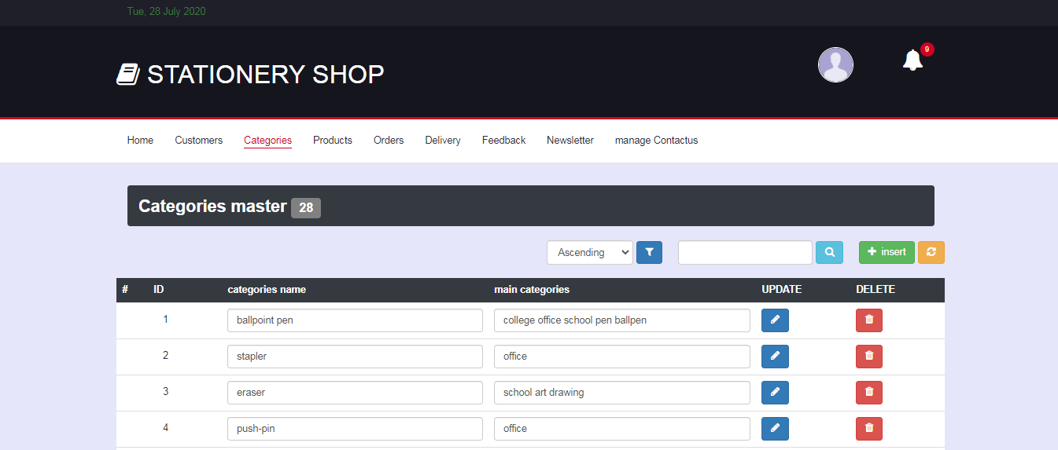

**Categories.php**

<!DOCTYPE html>

<html lang="en">

<head>

<title>ADMIN | categories </title>

<?php include "header.php";?>

<ul class="main-nav nav navbar-nav">

<li><a href="index.php">Home</a></li>

<li><a href="customer.php">Customers</a></li>

<li class="active"><a href="categories.php">Categories</a></li>

<li><a href="products.php">Products</a></li>

<li><a href="orders.php">Orders</a></li>

<li><a href="delivery.php">Delivery</a></li>

<li><a href="feedback.php">Feedback</a></li>

<li><a href="newsletter.php">Newsletter</a></li>

<li><a href="manage\_contactus.php">manage Contactus</a></li>

</ul>

<!-- /NAV -->

</div>

<!-- /responsive-nav -->

</div>

<!-- /container -->

</nav>

<!-- /NAVIGATION -->

<!-- SECTION -->

<div class="section">

<!-- container -->

<div class="container">

<!-- row -->

<div class="row">

<?php

$cmd1 = mysql\_query( "select \* from categories", $conn );

$cnt = mysql\_num\_rows( $cmd1 );

?>

<div class="col pull-left" >

<h2>Categories master <div class="label bg-grey"><?php echo $cnt; ?></div></h2>

</div>

<div class="col pull-right" >

<a class="btn btn-success" href="" data-toggle="modal" data-target="#Modal\_insert"><i class="fa fa-plus"></i> &nbsp;insert</a>

<a class="btn btn-warning" href="categories.php"><i class="fa fa-refresh"></i></a>

</div>

<div class="col-md-3 pull-right">

<form name="searchform" method="post" action="categories.php">

<div class="form-group form-inline">

<input class="form-control" type="text" name="stext" />

<button type="submit" name="sbtn" class="btn btn-info"><i class="fa fa-search"></i></button>

</div>

</form>

</div>

</div>

<div class="row">

<div class="table-responsive text-nowrap">

<table class="table table-hover">

<thead class="bg-dark">

<tr>

<th scope="col">#</th>

<th scope="col">ID</th>

<th scope="col">categories name</th>

<th scope="col">main categories</th>

<th scope="col">UPDATE</th>

<th scope="col">DELETE</th>

</tr>

</thead>

<tbody class="bg-light">

<?php

if(isset($\_POST['sbtn']))

{

$stext = $\_POST['stext'];

$sql="select \* from categories where CID='$stext' or cname LIKE '%$stext%' or scname LIKE '%$stext%'";

$cmd1 = mysql\_query( $sql, $conn ) or die(mysql\_error());

}

else

{

$cmd1 = mysql\_query( "select \* from categories", $conn );

}

while( $rset = mysql\_fetch\_array( $cmd1 ) )

{

?>

<form action="categories.php" method="post">

<tr>

<th scope="row"></th>

<td><h2 class="btn" style="background-color:white;"><?php echo "$rset[0]"; ?></h2><input type="hidden" name="catid" value="<?php echo $rset[0];?>"/></td>

<td><input class="form-control" type="text" name="name" value="<?php echo $rset[1];?>"/></td>

<td><input class="form-control" type="text" name="sub" value="<?php echo $rset[2];?>"/></td>

<td><button type="submit" class="btn btn-primary" name="up\_cat" ><i class="fa fa-pencil"></i></button></td>

<td><button type="submit" class="btn btn-danger" name="dl\_cat" ><i class="fa fa-trash"></i></button></td>

</tr>

</form>

<?php

}

?>

</tbody>

</table>

</div>

</div>

<!-- /row -->

</div>

<!-- /container -->

</div>

<!-- /SECTION -->

<!-- update start -->

<div class="modal fade" id="Modal\_insert" role="dialog">

<div class="modal-dialog">

<!-- Modal content-->

<div class="modal-content">

<div class="modal-header">

<button type="button" class="close" data-dismiss="modal">&times;</button>

</div>

<div class="modal-body">

<div class="container-fluid">

<?php

$sql = "select max( CID ) from categories";

$cmd = mysql\_query( $sql, $conn );

$cnt = mysql\_num\_rows( $cmd );

if( $cnt == 0 )

{

$cid = 1;

}

else

{

$rset = mysql\_fetch\_array( $cmd );

$cid = $rset[0] + 1;

}

?>

<form id="insert" class="login100-form " action="categories.php" method="POST">

<div class="billing-details jumbotron">

<div class="section-title">

<h2 class="login100-form-title p-b-49" >Insert categories</h2>

</div>

<div class="form-group">

<label for="id">ID</label>

<input class="input input-borders" type="text" name="catid" value="<?php echo $cid; ?>" >

</div>

<div class="form-group">

<label for="name">name</label>

<input class="input input-borders" type="text" name="name" value="" required>

</div>

<div class="form-group">

<label for="sub">sub tag</label>

<input class="input input-borders" type="text" name="sub" value="" required>

</div>

<input class="primary-btn btn-block" type="submit" Value="insert" name="in\_cat">

</div>

</form>

</div></div></div>

<!--/modal -->

</div>

</div>

<!-- /update end-->

</body>

</html>

<?php

//insert

if( isset( $\_POST['in\_cat'] ) )

{

$sub = $\_POST['sub'];

$name = $\_POST['name'];

$catid = $\_POST['catid'];

$sql = "insert into categories values( '$catid', '$name' ,'$sub' )";

$cmd = mysql\_query( $sql, $conn ) or die(mysql\_error());

echo "<script>alert( 'Inserted.' ); window.location.href='categories.php'; </script>";

}

//update

if( isset( $\_POST['up\_cat'] ) )

{

$sub = $\_POST['sub'];

$name = $\_POST['name'];

$catid = $\_POST['catid'];

$sql = " UPDATE categories SET cname = '$name',scname = '$sub' WHERE CID = $catid";

$cmd = mysql\_query( $sql, $conn ) or die(mysql\_error());

echo "<script>alert( 'Updated.' ); window.location.href='categories.php'; </script>";

}

//delete

if( isset( $\_POST['dl\_cat'] ) )

{

$catid = $\_POST['catid'];

$sql = "DELETE FROM categories WHERE CID='$catid'";

$cmd = mysql\_query( $sql, $conn ) or die( mysql\_error() );

echo "<script>alert( 'Deleted.' ); window.location.href='categories.php'; </script>";

}

?>

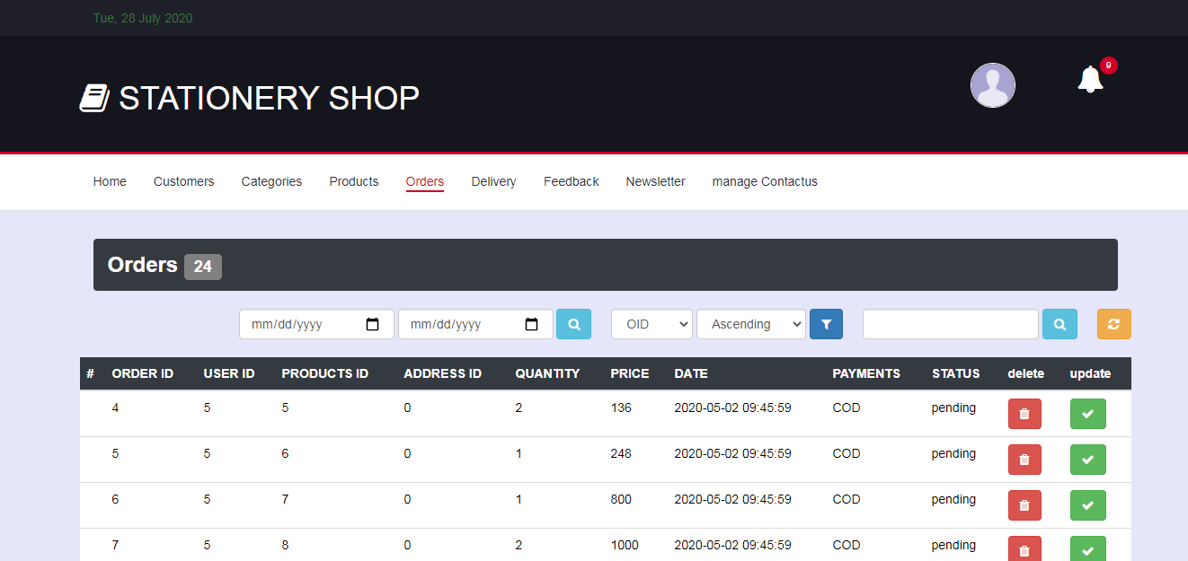

**Orders.php**

<!DOCTYPE html>

<html lang="en">

<head>

<title>ADMIN | orders </title>

<?php include "header.php";?>

<ul class="main-nav nav navbar-nav">

<li><a href="index.php">Home</a></li>

<li><a href="customer.php">Customers</a></li>

<li><a href="categories.php">Categories</a></li>

<li><a href="products.php">Products</a></li>

<li class="active"><a href="orders.php">Orders</a></li>

<li><a href="delivery.php">Delivery</a></li>

<li><a href="feedback.php">Feedback</a></li>

<li><a href="newsletter.php">Newsletter</a></li>

<li><a href="manage\_contactus.php">manage Contactus</a></li>

</ul>

<!-- /NAV -->

</div>

<!-- /responsive-nav -->

</div>

<!-- /container -->

</nav>

<!-- /NAVIGATION -->

<!-- SECTION -->

<div class="section">

<!-- container -->

<div class="container">

<!-- row -->

<div class="row">

<?php

$cmd1 = mysql\_query( "select \* from orders", $conn );

$cnt = mysql\_num\_rows( $cmd1 );

?>

<div class="col-md-6 pull-left" >

<h2>Orders <div class="label bg-grey"><?php echo $cnt; ?></div></h2>

</div>

<div class="col pull-right" >

<a class="btn btn-warning" href="orders.php" data-toggle="tooltip" title="Refresh page"><i class="fa fa-refresh"></i></a>

</div>

<div class="col-md-3 pull-right">

<form name="searchform" method="post" action="">

<div class="form-group form-inline">

<input class="form-control" type="text" name="stext" />

<button type="submit" name="sbtn" class="btn btn-info" data-toggle="tooltip" data-placement="top" title="Search row"><i class="fa fa-search"></i></button>

</div>

</form>

</div>

<table class="table table-hover">

<thead class="bg-dark">

<tr>

<th scope="col">#</th>

<th scope="col">ORDER ID</th>

<th scope="col">USER ID</th>

<th scope="col">PRODUCTS ID</th>

<th scope="col">ADDRESS ID</th>

<th scope="col">QUANTITY</th>

<th scope="col">PRICE</th>

<th scope="col">DATE</th>

<th scope="col">PAYMENTS</th>

<th scope="col">STATUS</th>

<th scope="col">delete</th>

<th scope="col">update</th>

</tr>

</thead>

<tbody class="bg-light">

<?php

if(isset($\_POST['sbtn']))

{

$stext = $\_POST['stext'];

$sql="select \* from orders where PID='$stext' or pay\_method='$stext'";

$cmd1 = mysql\_query( $sql, $conn ) or die(mysql\_error());

}

else

{

$cmd1 = mysql\_query( "select \* from orders", $conn );

}

while( $rset = mysql\_fetch\_array( $cmd1 ) )

{

?>

<tr>

<th></th>

<td><?php echo "$rset[0]"; ?></td>

<td><?php echo "$rset[1]"; ?></td>

<td><?php echo "$rset[2]"; ?></td>

<td><?php echo "$rset[3]"; ?></td>

<td><?php echo "$rset[4]"; ?></td>

<td><?php echo "$rset[5]"; ?></td>

<td><?php echo "$rset[6]"; ?></td>

<td><?php echo "$rset[7]"; ?></td>

<td><?php echo "$rset[8]"; ?></td>

<td><a class="btn btn-danger" href='orders.php?doid=<?php echo $rset[0]; ?>' data-toggle="tooltip" title="Delete row" ><i class="fa fa-trash"></a></a></td>

<td><a class="btn btn-success" href='orders.php?oid=<?php echo $rset[0]; ?>' data-toggle="tooltip" title="accept orders" ><i class="fa fa-check"></a></a></td>

</tr>

<?php

}

?>

</tbody>

</table>

</div>

<!-- /row -->

</div>

<!-- /container -->

</div>

<!-- /SECTION -->

</body>

</html>

<?php

//delete

if( isset( $\_GET['doid'] ) )

{

$oid = $\_GET['doid'];

$sql = "DELETE FROM orders WHERE OID='$oid'";

$cmd = mysql\_query( $sql, $conn ) or die( mysql\_error() );

echo "<script>alert( 'orders Deleted.' ); window.location.href='orders.php'; </script>";

}

if( isset( $\_GET['oid'] ) )

{

$oid = $\_GET['oid'];

$sql1= "select \* from orders where OID = $oid";

$cmd1 = mysql\_query( $sql1, $conn ) or die(mysql\_error());

$rset = mysql\_fetch\_array( $cmd1 );

$sql = "INSERT INTO delivery VALUES("."$rset[0]".","."$rset[1]".","."$rset[2]".","."$rset[3]".","."$rset[4]".","."$rset[5]".","."'$rset[6]'".","."'$rset[7]'".")";

$cmd = mysql\_query( $sql, $conn ) or die( mysql\_error() );

if($cmd)

{

$sql = "DELETE FROM orders WHERE OID='$oid'";

$cmd = mysql\_query( $sql, $conn ) or die( mysql\_error() );

}

echo "<script>alert( 'orders accepted.' ); window.location.href='orders.php'; </script>";

}

?>

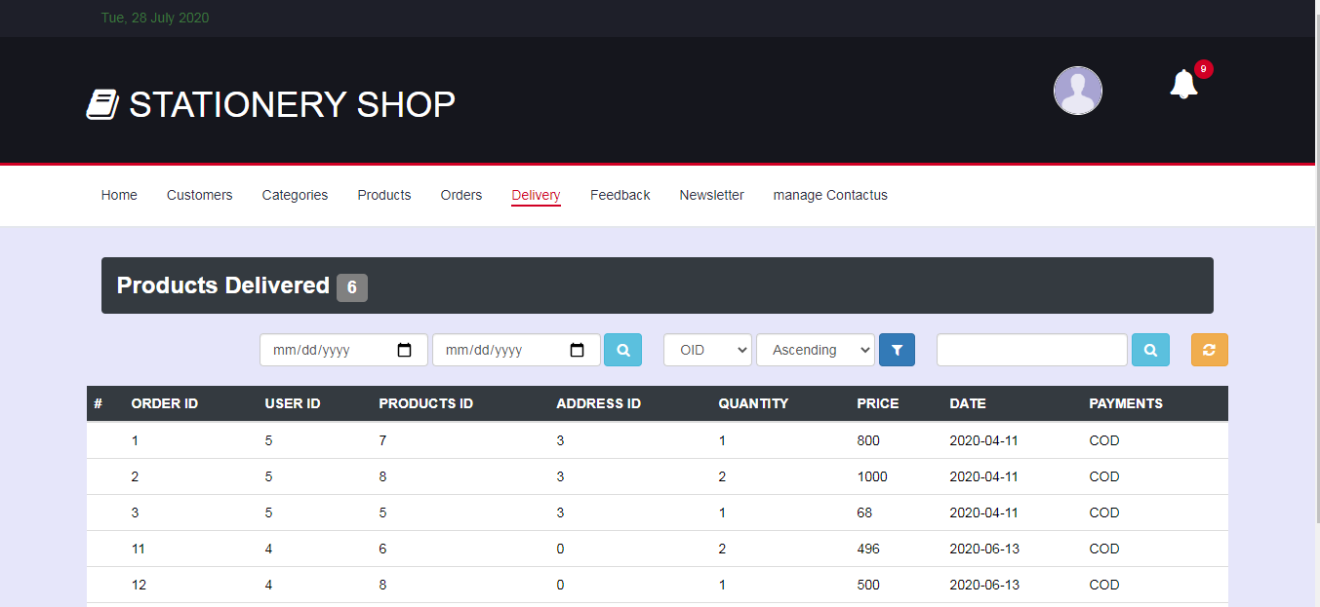

**Delivery.php**

<!DOCTYPE html>

<html lang="en">

<head>

<title>ADMIN | delevery </title>

<?php include "header.php";?>

<ul class="main-nav nav navbar-nav">

<li><a href="index.php">Home</a></li>

<li><a href="customer.php">Customers</a></li>

<li><a href="categories.php">Categories</a></li>

<li><a href="products.php">Products</a></li>

<li><a href="orders.php">Orders</a></li>

<li class="active"><a href="delivery.php">Delivery</a></li>

<li><a href="feedback.php">Feedback</a></li>

<li><a href="newsletter.php">Newsletter</a></li>

<li><a href="manage\_contactus.php">manage Contactus</a></li>

</ul>

<!-- /NAV -->

</div>

<!-- /responsive-nav -->

</div>

<!-- /container -->

</nav>

<!-- /NAVIGATION -->

<!-- SECTION -->

<div class="section">

<!-- container -->

<div class="container">

<!-- row -->

<div class="row">

<?php

$cmd1 = mysql\_query( "select \* from delivery", $conn );

$cnt = mysql\_num\_rows( $cmd1 );

?>

<div class="col-md-6 pull-left" >

<h2>products delivered <div class="label bg-grey"><?php echo $cnt; ?></div></h2>

</div>

<div class="col pull-right" >

<a class="btn btn-warning" href="" data-toggle="tooltip" title="Refresh page"><i class="fa fa-refresh"></i></a>

</div>

<div class="col-md-3 pull-right">

<form name="searchform" method="post" action="">

<div class="form-group form-inline">

<input class="form-control" type="text" name="stext" />

<button type="submit" name="sbtn" class="btn btn-info" data-toggle="tooltip" data-placement="top" title="Search row"><i class="fa fa-search"></i></button>

</div>

</form>

</div>

<table class="table table-hover">

<thead class="bg-dark">

<tr>

<th scope="col">#</th>

<th scope="col">ORDER ID</th>

<th scope="col">USER ID</th>

<th scope="col">PRODUCTS ID</th>

<th scope="col">ADDRESS ID</th>

<th scope="col">QUANTITY</th>

<th scope="col">PRICE</th>

<th scope="col">DATE</th>

<th scope="col">PAYMENTS</th>

</tr>

</thead>

<tbody class="bg-light">

<?php

if(isset($\_POST['sbtn']))

{

$stext = $\_POST['stext'];

$sql="select \* from delivery PID='$stext' or pay\_method='$stext'";

$cmd1 = mysql\_query( $sql, $conn ) or die(mysql\_error());

}

else

{

$cmd1 = mysql\_query( "select \* from delivery", $conn );

}

while( $rset = mysql\_fetch\_array( $cmd1 ) )

{

?>

<tr>

<th></th>

<td><?php echo "$rset[0]"; ?></td>

<td><?php echo "$rset[1]"; ?></td>

<td><?php echo "$rset[2]"; ?></td>

<td><?php echo "$rset[3]"; ?></td>

<td><?php echo "$rset[4]"; ?></td>

<td><?php echo "$rset[5]"; ?></td>

<td><?php echo "$rset[6]"; ?></td>

<td><?php echo "$rset[7]"; ?></td>

</tr>

<?php

}

?>

</tbody>

</table>

</div>

<!-- /row -->

</div>

<!-- /container -->

</div>

<!-- /SECTION -->

</body>

</html>

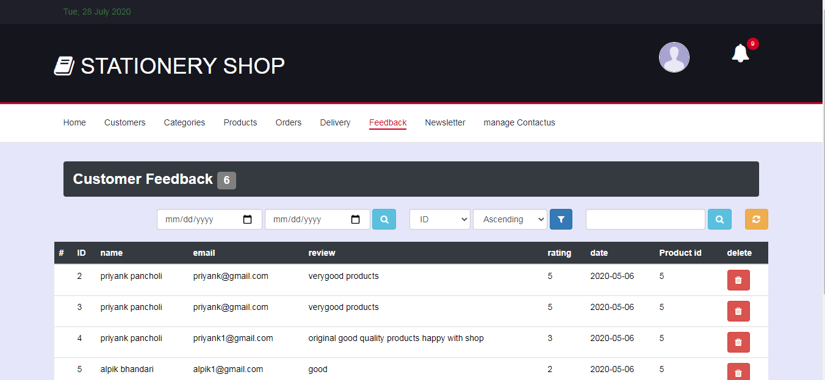

**Feedback.php**

<!DOCTYPE html>

<html lang="en">

<head>

<title>ADMIN | customer </title>

<?php include "header.php";?>

<ul class="main-nav nav navbar-nav">

<li><a href="index.php">Home</a></li>

<li><a href="customer.php">Customers</a></li>

<li><a href="categories.php">Categories</a></li>

<li><a href="products.php">Products</a></li>

<li><a href="orders.php">Orders</a></li>

<li><a href="delivery.php">Delivery</a></li>

<li class="active"><a href="feedback.php">Feedback</a></li>

<li><a href="newsletter.php">Newsletter</a></li>

<li><a href="manage\_contactus.php">manage Contactus</a></li>

</ul>

<!-- /NAV -->

</div>

<!-- /responsive-nav -->

</div>

<!-- /container -->

</nav>

<!-- /NAVIGATION -->

<!-- SECTION -->

<div class="section">

<!-- container -->

<div class="container">

<!-- row -->

<div class="row">

<?php

$cmd1 = mysql\_query( "select \* from review", $conn );

$cnt = mysql\_num\_rows( $cmd1 );

?>

<div class="col-md-6 pull-left" >

<h2>Customer master <div class="label bg-grey"><?php echo $cnt; ?></div></h2>

</div>

<div class="col pull-right" >

<a class="btn btn-warning" href="feedback.php" data-toggle="tooltip" title="Refresh page"><i class="fa fa-refresh"></i></a>

</div>

<div class="col-md-3 pull-right">

<form name="searchform" method="post" >

<div class="form-group form-inline">

<input class="form-control" type="text" name="stext" />

<button type="submit" name="sbtn" class="btn btn-info" data-toggle="tooltip" data-placement="top" title="Search row"><i class="fa fa-search"></i></button>

</div>

</form>

</div>

<table class="table table-hover">

<thead class="bg-dark">

<tr>

<th scope="col">#</th>

<th scope="col">ID</th>

<th scope="col">name</th>

<th scope="col">email</th>

<th scope="col">review</th>

<th scope="col">rating</th>

<th scope="col">date</th>

<th scope="col">Product id</th>

<th scope="col">delete</th>

</tr>

</thead>

<tbody class="bg-light">

<?php

if(isset($\_POST['sbtn']))

{

$stext = $\_POST['stext'];

$sql="select \* from review where name='$stext' or email='$stext' or PID='$stext'";

$cmd1 = mysql\_query( $sql, $conn ) or die(mysql\_error());

}

else

{

$cmd1 = mysql\_query( "select \* from review", $conn );

}

while( $rset = mysql\_fetch\_array( $cmd1 ) )

{

?>

<tr>

<th></th>

<td><?php echo "$rset[0]"; ?></td>

<td><?php echo "$rset[1]"; ?></td>

<td><?php echo "$rset[2]"; ?></td>

<td><?php echo "$rset[3]"; ?></td>

<td><?php echo "$rset[4]"; ?></td>

<td><?php echo "$rset[5]"; ?></td>

<td><?php echo "$rset[6]"; ?></td>

<td><a class="btn btn-danger" href='feedback.php?id=<?php echo $rset[0]; ?>' data-toggle="tooltip" title="Delete row" ><i class="fa fa-trash"></a></a></td>

</tr>

<?php

}

?>

</tbody>

</table>

</div>

<!-- /row -->

</div>

<!-- /container -->

</div>

<!-- /SECTION -->

</body>

</html>

<?php

if(isset($\_GET['id']))

{

$id = $\_GET['id'];

$sql = "DELETE FROM review WHERE ID='$id'";

$cmd = mysql\_query( $sql, $conn ) or die( mysql\_error() );

echo "<script>alert('deleted'); window.location.href='feedback.php'; </script>";

}

?>

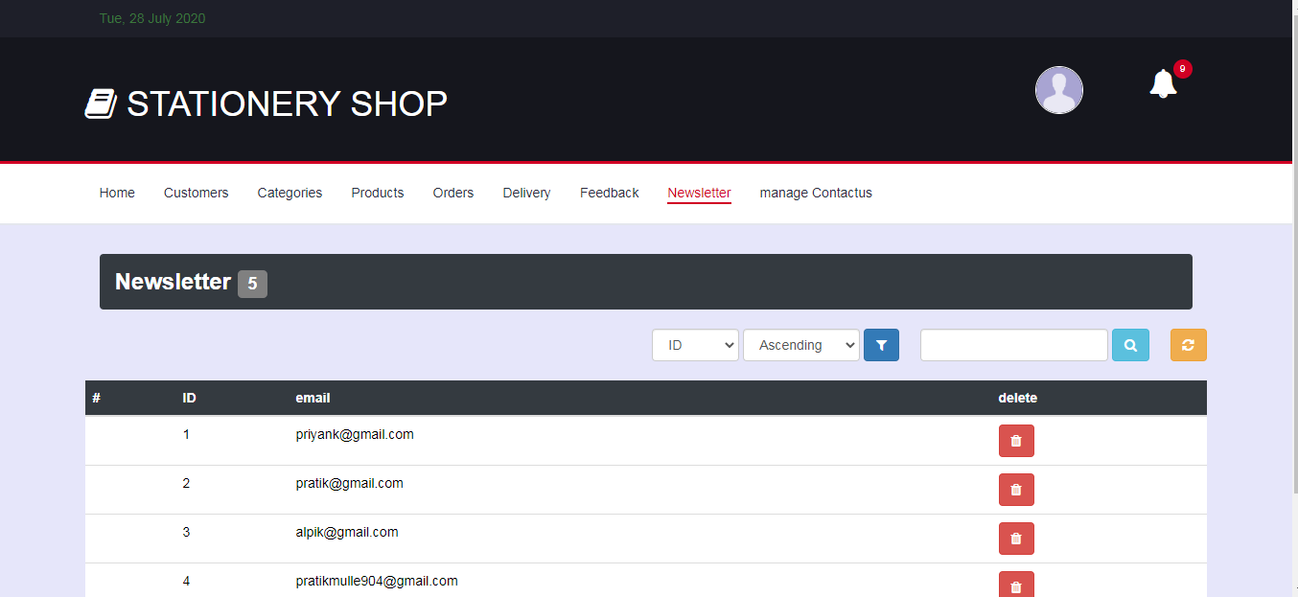

**Newsletter.php**

<!DOCTYPE html>

<html lang="en">

<head>

<title>ADMIN | Newsletter </title>

<?php include "header.php";?>

<ul class="main-nav nav navbar-nav">

<li><a href="index.php">Home</a></li>

<li><a href="customer.php">Customers</a></li>

<li><a href="categories.php">Categories</a></li>

<li><a href="products.php">Products</a></li>

<li><a href="orders.php">Orders</a></li>

<li><a href="delivery.php">Delivery</a></li>

<li><a href="feedback.php">Feedback</a></li>

<li class="active"><a href="newsletter.php">Newsletter</a></li>

<li><a href="manage\_contactus.php">manage Contactus</a></li>

</ul>

<!-- /NAV -->

</div>

<!-- /responsive-nav -->

</div>

<!-- /container -->

</nav>

<!-- /NAVIGATION -->

<!-- SECTION -->

<div class="section">

<!-- container -->

<div class="container">

<!-- row -->

<div class="row">

<?php

$cmd1 = mysql\_query( "select \* from newsletter", $conn );

$cnt = mysql\_num\_rows( $cmd1 );

?>

<div class="col-md-6 pull-left" >

<h2>Newsletter <div class="label bg-grey"><?php echo $cnt; ?></div></h2>

</div>

<div class="col pull-right" >

<a class="btn btn-warning" href="newsletter.php" data-toggle="tooltip" title="Refresh page"><i class="fa fa-refresh"></i></a>

</div>

<div class="col-md-3 pull-right">

<form name="searchform" method="post" action="">

<div class="form-group form-inline">

<input class="form-control" type="text" name="stext" />

<button type="submit" name="sbtn" class="btn btn-info" data-toggle="tooltip" data-placement="top" title="Search row"><i class="fa fa-search"></i></button>

</div>

</form>

</div>

<table class="table table-hover">

<thead class="bg-dark">

<tr>

<th scope="col">#</th>

<th scope="col">ID</th>

<th scope="col">email</th>

<th scope="col">delete</th>

</tr>

</thead>

<tbody class="bg-light">

<?php

if(isset($\_POST['sbtn']))

{

$stext = $\_POST['stext'];

$sql="select \* from user\_master where ID='$stext' or email='$stext' ";

$cmd1 = mysql\_query( $sql, $conn ) or die(mysql\_error());

}

else

{

$cmd1 = mysql\_query( "select \* from newsletter", $conn );

}

while( $rset = mysql\_fetch\_array( $cmd1 ) )

{

?>

<tr>

<th></th>

<td><?php echo "$rset[0]"; ?></td>

<td><?php echo "$rset[1]"; ?></td>

<td><a class="btn btn-danger" href='newsletter.php?id=<?php echo $rset[0]; ?>' data-toggle="tooltip" title="Delete row" ><i class="fa fa-trash"></a></a></td>

</tr>

<?php

}

?>

</tbody>

</table>

</div>

<!-- /row -->

</div>

<!-- /container -->

</div>

<!-- /SECTION -->

</body>

</html>

<?php

if( isset( $\_GET['id'] ) )

{

$id = $\_GET['id'];

$sql = "DELETE FROM newsletter WHERE ID='$id'";

$cmd = mysql\_query( $sql, $conn ) or die( mysql\_error() );

echo "<script>window.location.href='newsletter.php'; </script>";

}

?>

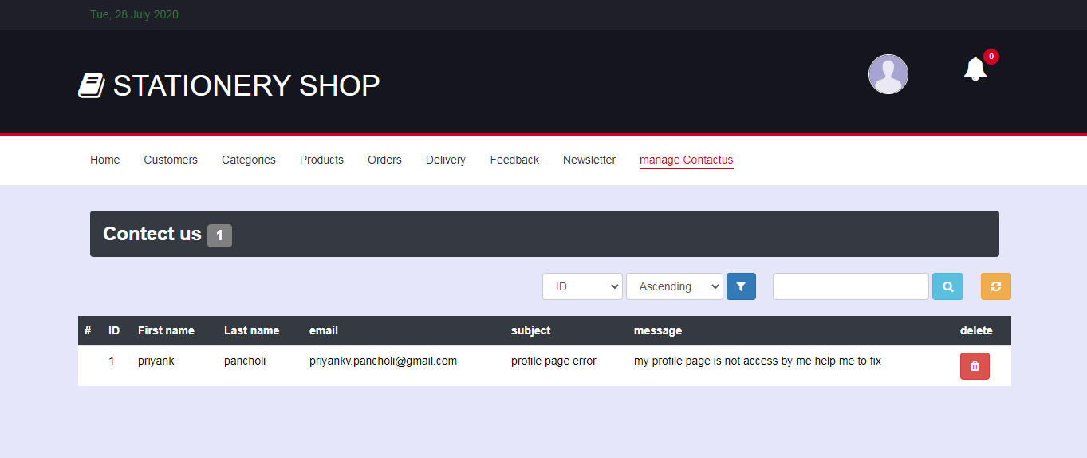

**Manage\_contactus.php**

<!DOCTYPE html>

<html lang="en">

<head>

<title>ADMIN | manage contactus </title>

<?php include "header.php";?>

<ul class="main-nav nav navbar-nav">

<li><a href="index.php">Home</a></li>

<li><a href="customer.php">Customers</a></li>

<li><a href="categories.php">Categories</a></li>

<li><a href="products.php">Products</a></li>

<li><a href="orders.php">Orders</a></li>

<li><a href="delivery.php">Delivery</a></li>

<li><a href="feedback.php">Feedback</a></li>

<li><a href="newsletter.php">Newsletter</a></li>

<li class="active"><a href="manage\_contactus.php">manage Contactus</a></li>

</ul>

<!-- /NAV -->

</div>

<!-- /responsive-nav -->

</div>

<!-- /container -->

</nav>

<!-- /NAVIGATION -->

<!-- SECTION -->

<div class="section">

<!-- container -->

<div class="container">

<!-- row -->

<div class="row">

<?php

$cmd1 = mysql\_query( "select \* from contactus", $conn );

$cnt = mysql\_num\_rows( $cmd1 );

?>

<div class="col-md-6 pull-left" >

<h2>Contect us <div class="label bg-grey"><?php echo $cnt; ?></div></h2>

</div>

<div class="col pull-right" >

<a class="btn btn-warning" href="" data-toggle="tooltip" title="Refresh page"><i class="fa fa-refresh"></i></a>

</div>

<div class="col-md-3 pull-right">

<form name="searchform" method="post" action="">

<div class="form-group form-inline">

<input class="form-control" type="text" name="stext" />

<button type="submit" name="sbtn" class="btn btn-info" data-toggle="tooltip" data-placement="top" title="Search row"><i class="fa fa-search"></i></button>

</div>

</form>

</div>

<table class="table table-hover">

<thead class="bg-dark">

<tr>

<th scope="col">#</th>

<th scope="col">ID</th>

<th scope="col">First name</th>

<th scope="col">Last name</th>

<th scope="col">email</th>

<th scope="col">subject</th>

<th scope="col">message</th>

<th scope="col">delete</th>

</tr>

</thead>

<tbody class="bg-light">

<?php

if(isset($\_POST['sbtn']))

{

$stext = $\_POST['stext'];

$sql="select \* from contactus where fname='$stext' or lname='$stext' or ID='$stext' or email='$stext' ";

$cmd1 = mysql\_query( $sql, $conn ) or die(mysql\_error());

}

else

{

$cmd1 = mysql\_query( "select \* from contactus", $conn );

}

while( $rset = mysql\_fetch\_array( $cmd1 ) )

{

?>

<tr>

<!--<th scope="row"><image src="../<?php echo $rset[6]; ?>" style="width:100px; height:auto"></image></th> -->

<th></th>

<td><?php echo "$rset[0]"; ?></td>

<td><?php echo "$rset[1]"; ?></td>

<td><?php echo "$rset[2]"; ?></td>

<td><?php echo "$rset[3]"; ?></td>

<td><?php echo "$rset[4]"; ?></td>

<td><?php echo "$rset[5]"; ?></td>

<td><a class="btn btn-danger" href='manage\_contactus.php?id=<?php echo $rset[0]; ?>' data-toggle="tooltip" title="Delete row" ><i class="fa fa-trash"></a></a></td>

</tr>

<?php

}

?>

</tbody>

</table>

</div>

<!-- /row -->

</div>

<!-- /container -->

</div>

<!-- /SECTION -->

</body>

</html>

<?php

if(isset($\_GET['id']))

{

$id = $\_GET['id'];

$sql = "DELETE FROM contactus WHERE ID='$id'";

$cmd = mysql\_query( $sql, $conn ) or die( mysql\_error() );

echo "<script>alert('deleted'); window.location.href='customer.php'; </script>";

}

?>

**Products\_update.php**

<!DOCTYPE html>

<html lang="en">

<head>

<title>ADMIN | products </title>

<?php include "header.php";?>

<ul class="main-nav nav navbar-nav">

<li><a href="index.php">Home</a></li>

<li><a href="customer.php">Customers</a></li>

<li><a href="categories.php">Categories</a></li>

<li class="active"><a href="products.php">Products</a></li>

<li><a href="orders.php">Orders</a></li>

<li><a href="delivery.php">Delivery</a></li>

<li><a href="feedback.php">Feedback</a></li>

<li><a href="manage\_contactus.php">manage Contactus</a></li>

</ul>

<!-- /NAV -->

</div>

<!-- /responsive-nav -->

</div>

<!-- /container -->

</nav>

<!-- /NAVIGATION -->

<!-- SECTION -->

<div class="section">

<!-- container -->

<div class="container">

<!-- row -->

<div class="row">

<div class=" col-md-2 pull-center">

</div>

<!-- update start -->

<div class="container-fluid col-md-8 pull-center">

<?php

//delete

if( isset( $\_GET['upid'] ) )

{

$upid = $\_GET['upid'];

$cmd = mysql\_query( "select \* from products where PID = $upid",$conn );

$rset = mysql\_fetch\_array( $cmd );

}

?>

<form id="insert" class="login100-form " action="products\_update.php" method="POST">

<div class="billing-details jumbotron">

<div class="section-title">

<h2 class="login100-form-title p-b-49" >Update Products</h2>

</div>

<div c lass="form-group">

<label for="id">ID</label>

<input class="input" type="text" name="pid" value="<?php echo $upid; ?>" readonly >

</div>

<div class="form-group">

<label for="name">Name</label>

<input class="input " type="text" name="name" value="<?php echo $rset[1]; ?>" required>

</div>

<div class="form-group">

<label for="sub">Description</label>

<textarea class="input" name="desc" required><?php echo $rset[2]; ?></textarea>

</div>

<div class="form-group">

<label for="price">Price: </label>

<input class="input" type="text" name="price"value="<?php echo $rset[3]; ?>" required style="width:250px">

<label for="discount">discount: </label>

<input class="input" type="text" name="discount" value="<?php echo $rset[5]; ?>" style="width:250px" required>

</div>

<div class="form-group">

<label for="categories">select categories</label>

<select id="category" name="cat" class="input">

<option value="">select</option>

<?php

$result = mysql\_query( "SELECT \* FROM categories", $conn );

while( $row = mysql\_fetch\_array( $result ) ) {

?>

<option value="<?php echo $row['CID'];?>"><?php echo $row['cname'];?></option>

<?php

}

?>

</select>

</div>

<div class="form-group">

<label for="name">products tag</label>

<textarea class="input" name="ptag" required><?php echo $rset[6]; ?></textarea>

</div>

<input class="primary-btn btn-block" type="submit" Value="update" name="update">

</div>

</form>

</div>

</div>

</div>

</div>

<!-- /update end-->

</body>

</html>

<?php

//update

if( isset( $\_POST['update'] ) )

{

$pid = $\_POST['pid'];

$pname = $\_POST['name'];

$desc = $\_POST['desc'];

$price = $\_POST['price'];

$discount = $\_POST['discount'];

$cat = $\_POST['cat'];

$ptag = $\_POST['ptag'];

$sql = " UPDATE products SET pname = '$pname', pdesc = '$desc', pprice = $price, pdiscount = '$discount', CID = '$cat', ptag = '$ptag' WHERE PID = $pid";

$cmd = mysql\_query( $sql, $conn ) or die(mysql\_error());

echo "<script>alert( 'Updated.' ); window.location.href='products.php'; </script>";

}

?>

**9. TESTING:**

1. REGISTRATION

|  |  |  |  |
| --- | --- | --- | --- |
| FIELD NAME | INPUT | RESULT | OUTPUT |
| First name | - | incorrect | Please enter first name |
| Priyank123 | Incorrect | Please enter only alphabets in first name |
| Priyank | Correct | - |
| Last name | - | Incorrect | Please enter last name |
| Pancholi123 | Incorrect | Please enter only alphabets in first name |
| Pancholi | Correct | - |
| Mobile no. | 81530031881 | Incorrect | Enter 10 digits only |
| - | Incorrect | Enter mobile no. |
| Priyank | Incorrect | Enter number digits only |
| 8153003188 | Correct | - |
| Email id | Pancholipriyank33gmail.Com | Incorrect |  |
|  | Pancholipriyank33@gmail.Com | Correct |  |
|  |  |  |  |

2.) LOGIN

|  |  |  |  |
| --- | --- | --- | --- |
| FIELD NAME | INPUT | RESULT | OUTPUT |
| Enter Email Id | Vikas123.com | Incorrect | Please enter valid email id |
| Blank | Incorrect | Please enter email id |
| [Vikas123@gmail.com](mailto:Vikas123@gmail.com) | Correct | - |
| Password | 1234 | Incorrect | Please enter password length more than 6 charecters |

3) Change password

|  |  |  |  |
| --- | --- | --- | --- |
| FIELD NAME | INPUT | RESULT | OUTPUT |
| oldpassword | 23453 | Incorrect | Please enter password length more than 6 charecters |
| Blank | Incorrect | Please enter password |
| Pratik@1234 | Correct | - |
| Newpassword | 1234 | Incorrect | Please enter password length more than 6 charecters |
| Pratik@567 | Correct | - |
| Newpassword1 | 1234 | Incorrect | Please enter password length more than 6 charecters |
| Blank | Incorrect | Please enter password |
| Pratik@567 | Correct | - |

4) Contactus

|  |  |  |  |
| --- | --- | --- | --- |
| FIELD NAME | INPUT | RESULT | OUTPUT |
| First name | - | incorrect | Please enter first name |
| Priyank123 | Incorrect | Please enter only alphabets in first name |
| Priyank | Correct | - |
| Last name | - | Incorrect | Please enter last name |
| Pancholi123 | Incorrect | Please enter only alphabets in first name |
| Pancholi | Correct | - |
| Email id | Pancholipriyankgmail.Com | Incorrect | Enter valid registered email |
| Pancholipriyank33@gmail.Com | Correct | - |
| Blank | Incorrect | Please Enter email |
| Subject | Blank | incorrect | Please enter email |
| Priyank | Correct | - |
| Message | Blank | incorrect | Please enter messagae |
| I have an issue with so and so,…… | Correct | - |

5) update profile

|  |  |  |  |
| --- | --- | --- | --- |
| FIELD NAME | INPUT | RESULT | OUTPUT |
| First name | - | incorrect | Please enter first name |
| Priyank123 | Incorrect | Please enter only alphabets in first name |
| Priyank | Correct | - |
| Last name | - | Incorrect | Please enter last name |
| Pancholi123 | Incorrect | Please enter only alphabets in first name |
| Pancholi | Correct | - |
| Mobile no. | 81530031881 | Incorrect | Enter 10 digits only |
| - | Incorrect | Enter mobile no. |
| Priyank | Incorrect | Enter number digits only |
| 8153003188 | Correct | - |
| Email id | Pancholipriyank33gmail.Com | Incorrect | Please enter register email |
| Pancholipriyank33@gmail.Com | Correct | - |
| Blank | Incorrect | Please enter email |
| Sec Question | Blank | Correct | - |
| Whats your pet name | Correct | - |
| Sec answer | Blank | Correct | - |
| Pratik | Correct | - |

**10. Conclusion**

The project work titled “Online Stationery Shop” has been designed using PHP Hypertext Pre-Processor (PHP) where in many user-friendly form controls have been added in order to make it a user interactive application. The system is developed in such a way that the user with common knowledge of computers can handle it easily. The system forms a general platform for building most advanced shopping systems.

Technology has made significant progress over the years to provide consumers a better online shopping experience and will continue to do so for years to come.  With the rapid growth of products and brands, people have speculated that online shopping will overtake in-store shopping.

While this has been the case in some areas, there is still demand for brick and mortar stores in market areas where the consumer feels more comfortable seeing and touching the product being bought.

However, the availability of online shopping has produced a more educated consumer that can shop around with relative ease without having to spend a large amount of time.  In exchange, online shopping has opened up doors to many small retailers that would never be in business if they had to incur the high cost of owning a brick and mortar store.  At the end, it has been a win-win situation for both consumer and sellers.

11) Future scope of the project

We can consider much future scope to this application. The following are some of these.

* In future, we can further enhance this software for tablets and mobile phones.
* Later basis software is developed as friendly and attractive
* Add more security features

.

13) references

* [books](http://www.colorlib.com/)
  1. [Essence of php](http://www.colorlib.com/)
* [website](http://www.colorlib.com/)
  1. [www.colorlib.com](http://www.colorlib.com/)
  2. [www.tutorialspoint.com](http://www.tutorialspoint.com/)
  3. [www.w3school.com](http://www.w3school.com/)